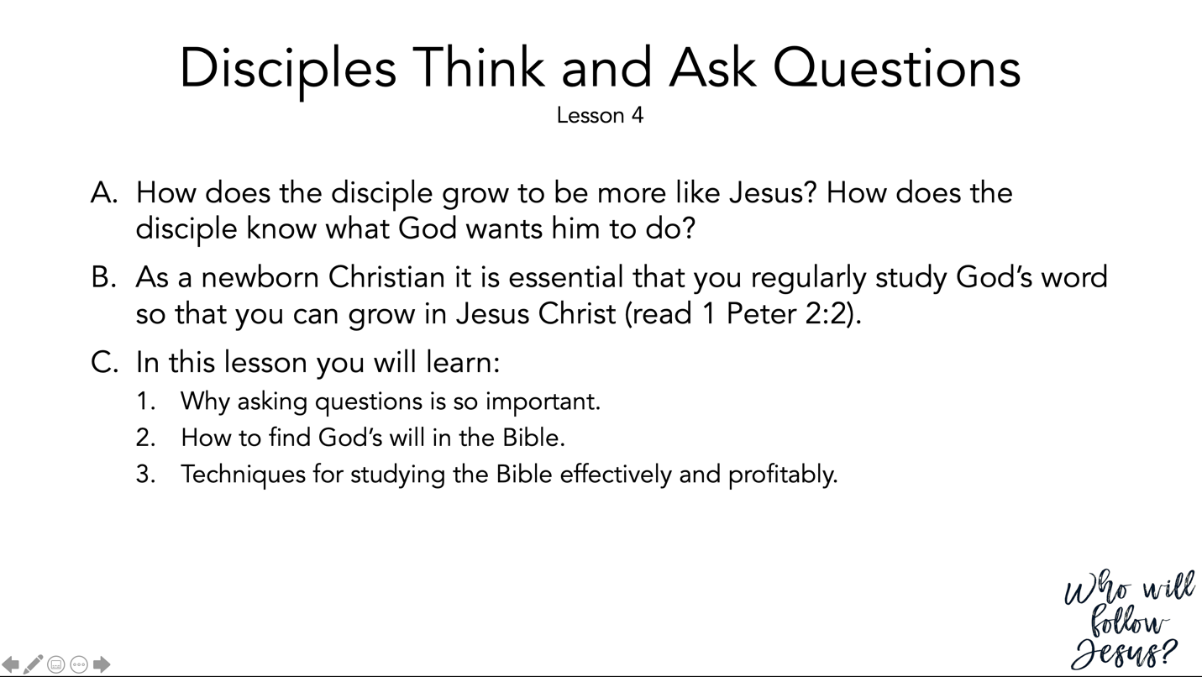

1 Peter 2:1–3 (NASB95) – As Newborn Babes
¹ Therefore, putting aside all malice and all deceit and hypocrisy and envy and all slander, ² like newborn babies, long for the pure milk of the word, so that by it you may grow in respect to salvation, ³ if you have tasted the kindness of the Lord.

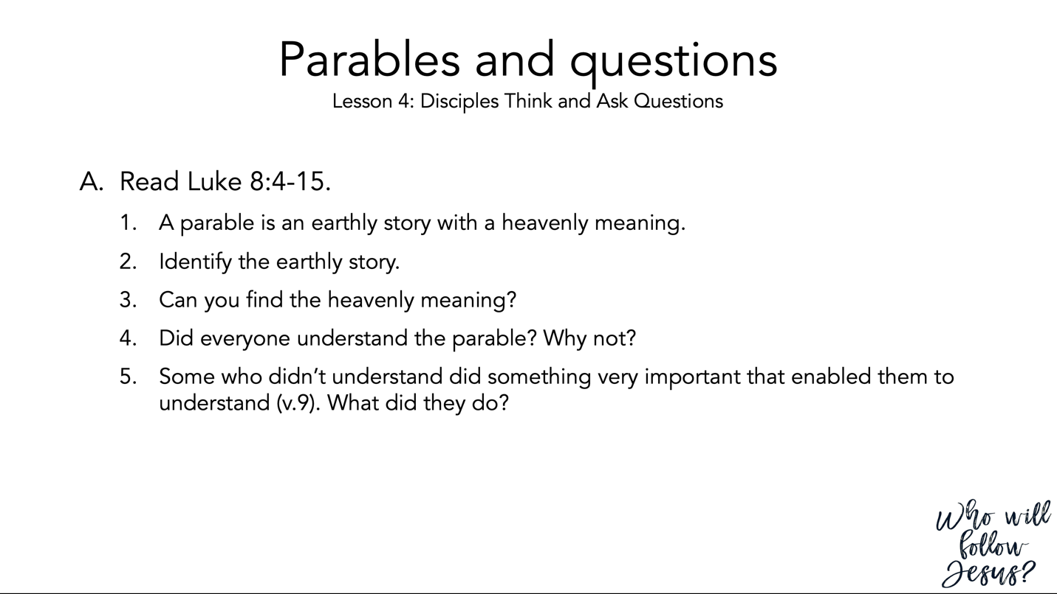

Luke 8:4–15 (NASB95) – Parable of the Sower
⁴ When a large crowd was coming together, and those from the various cities were journeying to Him, He spoke by way of a parable: ⁵ “The sower went out to sow his seed; and as he sowed, some fell beside the road, and it was trampled under foot and the birds of the air ate it up. ⁶ “Other seed fell on rocky soil, and as soon as it grew up, it withered away, because it had no moisture. ⁷ “Other seed fell among the thorns; and the thorns grew up with it and choked it out. ⁸ “Other seed fell into the good soil, and grew up, and produced a crop a hundred times as great.” As He said these things, He would call out, “He who has ears to hear, let him hear.” ⁹ His disciples began questioning Him as to what this parable meant. ¹⁰ And He said, “To you it has been granted to know the mysteries of the kingdom of God, but to the rest it is in parables, so that seeing they may not see, and hearing they may not understand. ¹¹ “Now the parable is this: the seed is the word of God. ¹² “Those beside the road are those who have heard; then the devil comes and takes away the word from their heart, so that they will not believe and be saved. ¹³ “Those on the rocky soil are those who, when they hear, receive the word with joy; and these have no firm root; they believe for a while, and in time of temptation fall away. ¹⁴ “The seed which fell among the thorns, these are the ones who have heard, and as they go on their way they are choked with worries and riches and pleasures of this life, and bring no fruit to maturity. ¹⁵ “But the seed in the good soil, these are the ones who have heard the word in an honest and good heart, and hold it fast, and bear fruit with perseverance.

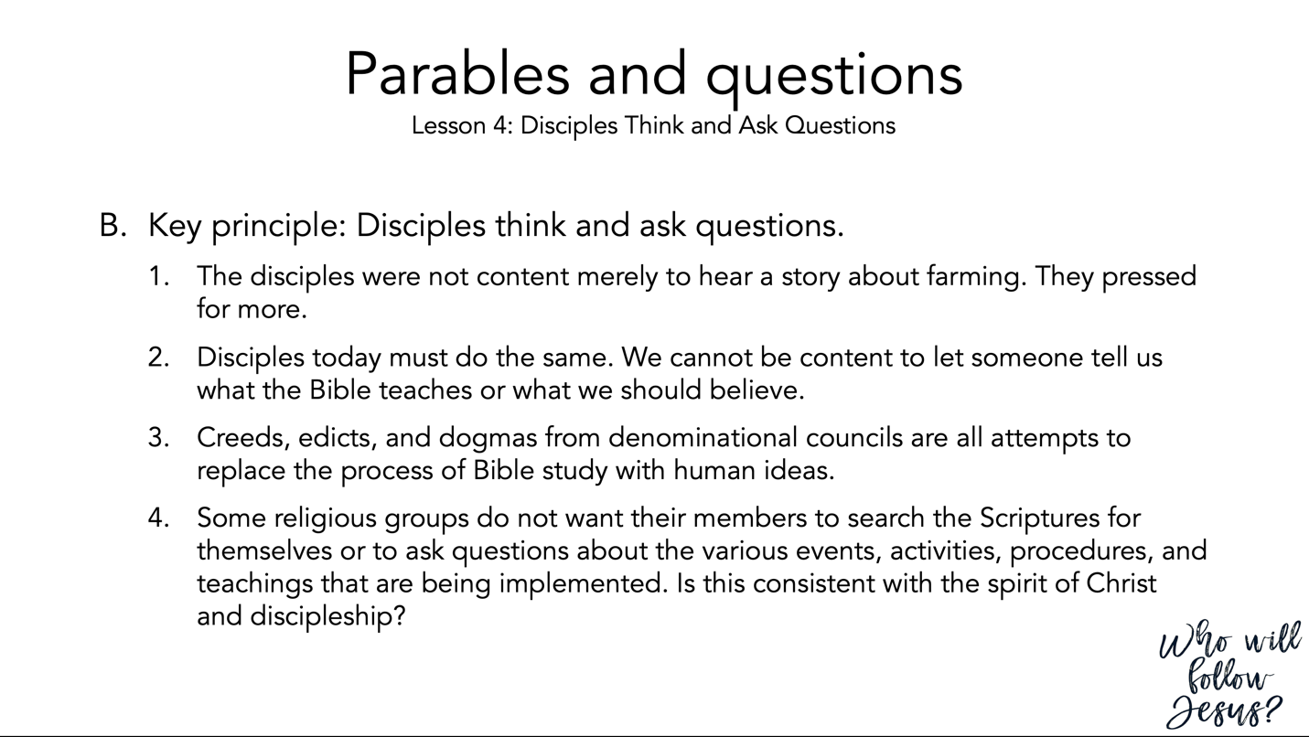

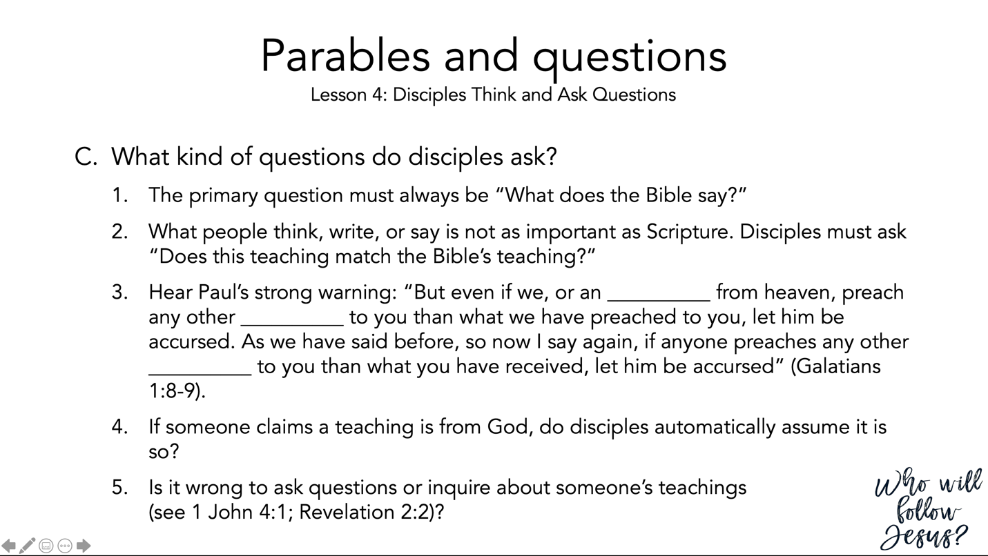

Galatians 1:6–10 (NASB95) – Perversion of the Gospel
⁶ I am amazed that you are so quickly deserting Him who called you by the grace of Christ, for a different gospel; ⁷ which is really not another; only there are some who are disturbing you and want to distort the gospel of Christ. ⁸ But even if we, or an angel from heaven, should preach to you a gospel contrary to what we have preached to you, he is to be accursed! ⁹ As we have said before, so I say again now, if any man is preaching to you a gospel contrary to what you received, he is to be accursed! ¹⁰ For am I now seeking the favor of men, or of God? Or am I striving to please men? If I were still trying to please men, I would not be a bond-servant of Christ.

1 John 4:1–6 (NASB95) – Testing the Spirits
¹ Beloved, do not believe every spirit, but test the spirits to see whether they are from God, because many false prophets have gone out into the world. ² By this you know the Spirit of God: every spirit that confesses that Jesus Christ has come in the flesh is from God; ³ and every spirit that does not confess Jesus is not from God; this is the spirit of the antichrist, of which you have heard that it is coming, and now it is already in the world. ⁴ You are from God, little children, and have overcome them; because greater is He who is in you than he who is in the world. ⁵ They are from the world; therefore they speak as from the world, and the world listens to them. ⁶ We are from God; he who knows God listens to us; he who is not from God does not listen to us. By this we know the spirit of truth and the spirit of error.

Revelation 2:1–7 (NASB95) – Message to Ephesus
¹ “To the angel of the church in Ephesus write: The One who holds the seven stars in His right hand, the One who walks among the seven golden lampstands, says this: ² ‘I know your deeds and your toil and perseverance, and that you cannot tolerate evil men, and you put to the test those who call themselves apostles, and they are not, and you found them to be false; ³ and you have perseverance and have endured for My name’s sake, and have not grown weary. ⁴ ‘But I have this against you, that you have left your first love. ⁵ ‘Therefore remember from where you have fallen, and repent and do the deeds you did at first; or else I am coming to you and will remove your lampstand out of its place—unless you repent. ⁶ ‘Yet this you do have, that you hate the deeds of the Nicolaitans, which I also hate. ⁷ ‘He who has an ear, let him hear what the Spirit says to the churches. To him who overcomes, I will grant to eat of the tree of life which is in the Paradise of God.’

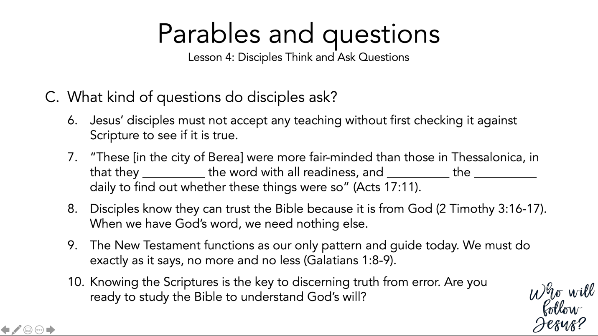

Acts 17:10–15 (NASB95) – Paul at Berea
¹⁰ The brethren immediately sent Paul and Silas away by night to Berea, and when they arrived, they went into the synagogue of the Jews. ¹¹ Now these were more noble-minded than those in Thessalonica, for they received the word with great eagerness, examining the Scriptures daily to see whether these things were so. ¹² Therefore many of them believed, along with a number of prominent Greek women and men. ¹³ But when the Jews of Thessalonica found out that the word of God had been proclaimed by Paul in Berea also, they came there as well, agitating and stirring up the crowds. ¹⁴ Then immediately the brethren sent Paul out to go as far as the sea; and Silas and Timothy remained there. ¹⁵ Now those who escorted Paul brought him as far as Athens; and receiving a command for Silas and Timothy to come to him as soon as possible, they left.

2 Timothy 3:10–17 (NASB95) – The Man of God and the Word of God
¹⁰ Now you followed my teaching, conduct, purpose, faith, patience, love, perseverance, ¹¹ persecutions, and sufferings, such as happened to me at Antioch, at Iconium and at Lystra; what persecutions I endured, and out of them all the Lord rescued me! ¹² Indeed, all who desire to live godly in Christ Jesus will be persecuted. ¹³ But evil men and impostors will proceed from bad to worse, deceiving and being deceived. ¹⁴ You, however, continue in the things you have learned and become convinced of, knowing from whom you have learned them, ¹⁵ and that from childhood you have known the sacred writings which are able to give you the wisdom that leads to salvation through faith which is in Christ Jesus. ¹⁶ All Scripture is inspired by God and profitable for teaching, for reproof, for correction, for training in righteousness; ¹⁷ so that the man of God may be adequate, equipped for every good work.

Galatians 1:6–10 (NASB95) – Perversion of the Gospel
⁶ I am amazed that you are so quickly deserting Him who called you by the grace of Christ, for a different gospel; ⁷ which is really not another; only there are some who are disturbing you and want to distort the gospel of Christ. ⁸ But even if we, or an angel from heaven, should preach to you a gospel contrary to what we have preached to you, he is to be accursed! ⁹ As we have said before, so I say again now, if any man is preaching to you a gospel contrary to what you received, he is to be accursed! ¹⁰ For am I now seeking the favor of men, or of God? Or am I striving to please men? If I were still trying to please men, I would not be a bond-servant of Christ.

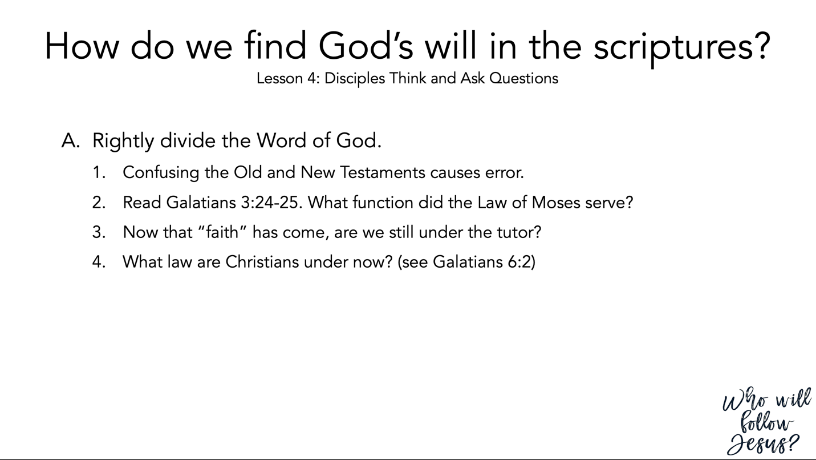

Galatians 3:23–29 (NASB95) – What Faith Has Brought Us
²³ But before faith came, we were kept in custody under the law, being shut up to the faith which was later to be revealed. ²⁴ Therefore the Law has become our tutor to lead us to Christ, so that we may be justified by faith. ²⁵ But now that faith has come, we are no longer under a tutor. ²⁶ For you are all sons of God through faith in Christ Jesus. ²⁷ For all of you who were baptized into Christ have clothed yourselves with Christ. ²⁸ There is neither Jew nor Greek, there is neither slave nor free man, there is neither male nor female; for you are all one in Christ Jesus. ²⁹ And if you belong to Christ, then you are Abraham’s descendants, heirs according to promise.

Galatians 6:1–5 (NASB95) – Bear and Share the Burdens
¹ Brethren, even if anyone is caught in any trespass, you who are spiritual, restore such a one in a spirit of gentleness; each one looking to yourself, so that you too will not be tempted. ² Bear one another’s burdens, and thereby fulfill the law of Christ. ³ For if anyone thinks he is something when he is nothing, he deceives himself. ⁴ But each one must examine his own work, and then he will have reason for boasting in regard to himself alone, and not in regard to another. ⁵ For each one will bear his own load.

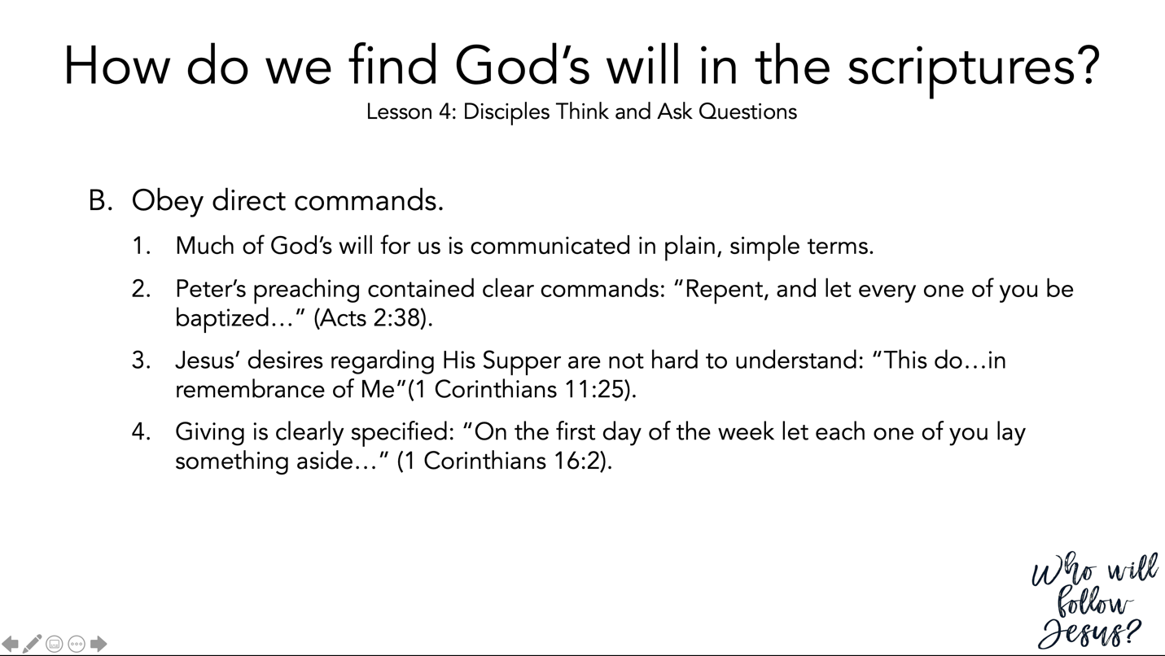

Acts 2:37–40 (NASB95) – Peter Concludes His Appeal
³⁷ Now when they heard this, they were pierced to the heart, and said to Peter and the rest of the apostles, “Brethren, what shall we do?” ³⁸ Peter said to them, “Repent, and each of you be baptized in the name of Jesus Christ for the forgiveness of your sins; and you will receive the gift of the Holy Spirit. ³⁹ “For the promise is for you and your children and for all who are far off, as many as the Lord our God will call to Himself.” ⁴⁰ And with many other words he solemnly testified and kept on exhorting them, saying, “Be saved from this perverse generation!”

1 Corinthians 11:23–26 (NASB95) – Institution of the Lord’s Supper
²³ For I received from the Lord that which I also delivered to you, that the Lord Jesus in the night in which He was betrayed took bread; ²⁴ and when He had given thanks, He broke it and said, “This is My body, which is for you; do this in remembrance of Me.” ²⁵ In the same way He took the cup also after supper, saying, “This cup is the new covenant in My blood; do this, as often as you drink it, in remembrance of Me.” ²⁶ For as often as you eat this bread and drink the cup, you proclaim the Lord’s death until He comes.

1 Corinthians 16:1–4 (NASB95) – The Collection for the Saints
¹ Now concerning the collection for the saints, as I directed the churches of Galatia, so do you also. ² On the first day of every week each one of you is to put aside and save, as he may prosper, so that no collections be made when I come. ³ When I arrive, whomever you may approve, I will send them with letters to carry your gift to Jerusalem; ⁴ and if it is fitting for me to go also, they will go with me.

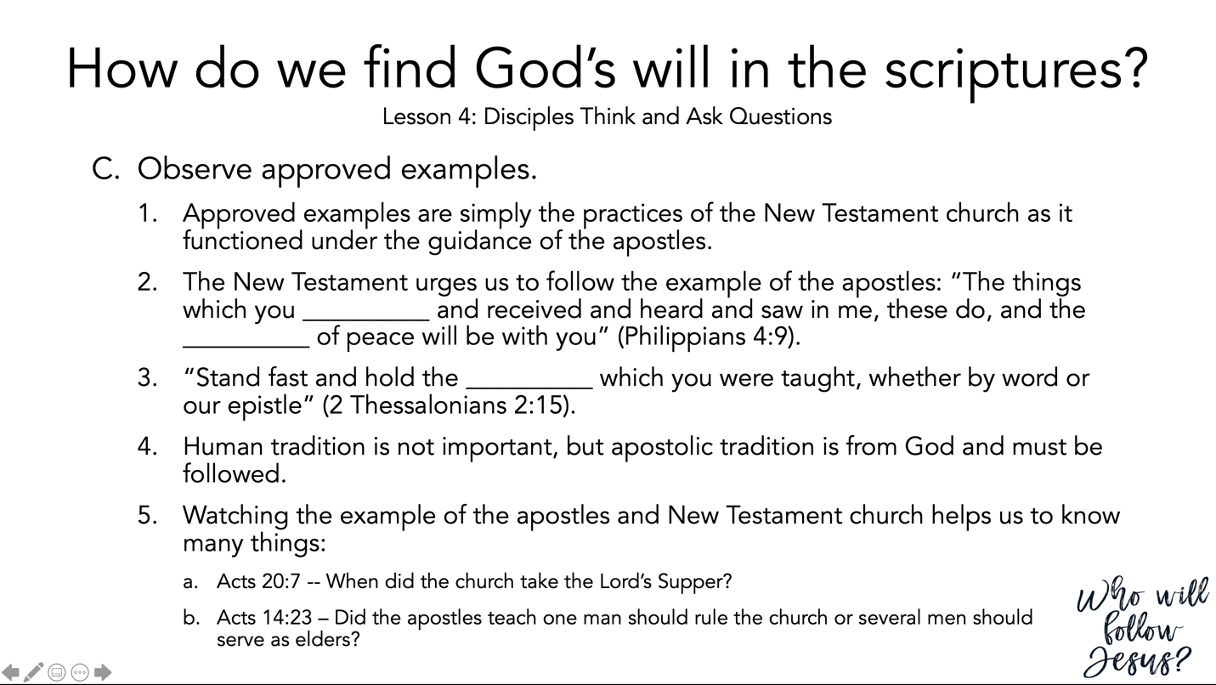

Philippians 4:8–9 (NASB95) – Think on These Things
⁸ Finally, brethren, whatever is true, whatever is honorable, whatever is right, whatever is pure, whatever is lovely, whatever is of good repute, if there is any excellence and if anything worthy of praise, dwell on these things. ⁹ The things you have learned and received and heard and seen in me, practice these things, and the God of peace will be with you.

2 Thessalonians 2:13–17 (NASB95) – Hold Fast to What You Were Taught
¹³ But we should always give thanks to God for you, brethren beloved by the Lord, because God has chosen you from the beginning for salvation through sanctification by the Spirit and faith in the truth. ¹⁴ It was for this He called you through our gospel, that you may gain the glory of our Lord Jesus Christ. ¹⁵ So then, brethren, stand firm and hold to the traditions which you were taught, whether by word of mouth or by letter from us. ¹⁶ Now may our Lord Jesus Christ Himself and God our Father, who has loved us and given us eternal comfort and good hope by grace, ¹⁷ comfort and strengthen your hearts in every good work and word.

Acts 20:7–12 (NASB95) – Paul Ministers at Troas
⁷ On the first day of the week, when we were gathered together to break bread, Paul began talking to them, intending to leave the next day, and he prolonged his message until midnight. ⁸ There were many lamps in the upper room where we were gathered together. ⁹ And there was a young man named Eutychus sitting on the window sill, sinking into a deep sleep; and as Paul kept on talking, he was overcome by sleep and fell down from the third floor and was picked up dead. ¹⁰ But Paul went down and fell upon him, and after embracing him, he said, “Do not be troubled, for his life is in him.” ¹¹ When he had gone back up and had broken the bread and eaten, he talked with them a long while until daybreak, and then left. ¹² They took away the boy alive, and were greatly comforted.

Acts 14:21–28 (NASB95) – Paul and Barnabas Strengthen Their Converts
²¹ After they had preached the gospel to that city and had made many disciples, they returned to Lystra and to Iconium and to Antioch, ²² strengthening the souls of the disciples, encouraging them to continue in the faith, and saying, “Through many tribulations we must enter the kingdom of God.” ²³ When they had appointed elders for them in every church, having prayed with fasting, they commended them to the Lord in whom they had believed. ²⁴ They passed through Pisidia and came into Pamphylia. ²⁵ When they had spoken the word in Perga, they went down to Attalia. ²⁶ From there they sailed to Antioch, from which they had been commended to the grace of God for the work that they had accomplished. ²⁷ When they had arrived and gathered the church together, they began to report all things that God had done with them and how He had opened a door of faith to the Gentiles. ²⁸ And they spent a long time with the disciples.

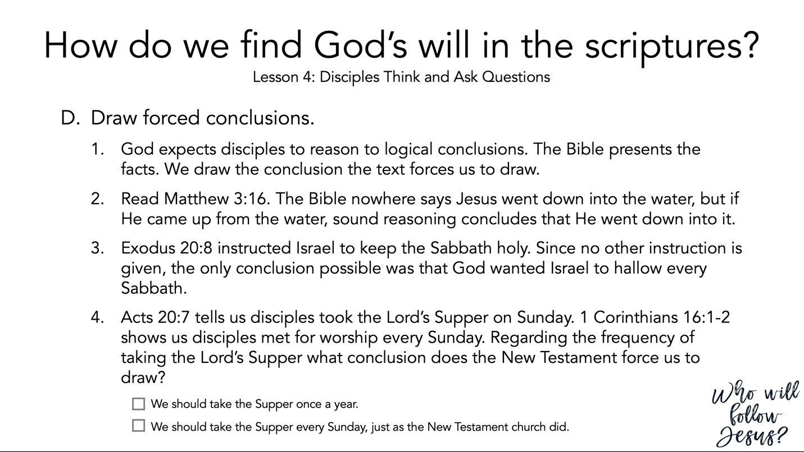

Matthew 3:13–17 (NASB95) – The Baptism of Jesus
¹³ Then Jesus arrived from Galilee at the Jordan coming to John, to be baptized by him. ¹⁴ But John tried to prevent Him, saying, “I have need to be baptized by You, and do You come to me?” ¹⁵ But Jesus answering said to him, “Permit it at this time; for in this way it is fitting for us to fulfill all righteousness.” Then he permitted Him. ¹⁶ After being baptized, Jesus came up immediately from the water; and behold, the heavens were opened, and he saw the Spirit of God descending as a dove and lighting on Him, ¹⁷ and behold, a voice out of the heavens said, “This is My beloved Son, in whom I am well-pleased.”

Exodus 20:1–17 (NASB95) – The Ten Commandments
¹ Then God spoke all these words, saying, ² “I am the Lord your God, who brought you out of the land of Egypt, out of the house of slavery. ³ “You shall have no other gods before Me. ⁴ “You shall not make for yourself an idol, or any likeness of what is in heaven above or on the earth beneath or in the water under the earth. ⁵ “You shall not worship them or serve them; for I, the Lord your God, am a jealous God, visiting the iniquity of the fathers on the children, on the third and the fourth generations of those who hate Me, ⁶ but showing lovingkindness to thousands, to those who love Me and keep My commandments. ⁷ “You shall not take the name of the Lord your God in vain, for the Lord will not leave him unpunished who takes His name in vain. ⁸ “Remember the sabbath day, to keep it holy. ⁹ “Six days you shall labor and do all your work, ¹⁰ but the seventh day is a sabbath of the Lord your God; in it you shall not do any work, you or your son or your daughter, your male or your female servant or your cattle or your sojourner who stays with you. ¹¹ “For in six days the Lord made the heavens and the earth, the sea and all that is in them, and rested on the seventh day; therefore the Lord blessed the sabbath day and made it holy. ¹² “Honor your father and your mother, that your days may be prolonged in the land which the Lord your God gives you. ¹³ “You shall not murder. ¹⁴ “You shall not commit adultery. ¹⁵ “You shall not steal. ¹⁶ “You shall not bear false witness against your neighbor. ¹⁷ “You shall not covet your neighbor’s house; you shall not covet your neighbor’s wife or his male servant or his female servant or his ox or his donkey or anything that belongs to your neighbor.”

Acts 20:1–12 (NASB95) – Paul in Macedonia and Greece
¹ After the uproar had ceased, Paul sent for the disciples, and when he had exhorted them and taken his leave of them, he left to go to Macedonia. ² When he had gone through those districts and had given them much exhortation, he came to Greece. ³ And there he spent three months, and when a plot was formed against him by the Jews as he was about to set sail for Syria, he decided to return through Macedonia. ⁴ And he was accompanied by Sopater of Berea, the son of Pyrrhus, and by Aristarchus and Secundus of the Thessalonians, and Gaius of Derbe, and Timothy, and Tychicus and Trophimus of Asia. ⁵ But these had gone on ahead and were waiting for us at Troas. ⁶ We sailed from Philippi after the days of Unleavened Bread, and came to them at Troas within five days; and there we stayed seven days. ⁷ On the first day of the week, when we were gathered together to break bread, Paul began talking to them, intending to leave the next day, and he prolonged his message until midnight. ⁸ There were many lamps in the upper room where we were gathered together. ⁹ And there was a young man named Eutychus sitting on the window sill, sinking into a deep sleep; and as Paul kept on talking, he was overcome by sleep and fell down from the third floor and was picked up dead. ¹⁰ But Paul went down and fell upon him, and after embracing him, he said, “Do not be troubled, for his life is in him.” ¹¹ When he had gone back up and had broken the bread and eaten, he talked with them a long while until daybreak, and then left. ¹² They took away the boy alive, and were greatly comforted.

1 Corinthians 16:1–4 (NASB95) – The Collection for the Saints
¹ Now concerning the collection for the saints, as I directed the churches of Galatia, so do you also. ² On the first day of every week each one of you is to put aside and save, as he may prosper, so that no collections be made when I come. ³ When I arrive, whomever you may approve, I will send them with letters to carry your gift to Jerusalem; ⁴ and if it is fitting for me to go also, they will go with me.

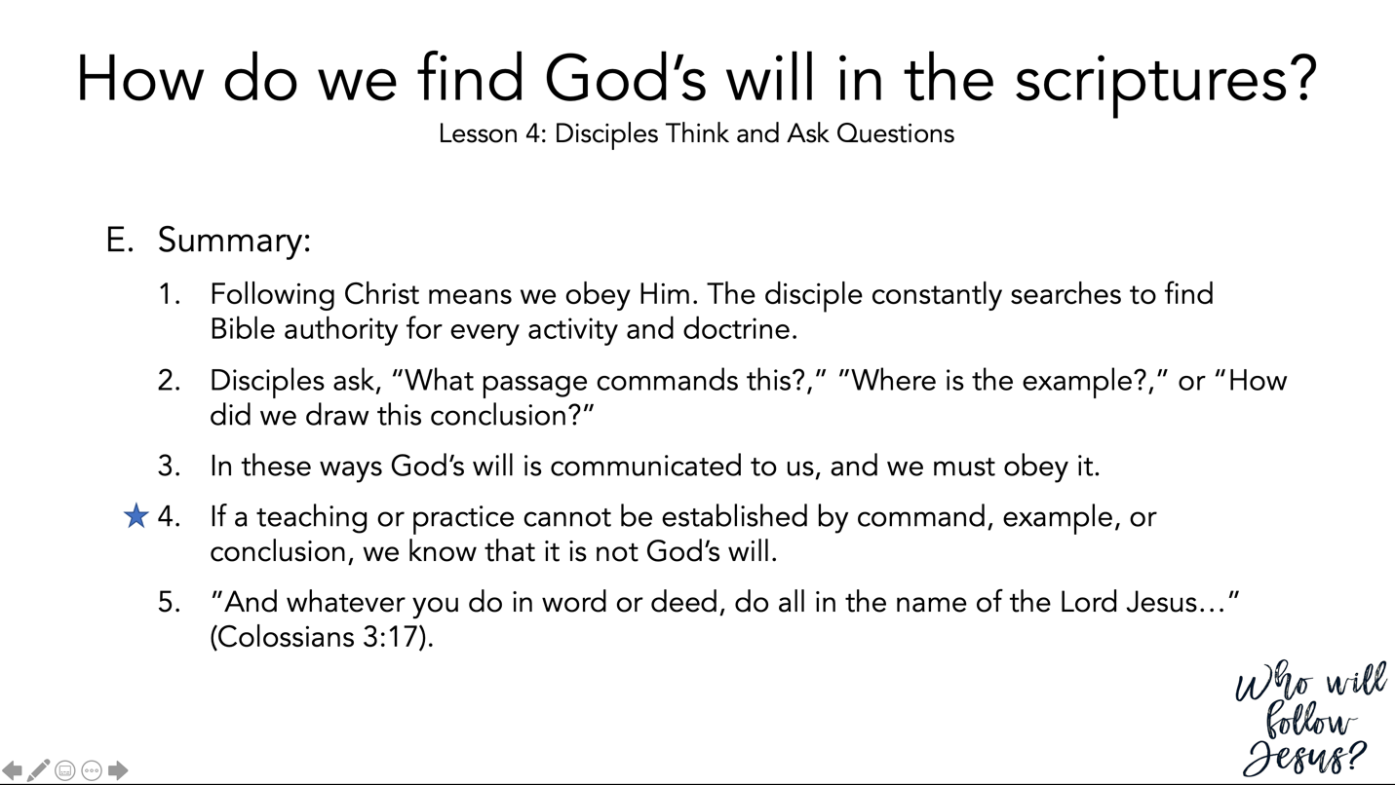

Colossians 3:12–17 (NASB95) – The Characteristics of Christ
¹² So, as those who have been chosen of God, holy and beloved, put on a heart of compassion, kindness, humility, gentleness and patience; ¹³ bearing with one another, and forgiving each other, whoever has a complaint against anyone; just as the Lord forgave you, so also should you. ¹⁴ Beyond all these things put on love, which is the perfect bond of unity. ¹⁵ Let the peace of Christ rule in your hearts, to which indeed you were called in one body; and be thankful. ¹⁶ Let the word of Christ richly dwell within you, with all wisdom teaching and admonishing one another with psalms and hymns and spiritual songs, singing with thankfulness in your hearts to God. ¹⁷ Whatever you do in word or deed, do all in the name of the Lord Jesus, giving thanks through Him to God the Father.

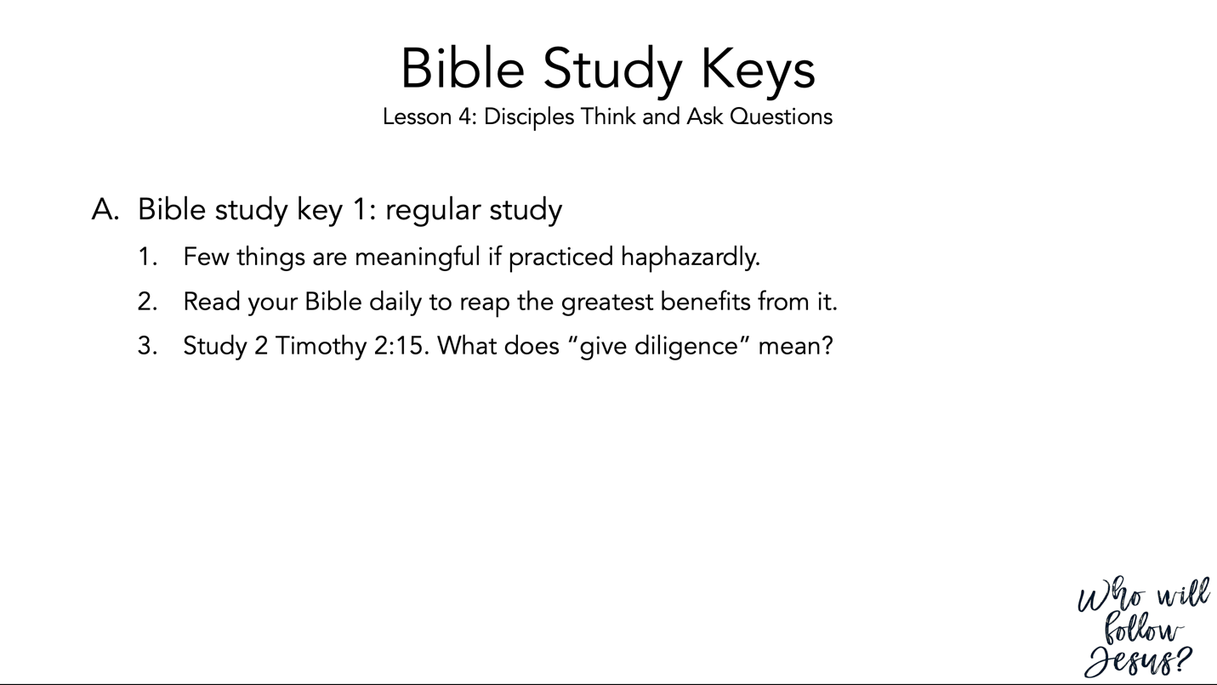

2 Timothy 2:14–26 (NASB95) – An Unashamed Workman
¹⁴ Remind them of these things, and solemnly charge them in the presence of God not to wrangle about words, which is useless and leads to the ruin of the hearers. ¹⁵ Be diligent to present yourself approved to God as a workman who does not need to be ashamed, accurately handling the word of truth. ¹⁶ But avoid worldly and empty chatter, for it will lead to further ungodliness, ¹⁷ and their talk will spread like gangrene. Among them are Hymenaeus and Philetus, ¹⁸ men who have gone astray from the truth saying that the resurrection has already taken place, and they upset the faith of some. ¹⁹ Nevertheless, the firm foundation of God stands, having this seal, “The Lord knows those who are His,” and, “Everyone who names the name of the Lord is to abstain from wickedness.” ²⁰ Now in a large house there are not only gold and silver vessels, but also vessels of wood and of earthenware, and some to honor and some to dishonor. ²¹ Therefore, if anyone cleanses himself from these things, he will be a vessel for honor, sanctified, useful to the Master, prepared for every good work. ²² Now flee from youthful lusts and pursue righteousness, faith, love and peace, with those who call on the Lord from a pure heart. ²³ But refuse foolish and ignorant speculations, knowing that they produce quarrels. ²⁴ The Lord’s bond-servant must not be quarrelsome, but be kind to all, able to teach, patient when wronged, ²⁵ with gentleness correcting those who are in opposition, if perhaps God may grant them repentance leading to the knowledge of the truth, ²⁶ and they may come to their senses and escape from the snare of the devil, having been held captive by him to do his will.

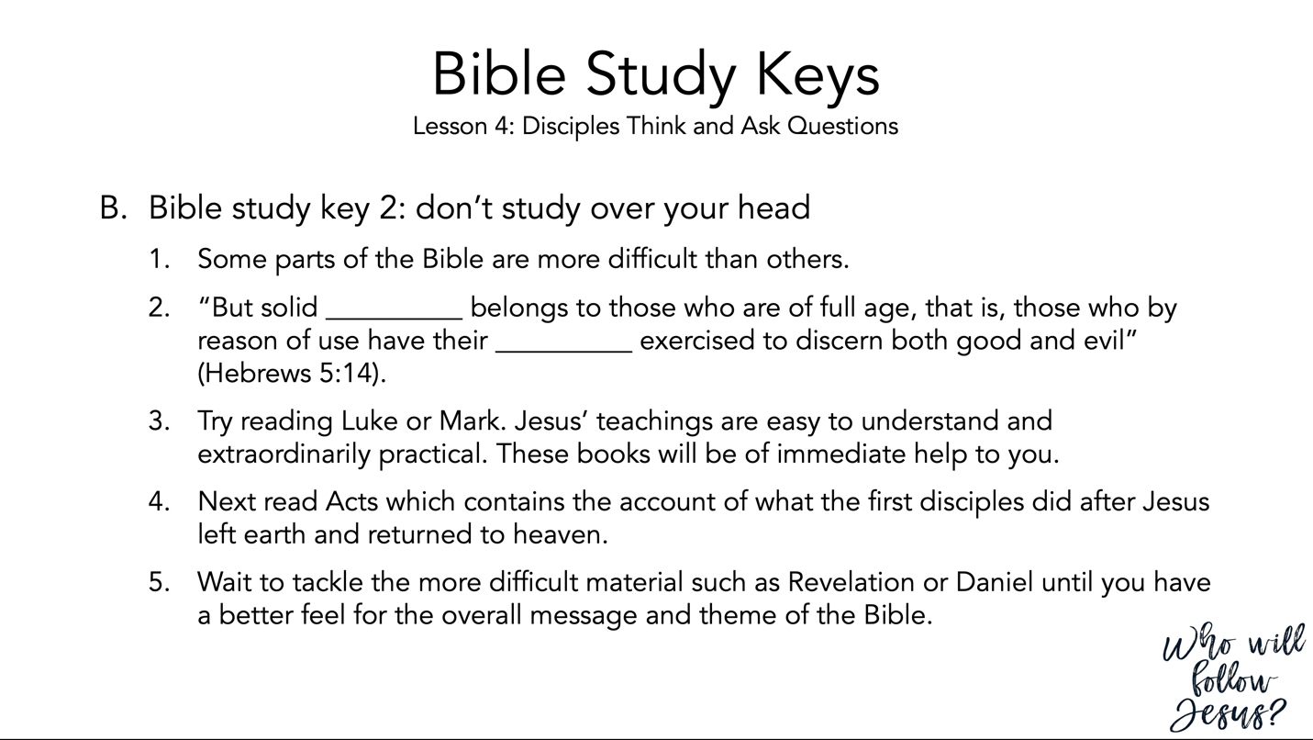

Hebrews 5:12–14 (NASB95) – Christian Life and Theology
¹² For though by this time you ought to be teachers, you have need again for someone to teach you the elementary principles of the oracles of God, and you have come to need milk and not solid food. ¹³ For everyone who partakes only of milk is not accustomed to the word of righteousness, for he is an infant. ¹⁴ But solid food is for the mature, who because of practice have their senses trained to discern good and evil.

