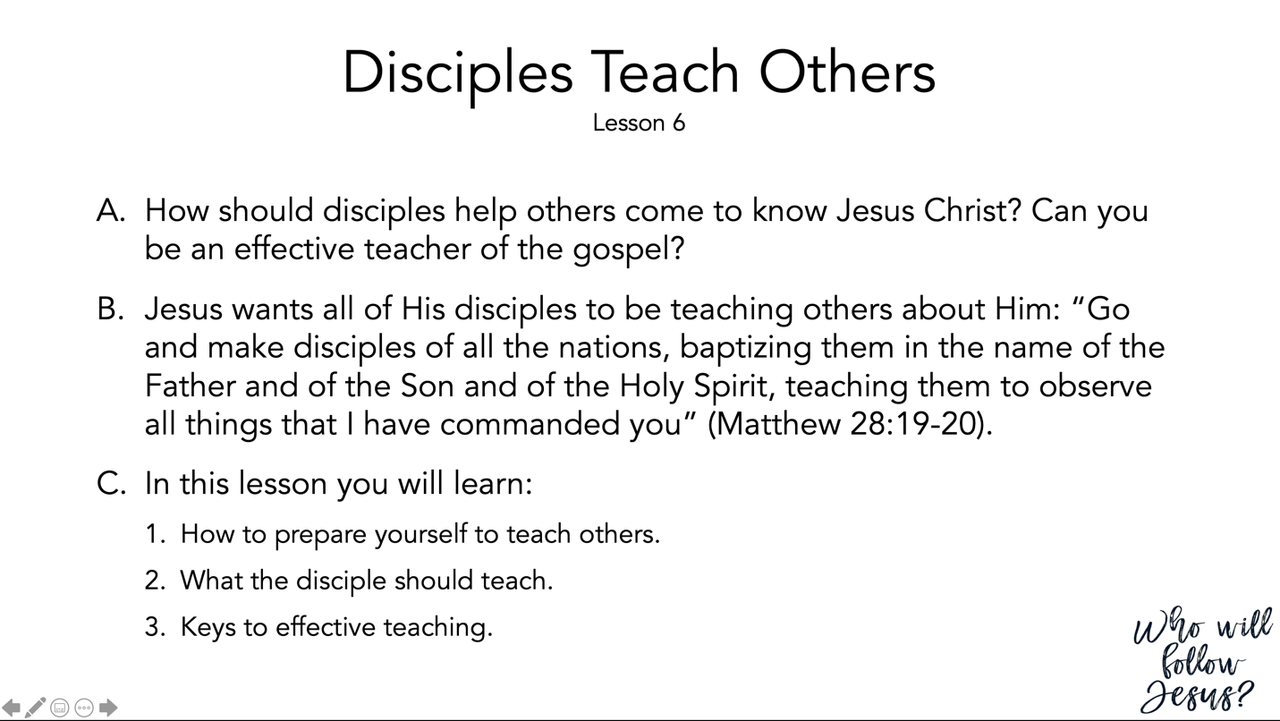

Matthew 28:16–20 (NASB95) – The Great Commission
¹⁶ But the eleven disciples proceeded to Galilee, to the mountain which Jesus had designated. ¹⁷ When they saw Him, they worshiped Him; but some were doubtful. ¹⁸ And Jesus came up and spoke to them, saying, “All authority has been given to Me in heaven and on earth. ¹⁹ “Go therefore and make disciples of all the nations, baptizing them in the name of the Father and the Son and the Holy Spirit, ²⁰ teaching them to observe all that I commanded you; and lo, I am with you always, even to the end of the age.”

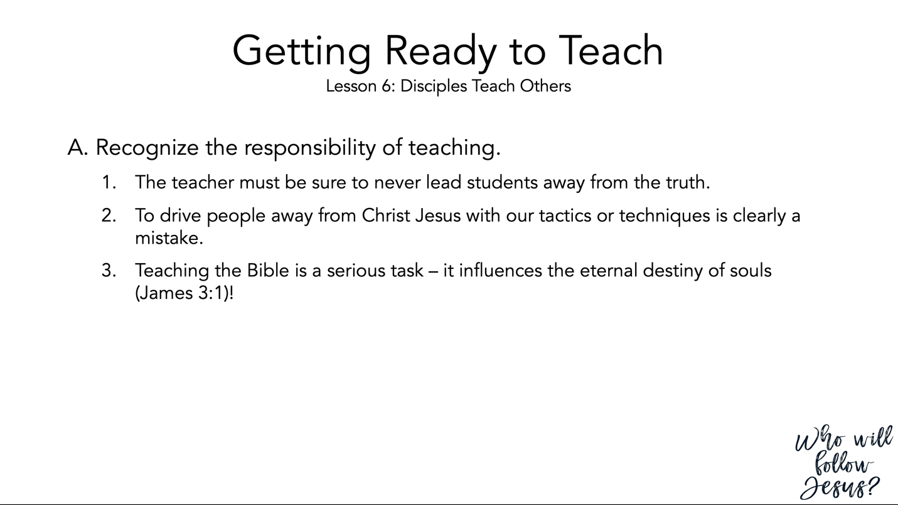

James 3:1–12 (NASB95) – The Tongue is a Fire
¹ Let not many of you become teachers, my brethren, knowing that as such we will incur a stricter judgment. ² For we all stumble in many ways. If anyone does not stumble in what he says, he is a perfect man, able to bridle the whole body as well. ³ Now if we put the bits into the horses’ mouths so that they will obey us, we direct their entire body as well. ⁴ Look at the ships also, though they are so great and are driven by strong winds, are still directed by a very small rudder wherever the inclination of the pilot desires. ⁵ So also the tongue is a small part of the body, and yet it boasts of great things. See how great a forest is set aflame by such a small fire! ⁶ And the tongue is a fire, the very world of iniquity; the tongue is set among our members as that which defiles the entire body, and sets on fire the course of our life, and is set on fire by hell. ⁷ For every species of beasts and birds, of reptiles and creatures of the sea, is tamed and has been tamed by the human race. ⁸ But no one can tame the tongue; it is a restless evil and full of deadly poison. ⁹ With it we bless our Lord and Father, and with it we curse men, who have been made in the likeness of God; ¹⁰ from the same mouth come both blessing and cursing. My brethren, these things ought not to be this way. ¹¹ Does a fountain send out from the same opening both fresh and bitter water? ¹² Can a fig tree, my brethren, produce olives, or a vine produce figs? Nor can salt water produce fresh.

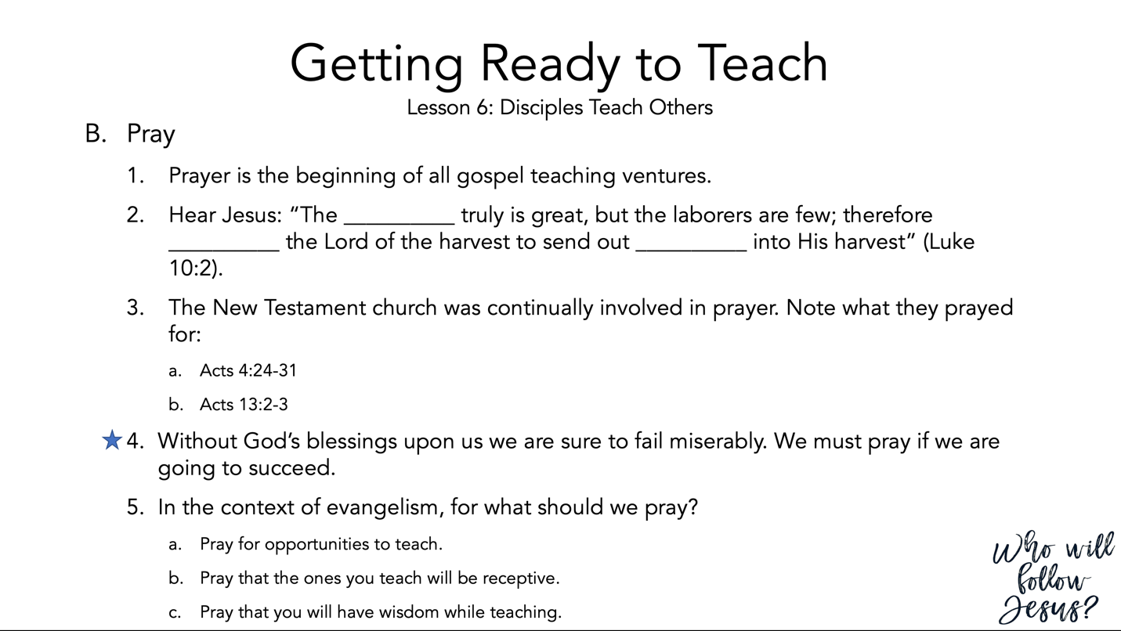

Luke 10:1–12 (NASB95) – Jesus Sends Out the Seventy
¹ Now after this the Lord appointed seventy others, and sent them in pairs ahead of Him to every city and place where He Himself was going to come. ² And He was saying to them, “The harvest is plentiful, but the laborers are few; therefore beseech the Lord of the harvest to send out laborers into His harvest. ³ “Go; behold, I send you out as lambs in the midst of wolves. ⁴ “Carry no money belt, no bag, no shoes; and greet no one on the way. ⁵ “Whatever house you enter, first say, ‘Peace be to this house.’ ⁶ “If a man of peace is there, your peace will rest on him; but if not, it will return to you. ⁷ “Stay in that house, eating and drinking what they give you; for the laborer is worthy of his wages. Do not keep moving from house to house. ⁸ “Whatever city you enter and they receive you, eat what is set before you; ⁹ and heal those in it who are sick, and say to them, ‘The kingdom of God has come near to you.’ ¹⁰ “But whatever city you enter and they do not receive you, go out into its streets and say, ¹¹ ‘Even the dust of your city which clings to our feet we wipe off in protest against you; yet be sure of this, that the kingdom of God has come near.’ ¹² “I say to you, it will be more tolerable in that day for Sodom than for that city.

Acts 4:23–31 (NASB95) – The Believers Pray for Boldness
²³ When they had been released, they went to their own companions and reported all that the chief priests and the elders had said to them. ²⁴ And when they heard this, they lifted their voices to God with one accord and said, “O Lord, it is You who made the heaven and the earth and the sea, and all that is in them, ²⁵ who by the Holy Spirit, through the mouth of our father David Your servant, said, ‘Why did the Gentiles rage, And the peoples devise futile things? ²⁶ ‘The kings of the earth took their stand, And the rulers were gathered together Against the Lord and against His Christ.’ ²⁷ “For truly in this city there were gathered together against Your holy servant Jesus, whom You anointed, both Herod and Pontius Pilate, along with the Gentiles and the peoples of Israel, ²⁸ to do whatever Your hand and Your purpose predestined to occur. ²⁹ “And now, Lord, take note of their threats, and grant that Your bond-servants may speak Your word with all confidence, ³⁰ while You extend Your hand to heal, and signs and wonders take place through the name of Your holy servant Jesus.” ³¹ And when they had prayed, the place where they had gathered together was shaken, and they were all filled with the Holy Spirit and began to speak the word of God with boldness.

Acts 13:1–3 (NASB95) – Barnabas and Saul Are Sent Out from Antioch
¹ Now there were at Antioch, in the church that was there, prophets and teachers: Barnabas, and Simeon who was called Niger, and Lucius of Cyrene, and Manaen who had been brought up with Herod the tetrarch, and Saul. ² While they were ministering to the Lord and fasting, the Holy Spirit said, “Set apart for Me Barnabas and Saul for the work to which I have called them.” ³ Then, when they had fasted and prayed and laid their hands on them, they sent them away.

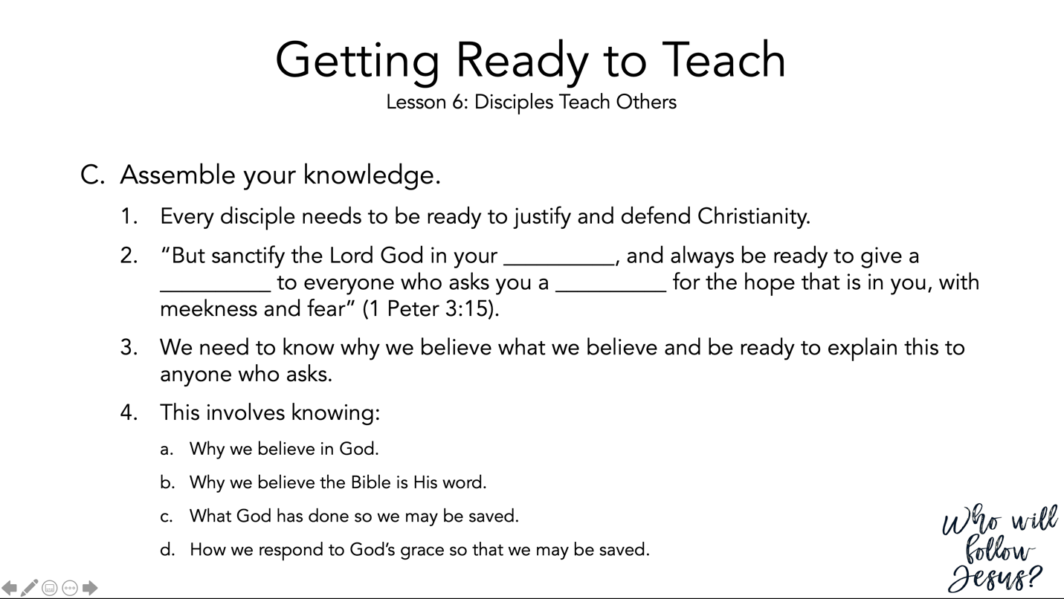

1 Peter 3:8–16 (NASB95) – Life in Relation to Suffering
⁸ To sum up, all of you be harmonious, sympathetic, brotherly, kindhearted, and humble in spirit; ⁹ not returning evil for evil or insult for insult, but giving a blessing instead; for you were called for the very purpose that you might inherit a blessing. ¹⁰ For, “The one who desires life, to love and see good days, Must keep his tongue from evil and his lips from speaking deceit. ¹¹ “He must turn away from evil and do good; He must seek peace and pursue it. ¹² “For the eyes of the Lord are toward the righteous, And His ears attend to their prayer, But the face of the Lord is against those who do evil.” ¹³ Who is there to harm you if you prove zealous for what is good? ¹⁴ But even if you should suffer for the sake of righteousness, you are blessed. And do not fear their intimidation, and do not be troubled, ¹⁵ but sanctify Christ as Lord in your hearts, always being ready to make a defense to everyone who asks you to give an account for the hope that is in you, yet with gentleness and reverence; ¹⁶ and keep a good conscience so that in the thing in which you are slandered, those who revile your good behavior in Christ will be put to shame.

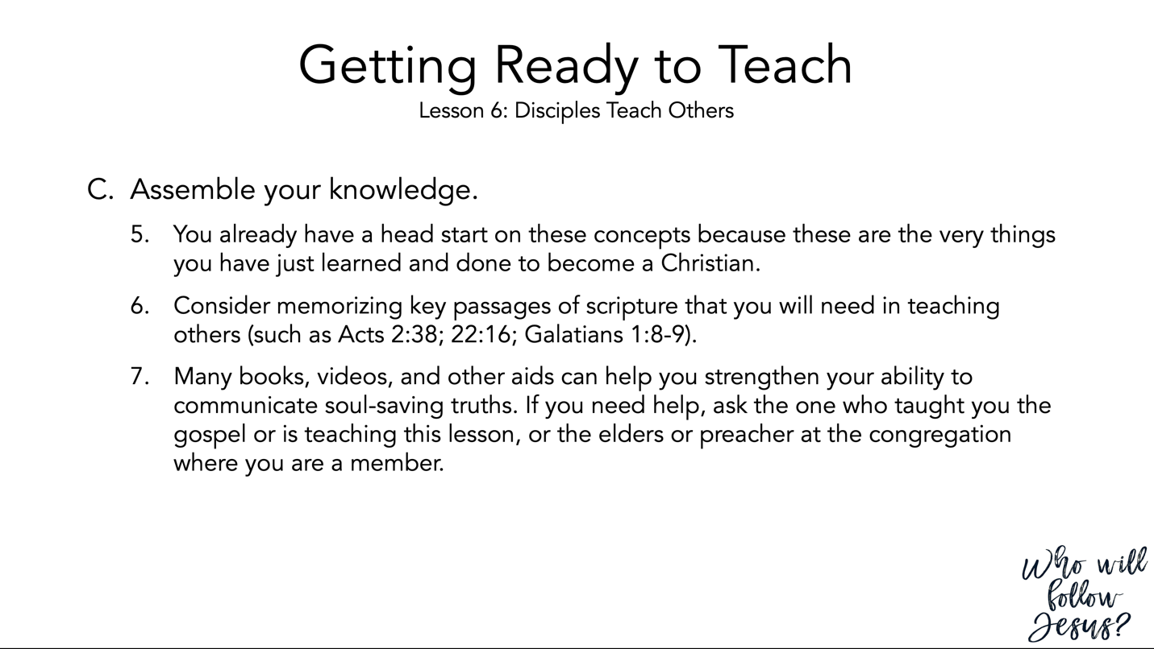

Acts 2:37–41 (NASB95) – The Response to Peter’s Sermon
³⁷ Now when they heard this, they were pierced to the heart, and said to Peter and the rest of the apostles, “Brethren, what shall we do?” ³⁸ Peter said to them, “Repent, and each of you be baptized in the name of Jesus Christ for the forgiveness of your sins; and you will receive the gift of the Holy Spirit. ³⁹ “For the promise is for you and your children and for all who are far off, as many as the Lord our God will call to Himself.” ⁴⁰ And with many other words he solemnly testified and kept on exhorting them, saying, “Be saved from this perverse generation!” ⁴¹ So then, those who had received his word were baptized; and that day there were added about three thousand souls.

Acts 22:1–21 (NASB95) – Paul’s Defense Before the Jerusalem Jews
¹ “Brethren and fathers, hear my defense which I now offer to you.” ² And when they heard that he was addressing them in the Hebrew dialect, they became even more quiet; and he said, ³ “I am a Jew, born in Tarsus of Cilicia, but brought up in this city, educated under Gamaliel, strictly according to the law of our fathers, being zealous for God just as you all are today. ⁴ “I persecuted this Way to the death, binding and putting both men and women into prisons, ⁵ as also the high priest and all the Council of the elders can testify. From them I also received letters to the brethren, and started off for Damascus in order to bring even those who were there to Jerusalem as prisoners to be punished. ⁶ “But it happened that as I was on my way, approaching Damascus about noontime, a very bright light suddenly flashed from heaven all around me, ⁷ and I fell to the ground and heard a voice saying to me, ‘Saul, Saul, why are you persecuting Me?’ ⁸ “And I answered, ‘Who are You, Lord?’ And He said to me, ‘I am Jesus the Nazarene, whom you are persecuting.’ ⁹ “And those who were with me saw the light, to be sure, but did not understand the voice of the One who was speaking to me. ¹⁰ “And I said, ‘What shall I do, Lord?’ And the Lord said to me, ‘Get up and go on into Damascus, and there you will be told of all that has been appointed for you to do.’ ¹¹ “But since I could not see because of the brightness of that light, I was led by the hand by those who were with me and came into Damascus. ¹² “A certain Ananias, a man who was devout by the standard of the Law, and well spoken of by all the Jews who lived there, ¹³ came to me, and standing near said to me, ‘Brother Saul, receive your sight!’ And at that very time I looked up at him. ¹⁴ “And he said, ‘The God of our fathers has appointed you to know His will and to see the Righteous One and to hear an utterance from His mouth. ¹⁵ ‘For you will be a witness for Him to all men of what you have seen and heard. ¹⁶ ‘Now why do you delay? Get up and be baptized, and wash away your sins, calling on His name.’ ¹⁷ “It happened when I returned to Jerusalem and was praying in the temple, that I fell into a trance, ¹⁸ and I saw Him saying to me, ‘Make haste, and get out of Jerusalem quickly, because they will not accept your testimony about Me.’ ¹⁹ “And I said, ‘Lord, they themselves understand that in one synagogue after another I used to imprison and beat those who believed in You. ²⁰ ‘And when the blood of Your witness Stephen was being shed, I also was standing by approving, and watching out for the coats of those who were slaying him.’ ²¹ “And He said to me, ‘Go! For I will send you far away to the Gentiles.’ ”

Galatians 1:6–10 (NASB95) – Perversion of the Gospel
⁶ I am amazed that you are so quickly deserting Him who called you by the grace of Christ, for a different gospel; ⁷ which is really not another; only there are some who are disturbing you and want to distort the gospel of Christ. ⁸ But even if we, or an angel from heaven, should preach to you a gospel contrary to what we have preached to you, he is to be accursed! ⁹ As we have said before, so I say again now, if any man is preaching to you a gospel contrary to what you received, he is to be accursed! ¹⁰ For am I now seeking the favor of men, or of God? Or am I striving to please men? If I were still trying to please men, I would not be a bond-servant of Christ.

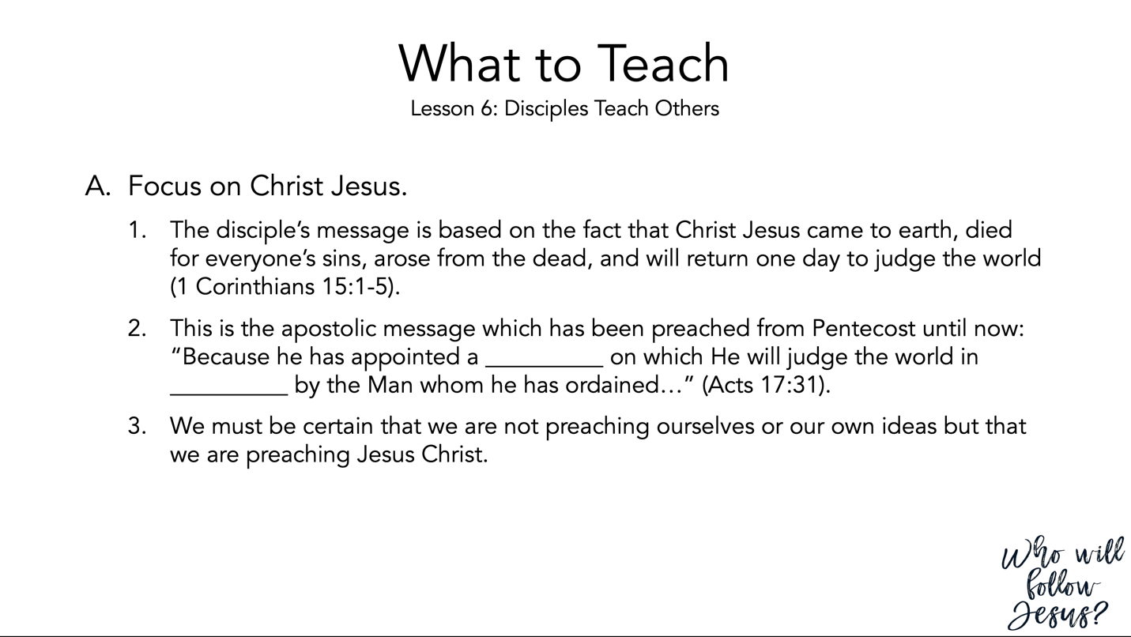

1 Corinthians 15:1–11 (NASB95) – Christ Risen is Fundamental to the Faith
¹ Now I make known to you, brethren, the gospel which I preached to you, which also you received, in which also you stand, ² by which also you are saved, if you hold fast the word which I preached to you, unless you believed in vain. ³ For I delivered to you as of first importance what I also received, that Christ died for our sins according to the Scriptures, ⁴ and that He was buried, and that He was raised on the third day according to the Scriptures, ⁵ and that He appeared to Cephas, then to the twelve. ⁶ After that He appeared to more than five hundred brethren at one time, most of whom remain until now, but some have fallen asleep; ⁷ then He appeared to James, then to all the apostles; ⁸ and last of all, as to one untimely born, He appeared to me also. ⁹ For I am the least of the apostles, and not fit to be called an apostle, because I persecuted the church of God. ¹⁰ But by the grace of God I am what I am, and His grace toward me did not prove vain; but I labored even more than all of them, yet not I, but the grace of God with me. ¹¹ Whether then it was I or they, so we preach and so you believed.

Acts 17:16–34 (NASB95) – Paul Preaches in Athens
¹⁶ Now while Paul was waiting for them at Athens, his spirit was being provoked within him as he was observing the city full of idols. ¹⁷ So he was reasoning in the synagogue with the Jews and the God-fearing Gentiles, and in the market place every day with those who happened to be present. ¹⁸ And also some of the Epicurean and Stoic philosophers were conversing with him. Some were saying, “What would this idle babbler wish to say?” Others, “He seems to be a proclaimer of strange deities,”—because he was preaching Jesus and the resurrection. ¹⁹ And they took him and brought him to the Areopagus, saying, “May we know what this new teaching is which you are proclaiming? ²⁰ “For you are bringing some strange things to our ears; so we want to know what these things mean.” ²¹ (Now all the Athenians and the strangers visiting there used to spend their time in nothing other than telling or hearing something new.) ²² So Paul stood in the midst of the Areopagus and said, “Men of Athens, I observe that you are very religious in all respects. ²³ “For while I was passing through and examining the objects of your worship, I also found an altar with this inscription, ‘TO AN UNKNOWN GOD.’ Therefore what you worship in ignorance, this I proclaim to you. ²⁴ “The God who made the world and all things in it, since He is Lord of heaven and earth, does not dwell in temples made with hands; ²⁵ nor is He served by human hands, as though He needed anything, since He Himself gives to all people life and breath and all things; ²⁶ and He made from one man every nation of mankind to live on all the face of the earth, having determined their appointed times and the boundaries of their habitation, ²⁷ that they would seek God, if perhaps they might grope for Him and find Him, though He is not far from each one of us; ²⁸ for in Him we live and move and exist, as even some of your own poets have said, ‘For we also are His children.’ ²⁹ “Being then the children of God, we ought not to think that the Divine Nature is like gold or silver or stone, an image formed by the art and thought of man. ³⁰ “Therefore having overlooked the times of ignorance, God is now declaring to men that all people everywhere should repent, ³¹ because He has fixed a day in which He will judge the world in righteousness through a Man whom He has appointed, having furnished proof to all men by raising Him from the dead.” ³² Now when they heard of the resurrection of the dead, some began to sneer, but others said, “We shall hear you again concerning this.” ³³ So Paul went out of their midst. ³⁴ But some men joined him and believed, among whom also were Dionysius the Areopagite and a woman named Damaris and others with them.

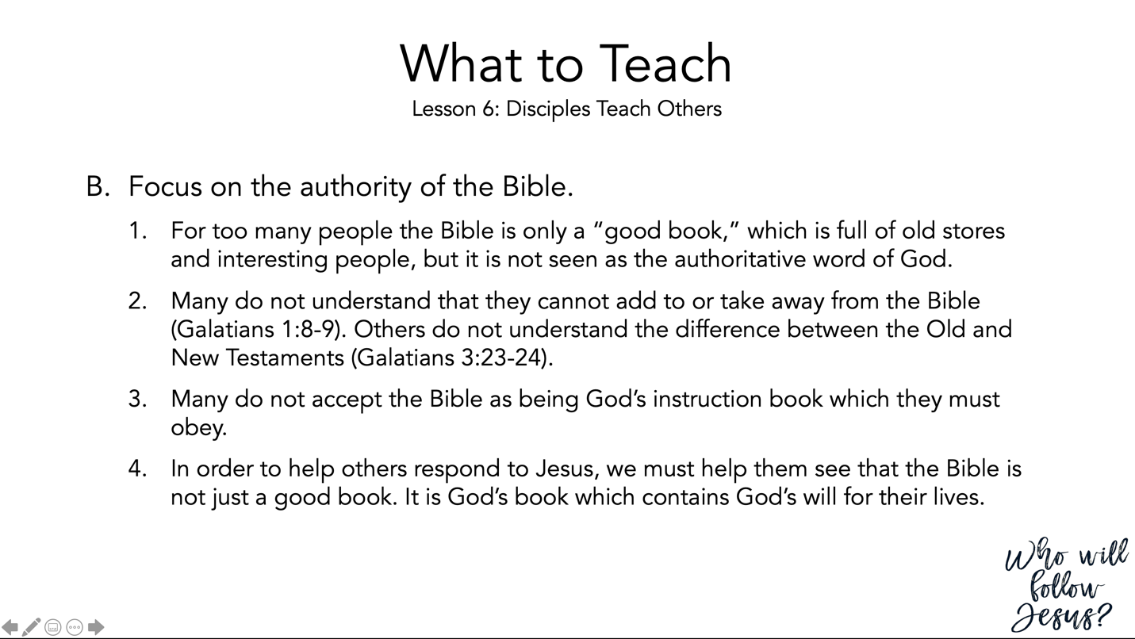

Galatians 1:6–10 (NASB95) – Perversion of the Gospel
⁶ I am amazed that you are so quickly deserting Him who called you by the grace of Christ, for a different gospel; ⁷ which is really not another; only there are some who are disturbing you and want to distort the gospel of Christ. ⁸ But even if we, or an angel from heaven, should preach to you a gospel contrary to what we have preached to you, he is to be accursed! ⁹ As we have said before, so I say again now, if any man is preaching to you a gospel contrary to what you received, he is to be accursed! ¹⁰ For am I now seeking the favor of men, or of God? Or am I striving to please men? If I were still trying to please men, I would not be a bond-servant of Christ.

Galatians 3:19–26 (NASB95) – The Purpose of the Law
¹⁹ Why the Law then? It was added because of transgressions, having been ordained through angels by the agency of a mediator, until the seed would come to whom the promise had been made. ²⁰ Now a mediator is not for one party only; whereas God is only one. ²¹ Is the Law then contrary to the promises of God? May it never be! For if a law had been given which was able to impart life, then righteousness would indeed have been based on law. ²² But the Scripture has shut up everyone under sin, so that the promise by faith in Jesus Christ might be given to those who believe. ²³ But before faith came, we were kept in custody under the law, being shut up to the faith which was later to be revealed. ²⁴ Therefore the Law has become our tutor to lead us to Christ, so that we may be justified by faith. ²⁵ But now that faith has come, we are no longer under a tutor. ²⁶ For you are all sons of God through faith in Christ Jesus.

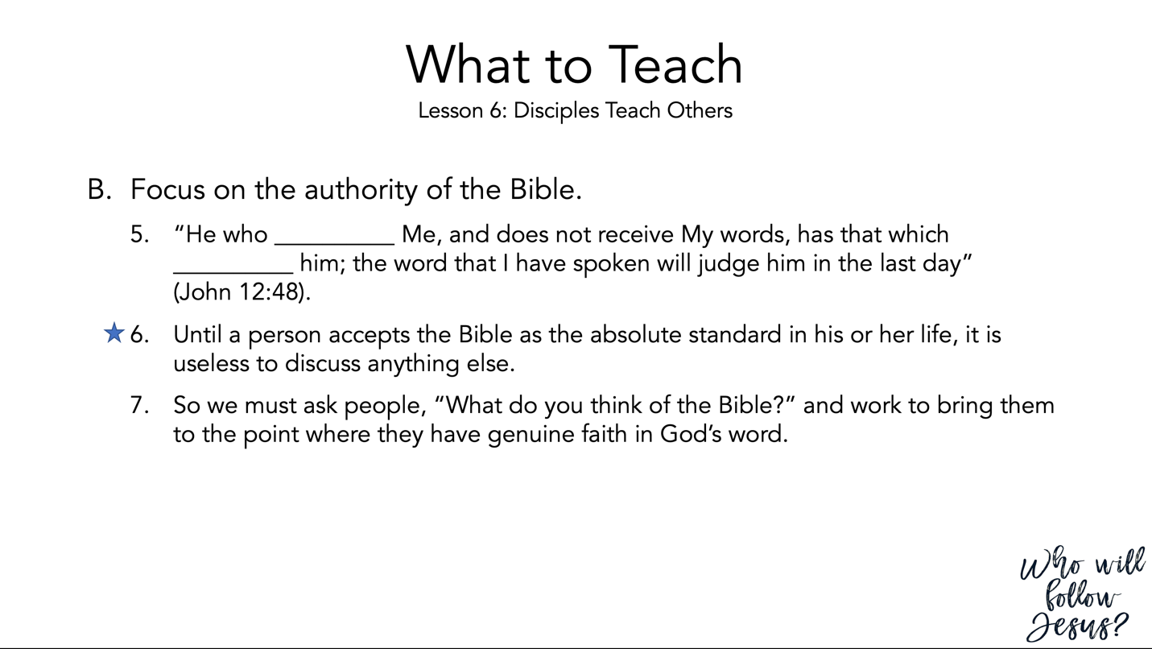
John 12:44–50 (NASB95) – Jesus’ Final Public Appeal
⁴⁴ And Jesus cried out and said, “He who believes in Me, does not believe in Me but in Him who sent Me. ⁴⁵ “He who sees Me sees the One who sent Me. ⁴⁶ “I have come as Light into the world, so that everyone who believes in Me will not remain in darkness. ⁴⁷ “If anyone hears My sayings and does not keep them, I do not judge him; for I did not come to judge the world, but to save the world. ⁴⁸ “He who rejects Me and does not receive My sayings, has one who judges him; the word I spoke is what will judge him at the last day. ⁴⁹ “For I did not speak on My own initiative, but the Father Himself who sent Me has given Me a commandment as to what to say and what to speak. ⁵⁰ “I know that His commandment is eternal life; therefore the things I speak, I speak just as the Father has told Me.”

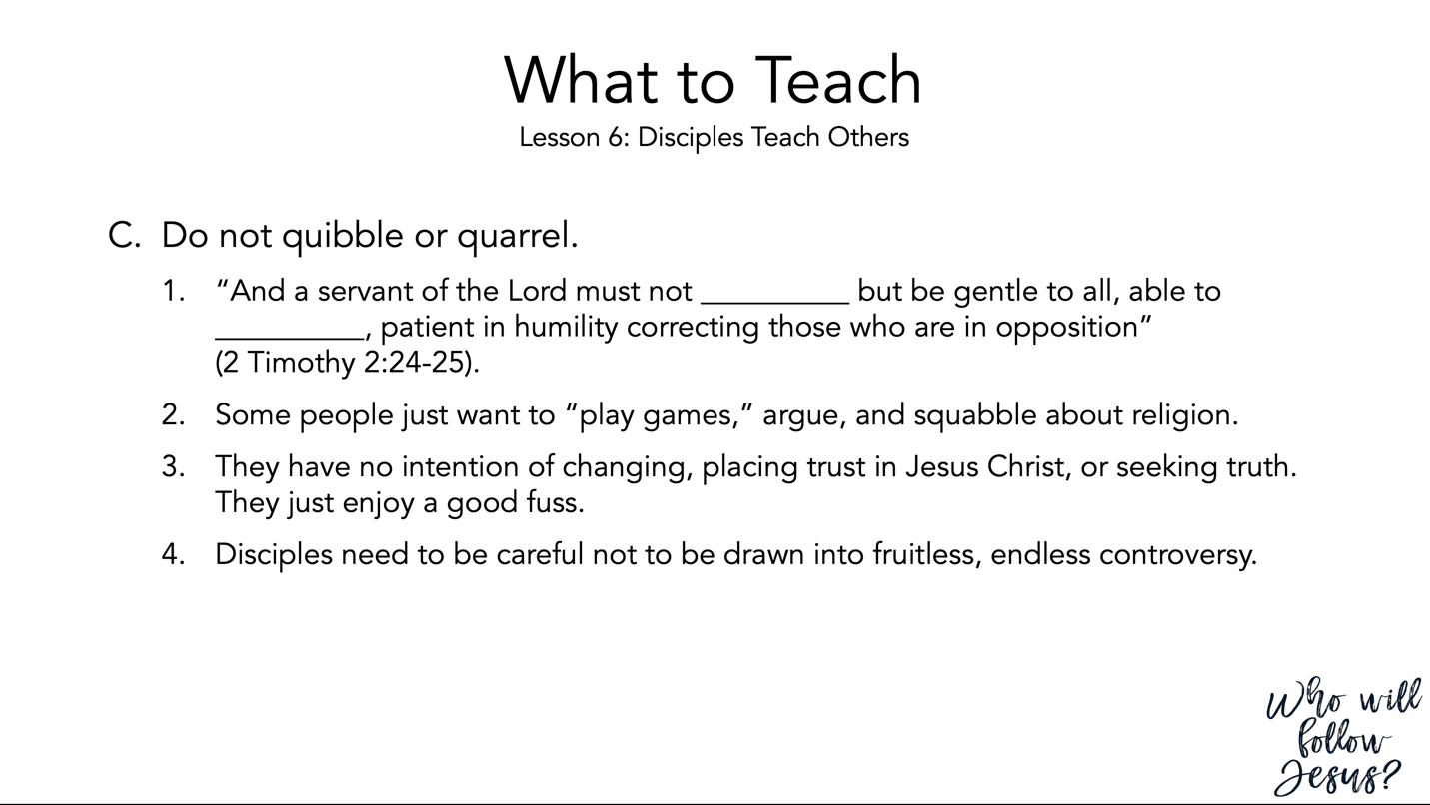
2 Timothy 2:14–26 (NASB95) – An Unashamed Workman
¹⁴ Remind them of these things, and solemnly charge them in the presence of God not to wrangle about words, which is useless and leads to the ruin of the hearers. ¹⁵ Be diligent to present yourself approved to God as a workman who does not need to be ashamed, accurately handling the word of truth. ¹⁶ But avoid worldly and empty chatter, for it will lead to further ungodliness, ¹⁷ and their talk will spread like gangrene. Among them are Hymenaeus and Philetus, ¹⁸ men who have gone astray from the truth saying that the resurrection has already taken place, and they upset the faith of some. ¹⁹ Nevertheless, the firm foundation of God stands, having this seal, “The Lord knows those who are His,” and, “Everyone who names the name of the Lord is to abstain from wickedness.” ²⁰ Now in a large house there are not only gold and silver vessels, but also vessels of wood and of earthenware, and some to honor and some to dishonor. ²¹ Therefore, if anyone cleanses himself from these things, he will be a vessel for honor, sanctified, useful to the Master, prepared for every good work. ²² Now flee from youthful lusts and pursue righteousness, faith, love and peace, with those who call on the Lord from a pure heart. ²³ But refuse foolish and ignorant speculations, knowing that they produce quarrels. ²⁴ The Lord’s bond-servant must not be quarrelsome, but be kind to all, able to teach, patient when wronged, ²⁵ with gentleness correcting those who are in opposition, if perhaps God may grant them repentance leading to the knowledge of the truth, ²⁶ and they may come to their senses and escape from the snare of the devil, having been held captive by him to do his will.

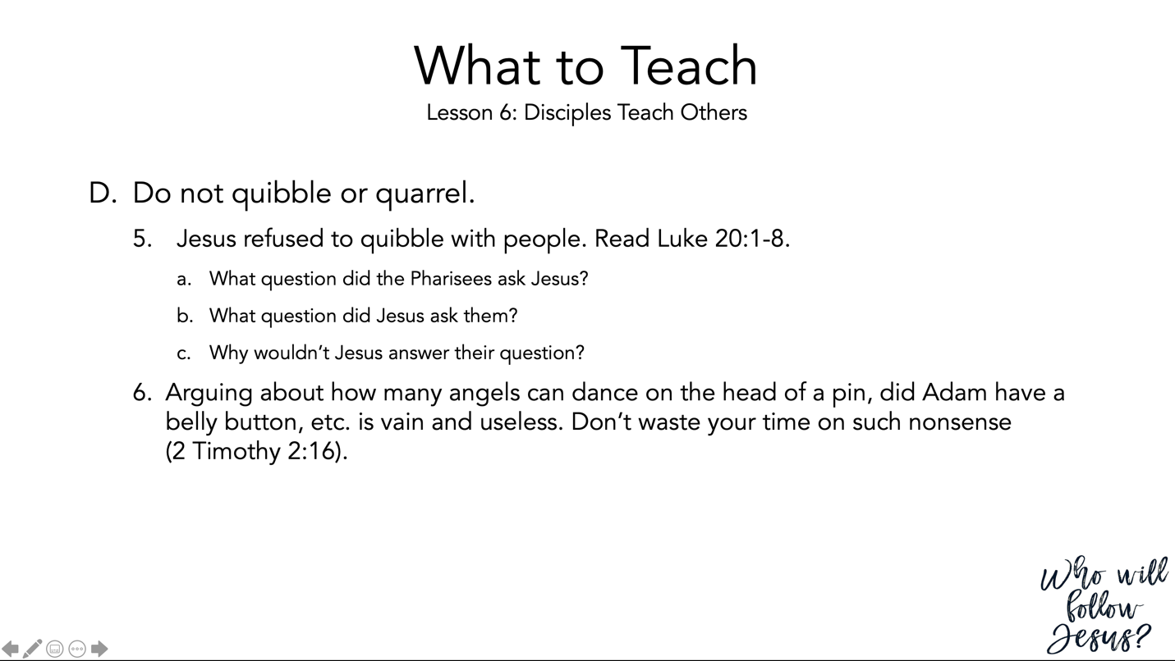
Luke 20:1–8 (NASB95) – Jesus’ Authority Questioned
¹ On one of the days while He was teaching the people in the temple and preaching the gospel, the chief priests and the scribes with the elders confronted Him, ² and they spoke, saying to Him, “Tell us by what authority You are doing these things, or who is the one who gave You this authority?” ³ Jesus answered and said to them, “I will also ask you a question, and you tell Me: ⁴ “Was the baptism of John from heaven or from men?” ⁵ They reasoned among themselves, saying, “If we say, ‘From heaven,’ He will say, ‘Why did you not believe him?’ ⁶ “But if we say, ‘From men,’ all the people will stone us to death, for they are convinced that John was a prophet.” ⁷ So they answered that they did not know where it came from. ⁸ And Jesus said to them, “Nor will I tell you by what authority I do these things.”

2 Timothy 2:15–26 (NASB95) – An Approved Worker
¹⁵ Be diligent to present yourself approved to God as a workman who does not need to be ashamed, accurately handling the word of truth. ¹⁶ But avoid worldly and empty chatter, for it will lead to further ungodliness, ¹⁷ and their talk will spread like gangrene. Among them are Hymenaeus and Philetus, ¹⁸ men who have gone astray from the truth saying that the resurrection has already taken place, and they upset the faith of some. ¹⁹ Nevertheless, the firm foundation of God stands, having this seal, “The Lord knows those who are His,” and, “Everyone who names the name of the Lord is to abstain from wickedness.” ²⁰ Now in a large house there are not only gold and silver vessels, but also vessels of wood and of earthenware, and some to honor and some to dishonor. ²¹ Therefore, if anyone cleanses himself from these things, he will be a vessel for honor, sanctified, useful to the Master, prepared for every good work. ²² Now flee from youthful lusts and pursue righteousness, faith, love and peace, with those who call on the Lord from a pure heart. ²³ But refuse foolish and ignorant speculations, knowing that they produce quarrels. ²⁴ The Lord’s bond-servant must not be quarrelsome, but be kind to all, able to teach, patient when wronged, ²⁵ with gentleness correcting those who are in opposition, if perhaps God may grant them repentance leading to the knowledge of the truth, ²⁶ and they may come to their senses and escape from the snare of the devil, having been held captive by him to do his will.

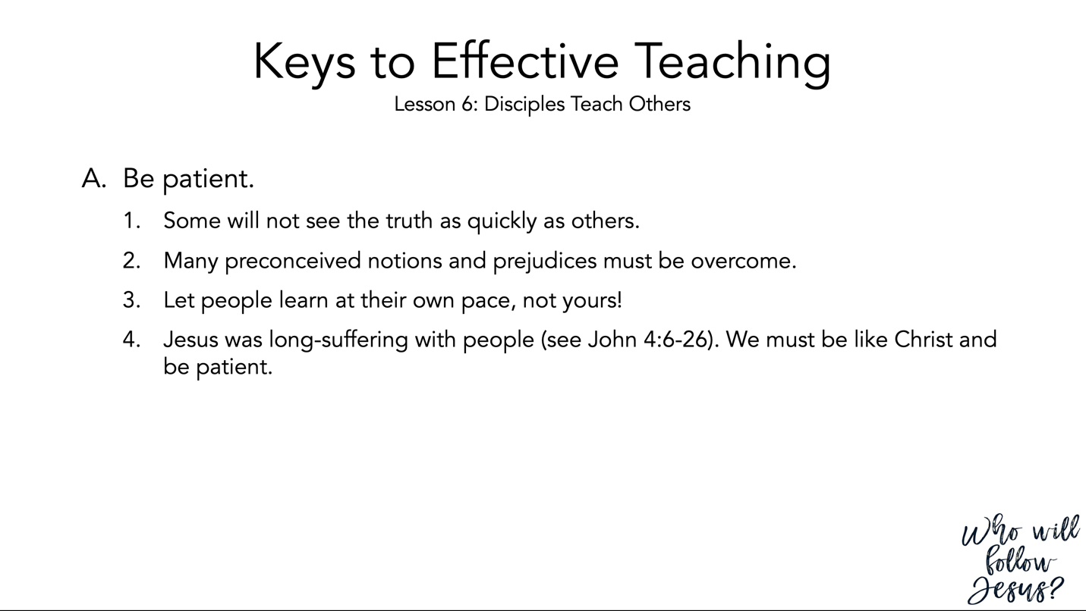

John 4:1–26 (NASB95) – The Woman of Samaria
¹ Therefore when the Lord knew that the Pharisees had heard that Jesus was making and baptizing more disciples than John ² (although Jesus Himself was not baptizing, but His disciples were), ³ He left Judea and went away again into Galilee. ⁴ And He had to pass through Samaria. ⁵ So He came to a city of Samaria called Sychar, near the parcel of ground that Jacob gave to his son Joseph; ⁶ and Jacob’s well was there. So Jesus, being wearied from His journey, was sitting thus by the well. It was about the sixth hour. ⁷ There came a woman of Samaria to draw water. Jesus said to her, “Give Me a drink.” ⁸ For His disciples had gone away into the city to buy food. ⁹ Therefore the Samaritan woman said to Him, “How is it that You, being a Jew, ask me for a drink since I am a Samaritan woman?” (For Jews have no dealings with Samaritans.) ¹⁰ Jesus answered and said to her, “If you knew the gift of God, and who it is who says to you, ‘Give Me a drink,’ you would have asked Him, and He would have given you living water.” ¹¹ She said to Him, “Sir, You have nothing to draw with and the well is deep; where then do You get that living water? ¹² “You are not greater than our father Jacob, are You, who gave us the well, and drank of it himself and his sons and his cattle?” ¹³ Jesus answered and said to her, “Everyone who drinks of this water will thirst again; ¹⁴ but whoever drinks of the water that I will give him shall never thirst; but the water that I will give him will become in him a well of water springing up to eternal life.” ¹⁵ The woman said to Him, “Sir, give me this water, so I will not be thirsty nor come all the way here to draw.” ¹⁶ He said to her, “Go, call your husband and come here.” ¹⁷ The woman answered and said, “I have no husband.” Jesus said to her, “You have correctly said, ‘I have no husband’; ¹⁸ for you have had five husbands, and the one whom you now have is not your husband; this you have said truly.” ¹⁹ The woman said to Him, “Sir, I perceive that You are a prophet. ²⁰ “Our fathers worshiped in this mountain, and you people say that in Jerusalem is the place where men ought to worship.” ²¹ Jesus said to her, “Woman, believe Me, an hour is coming when neither in this mountain nor in Jerusalem will you worship the Father. ²² “You worship what you do not know; we worship what we know, for salvation is from the Jews. ²³ “But an hour is coming, and now is, when the true worshipers will worship the Father in spirit and truth; for such people the Father seeks to be His worshipers. ²⁴ “God is spirit, and those who worship Him must worship in spirit and truth.” ²⁵ The woman said to Him, “I know that Messiah is coming (He who is called Christ); when that One comes, He will declare all things to us.” ²⁶ Jesus said to her, “I who speak to you am He.”

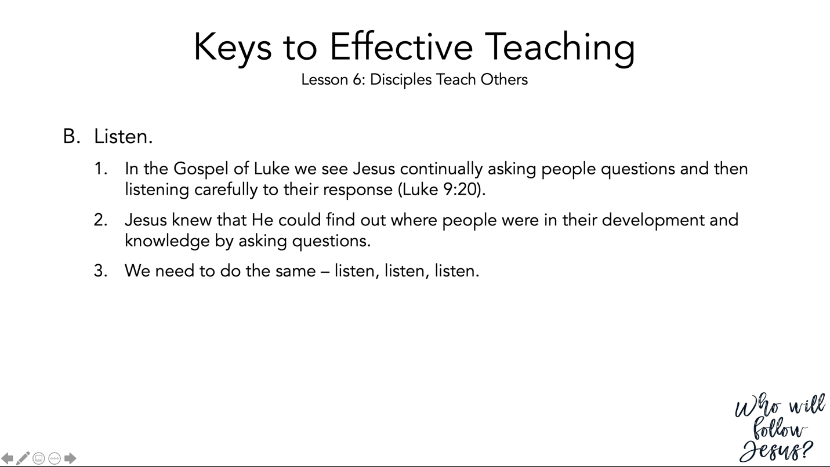
Luke 9:18–22 (NASB95) – Peter’s Confession
¹⁸ And it happened that while He was praying alone, the disciples were with Him, and He questioned them, saying, “Who do the people say that I am?” ¹⁹ They answered and said, “John the Baptist, and others say Elijah; but others, that one of the prophets of old has risen again.” ²⁰ And He said to them, “But who do you say that I am?” And Peter answered and said, “The Christ of God.” ²¹ But He warned them and instructed them not to tell this to anyone, ²² saying, “The Son of Man must suffer many things and be rejected by the elders and chief priests and scribes, and be killed and be raised up on the third day.”

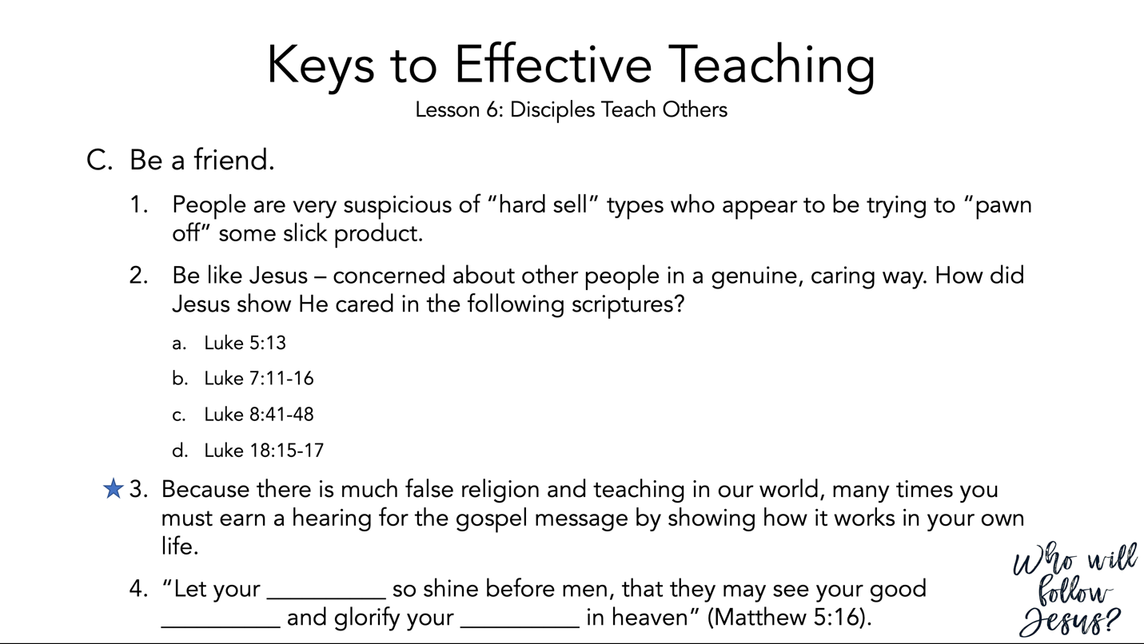
Luke 5:12–16 (NASB95) – Jesus Cleanses a Leper
¹² While He was in one of the cities, behold, there was a man covered with leprosy; and when he saw Jesus, he fell on his face and implored Him, saying, “Lord, if You are willing, You can make me clean.” ¹³ And He stretched out His hand and touched him, saying, “I am willing; be cleansed.” And immediately the leprosy left him. ¹⁴ And He ordered him to tell no one, “But go and show yourself to the priest and make an offering for your cleansing, just as Moses commanded, as a testimony to them.” ¹⁵ But the news about Him was spreading even farther, and large crowds were gathering to hear Him and to be healed of their sicknesses. ¹⁶ But Jesus Himself would often slip away to the wilderness and pray.
Luke 7:11–17 (NASB95) – Jesus Raises the Son of the Widow of Nain
¹¹ Soon afterwards He went to a city called Nain; and His disciples were going along with Him, accompanied by a large crowd. ¹² Now as He approached the gate of the city, a dead man was being carried out, the only son of his mother, and she was a widow; and a sizeable crowd from the city was with her. ¹³ When the Lord saw her, He felt compassion for her, and said to her, “Do not weep.” ¹⁴ And He came up and touched the coffin; and the bearers came to a halt. And He said, “Young man, I say to you, arise!” ¹⁵ The dead man sat up and began to speak. And Jesus gave him back to his mother. ¹⁶ Fear gripped them all, and they began glorifying God, saying, “A great prophet has arisen among us!” and, “God has visited His people!” ¹⁷ This report concerning Him went out all over Judea and in all the surrounding district.

Luke 8:40–48 (NASB95) – A Hemorrhaging Woman is Heales
⁴⁰ And as Jesus returned, the people welcomed Him, for they had all been waiting for Him. ⁴¹ And there came a man named Jairus, and he was an official of the synagogue; and he fell at Jesus’ feet, and began to implore Him to come to his house; ⁴² for he had an only daughter, about twelve years old, and she was dying. But as He went, the crowds were pressing against Him. ⁴³ And a woman who had a hemorrhage for twelve years, and could not be healed by anyone, ⁴⁴ came up behind Him and touched the fringe of His cloak, and immediately her hemorrhage stopped. ⁴⁵ And Jesus said, “Who is the one who touched Me?” And while they were all denying it, Peter said, “Master, the people are crowding and pressing in on You.” ⁴⁶ But Jesus said, “Someone did touch Me, for I was aware that power had gone out of Me.” ⁴⁷ When the woman saw that she had not escaped notice, she came trembling and fell down before Him, and declared in the presence of all the people the reason why she had touched Him, and how she had been immediately healed. ⁴⁸ And He said to her, “Daughter, your faith has made you well; go in peace.”
Luke 18:15–17 (NASB95) – Jesus Blesses Little Children
¹⁵ And they were bringing even their babies to Him so that He would touch them, but when the disciples saw it, they began rebuking them. ¹⁶ But Jesus called for them, saying, “Permit the children to come to Me, and do not hinder them, for the kingdom of God belongs to such as these. ¹⁷ “Truly I say to you, whoever does not receive the kingdom of God like a child will not enter it at all.”
Matthew 5:13–16 (NASB95) – Believers are Salt and Light
¹³ “You are the salt of the earth; but if the salt has become tasteless, how can it be made salty again? It is no longer good for anything, except to be thrown out and trampled under foot by men. ¹⁴ “You are the light of the world. A city set on a hill cannot be hidden; ¹⁵ nor does anyone light a lamp and put it under a basket, but on the lampstand, and it gives light to all who are in the house. ¹⁶ “Let your light shine before men in such a way that they may see your good works, and glorify your Father who is in heaven.

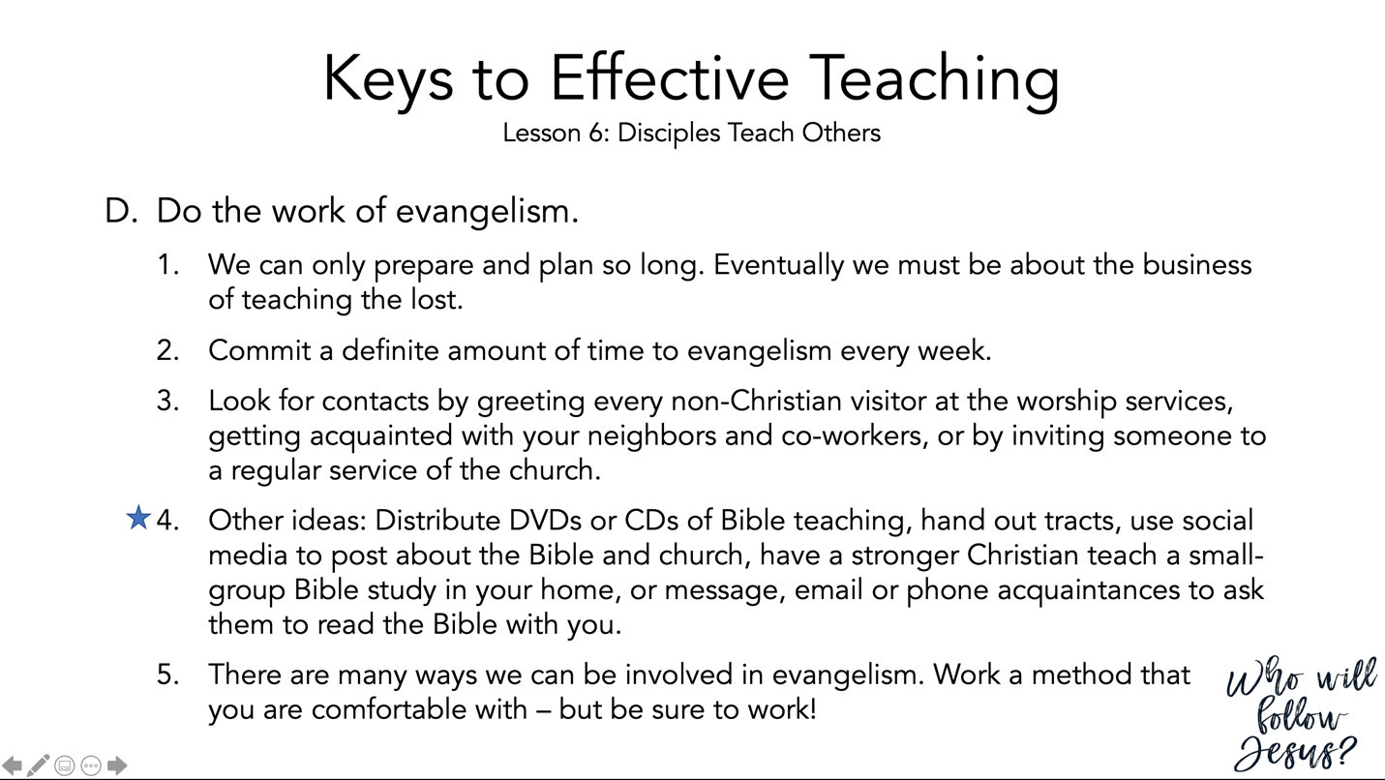

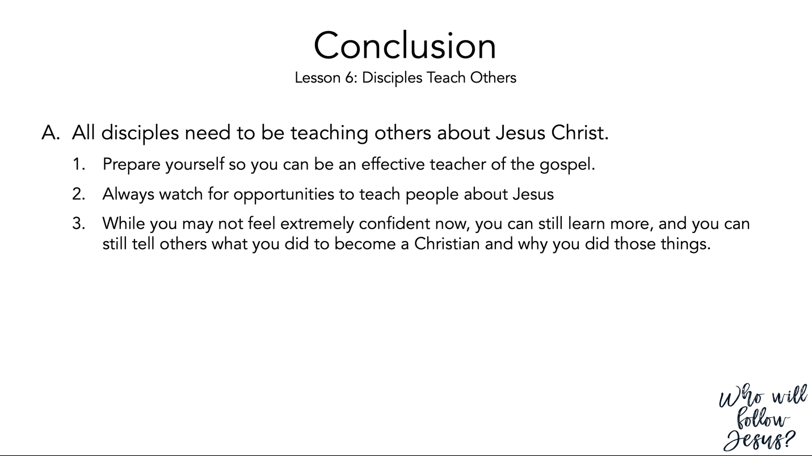

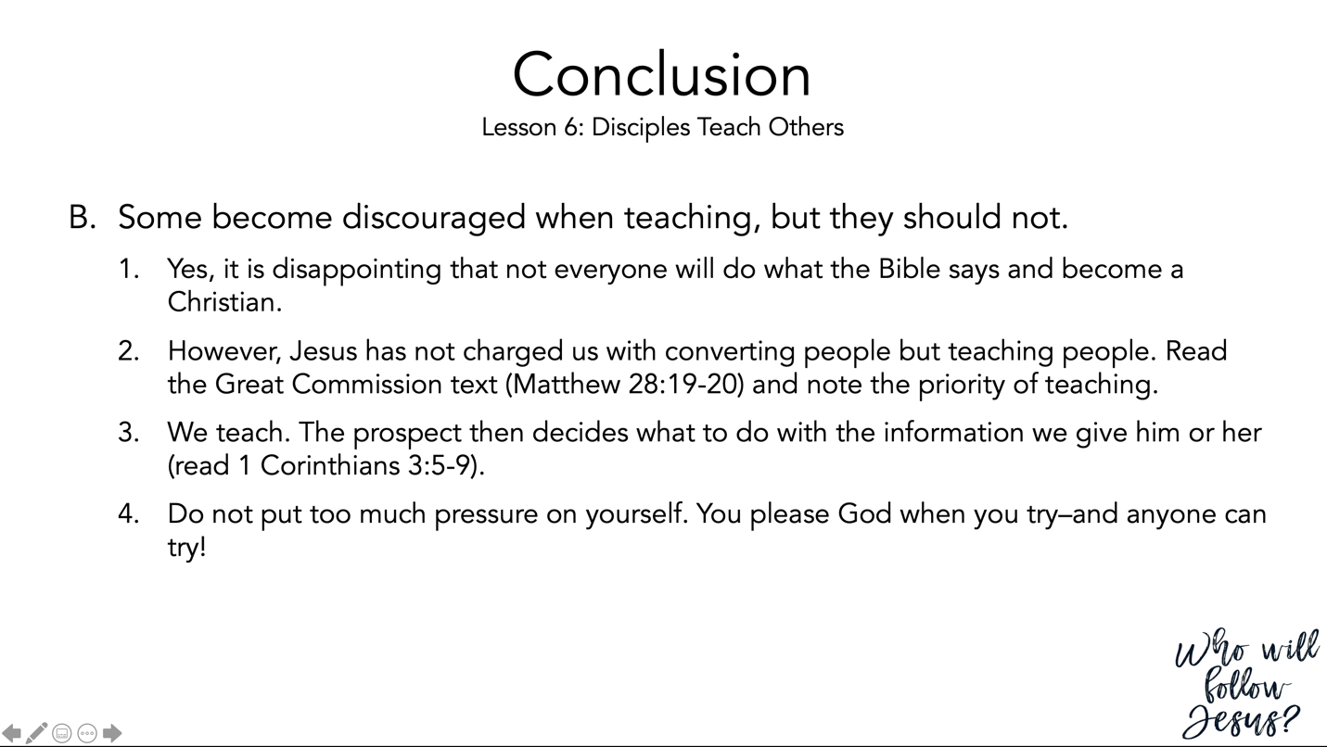
Matthew 28:16–20 (NASB95) – The Great Commission
¹⁶ But the eleven disciples proceeded to Galilee, to the mountain which Jesus had designated. ¹⁷ When they saw Him, they worshiped Him; but some were doubtful. ¹⁸ And Jesus came up and spoke to them, saying, “All authority has been given to Me in heaven and on earth. ¹⁹ “Go therefore and make disciples of all the nations, baptizing them in the name of the Father and the Son and the Holy Spirit, ²⁰ teaching them to observe all that I commanded you; and lo, I am with you always, even to the end of the age.”
1 Corinthians 3:1–9 (NASB95) – Spiritual Immaturity
¹ And I, brethren, could not speak to you as to spiritual men, but as to men of flesh, as to infants in Christ. ² I gave you milk to drink, not solid food; for you were not yet able to receive it. Indeed, even now you are not yet able, ³ for you are still fleshly. For since there is jealousy and strife among you, are you not fleshly, and are you not walking like mere men? ⁴ For when one says, “I am of Paul,” and another, “I am of Apollos,” are you not mere men? ⁵ What then is Apollos? And what is Paul? Servants through whom you believed, even as the Lord gave opportunity to each one. ⁶ I planted, Apollos watered, but God was causing the growth. ⁷ So then neither the one who plants nor the one who waters is anything, but God who causes the growth. ⁸ Now he who plants and he who waters are one; but each will receive his own reward according to his own labor. ⁹ For we are God’s fellow workers; you are God’s field, God’s building.

