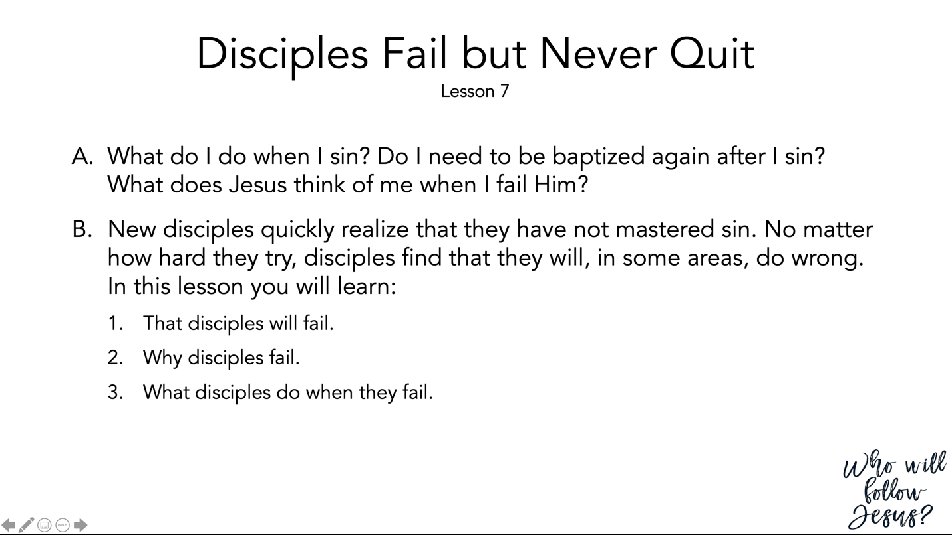

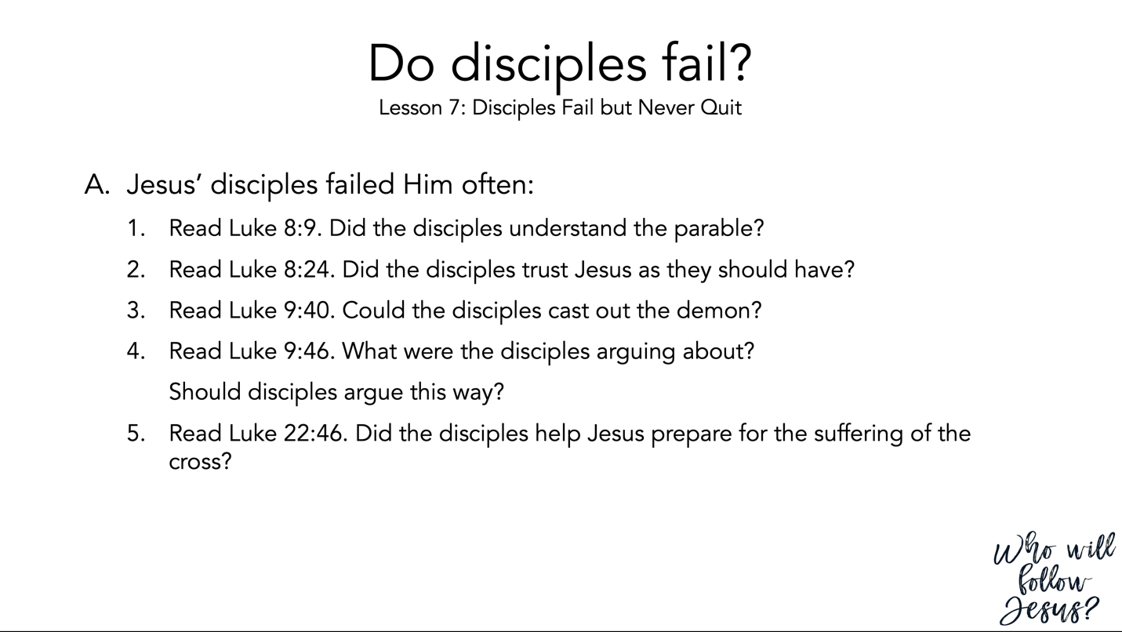

Luke 8:1–15 (NASB95) – The Parable of the Sower
¹ Soon afterwards, He began going around from one city and village to another, proclaiming and preaching the kingdom of God. The twelve were with Him, ² and also some women who had been healed of evil spirits and sicknesses: Mary who was called Magdalene, from whom seven demons had gone out, ³ and Joanna the wife of Chuza, Herod’s steward, and Susanna, and many others who were contributing to their support out of their private means. ⁴ When a large crowd was coming together, and those from the various cities were journeying to Him, He spoke by way of a parable: ⁵ “The sower went out to sow his seed; and as he sowed, some fell beside the road, and it was trampled under foot and the birds of the air ate it up. ⁶ “Other seed fell on rocky soil, and as soon as it grew up, it withered away, because it had no moisture. ⁷ “Other seed fell among the thorns; and the thorns grew up with it and choked it out. ⁸ “Other seed fell into the good soil, and grew up, and produced a crop a hundred times as great.” As He said these things, He would call out, “He who has ears to hear, let him hear.” ⁹ His disciples began questioning Him as to what this parable meant. ¹⁰ And He said, “To you it has been granted to know the mysteries of the kingdom of God, but to the rest it is in parables, so that seeing they may not see, and hearing they may not understand. ¹¹ “Now the parable is this: the seed is the word of God. ¹² “Those beside the road are those who have heard; then the devil comes and takes away the word from their heart, so that they will not believe and be saved. ¹³ “Those on the rocky soil are those who, when they hear, receive the word with joy; and these have no firm root; they believe for a while, and in time of temptation fall away. ¹⁴ “The seed which fell among the thorns, these are the ones who have heard, and as they go on their way they are choked with worries and riches and pleasures of this life, and bring no fruit to maturity. ¹⁵ “But the seed in the good soil, these are the ones who have heard the word in an honest and good heart, and hold it fast, and bear fruit with perseverance.

Luke 8:22–25 (NASB95) – Jesus Stills the Sea
²² Now on one of those days Jesus and His disciples got into a boat, and He said to them, “Let us go over to the other side of the lake.” So they launched out. ²³ But as they were sailing along He fell asleep; and a fierce gale of wind descended on the lake, and they began to be swamped and to be in danger. ²⁴ They came to Jesus and woke Him up, saying, “Master, Master, we are perishing!” And He got up and rebuked the wind and the surging waves, and they stopped, and it became calm. ²⁵ And He said to them, “Where is your faith?” They were fearful and amazed, saying to one another, “Who then is this, that He commands even the winds and the water, and they obey Him?”

Luke 9:37–43 (NASB95) – Jesus Heals a Boy with an Unclean Spirit
³⁷ On the next day, when they came down from the mountain, a large crowd met Him. ³⁸ And a man from the crowd shouted, saying, “Teacher, I beg You to look at my son, for he is my only boy, ³⁹ and a spirit seizes him, and he suddenly screams, and it throws him into a convulsion with foaming at the mouth; and only with difficulty does it leave him, mauling him as it leaves. ⁴⁰ “I begged Your disciples to cast it out, and they could not.” ⁴¹ And Jesus answered and said, “You unbelieving and perverted generation, how long shall I be with you and put up with you? Bring your son here.” ⁴² While he was still approaching, the demon slammed him to the ground and threw him into a convulsion. But Jesus rebuked the unclean spirit, and healed the boy and gave him back to his father. ⁴³ And they were all amazed at the greatness of God. But while everyone was marveling at all that He was doing, He said to His disciples,

Luke 9:46–50 (NASB95) – A Question About Who is the Greatest
⁴⁶ An argument started among them as to which of them might be the greatest. ⁴⁷ But Jesus, knowing what they were thinking in their heart, took a child and stood him by His side, ⁴⁸ and said to them, “Whoever receives this child in My name receives Me, and whoever receives Me receives Him who sent Me; for the one who is least among all of you, this is the one who is great.” ⁴⁹ John answered and said, “Master, we saw someone casting out demons in Your name; and we tried to prevent him because he does not follow along with us.” ⁵⁰ But Jesus said to him, “Do not hinder him; for he who is not against you is for you.”

Luke 22:39–46 (NASB95) – The Garden of Gethsemane
³⁹ And He came out and proceeded as was His custom to the Mount of Olives; and the disciples also followed Him. ⁴⁰ When He arrived at the place, He said to them, “Pray that you may not enter into temptation.” ⁴¹ And He withdrew from them about a stone’s throw, and He knelt down and began to pray, ⁴² saying, “Father, if You are willing, remove this cup from Me; yet not My will, but Yours be done.” ⁴³ Now an angel from heaven appeared to Him, strengthening Him. ⁴⁴ And being in agony He was praying very fervently; and His sweat became like drops of blood, falling down upon the ground. ⁴⁵ When He rose from prayer, He came to the disciples and found them sleeping from sorrow, ⁴⁶ and said to them, “Why are you sleeping? Get up and pray that you may not enter into temptation.”

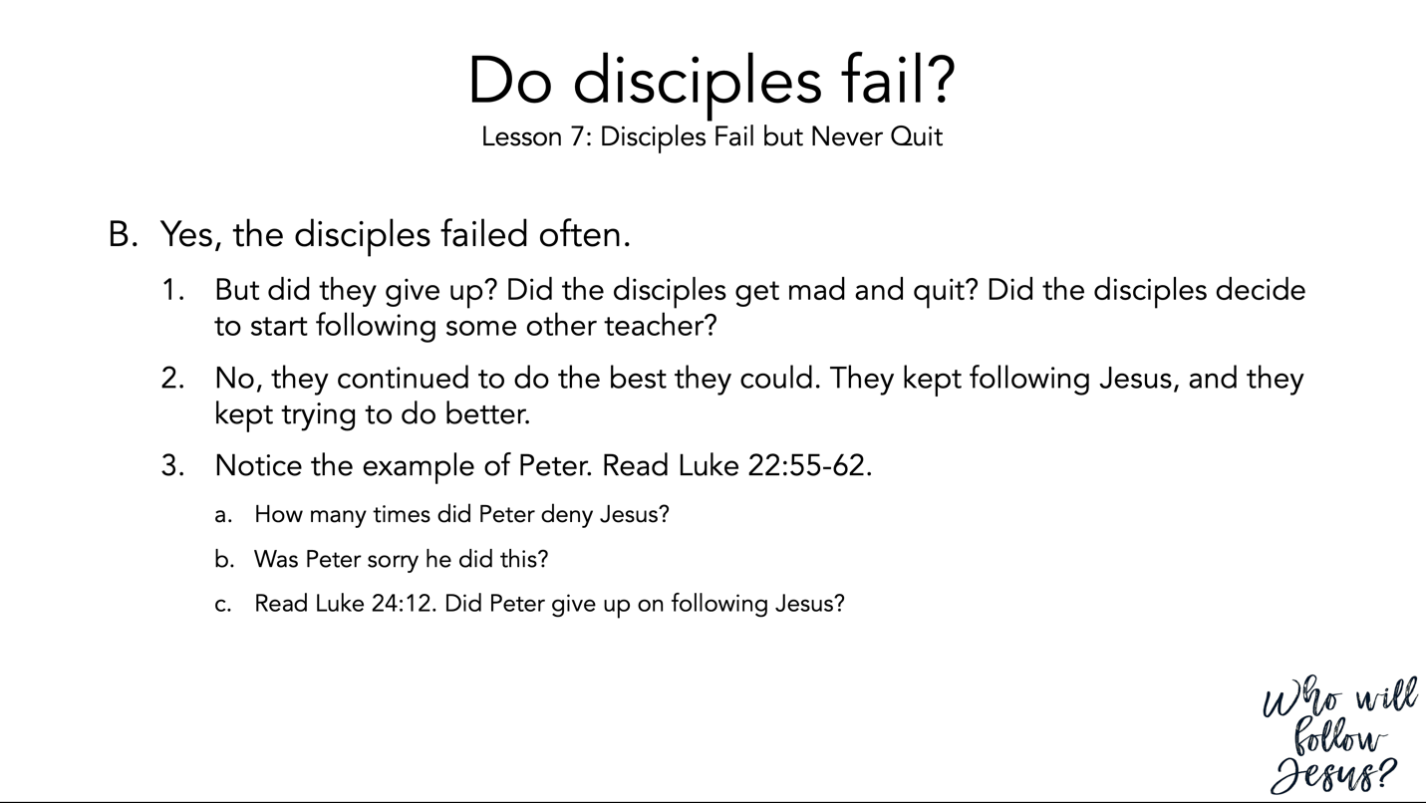

Luke 22:54–65 (NASB95) – Jesus’ Arrest
⁵⁴ Having arrested Him, they led Him away and brought Him to the house of the high priest; but Peter was following at a distance. ⁵⁵ After they had kindled a fire in the middle of the courtyard and had sat down together, Peter was sitting among them. ⁵⁶ And a servant-girl, seeing him as he sat in the firelight and looking intently at him, said, “This man was with Him too.” ⁵⁷ But he denied it, saying, “Woman, I do not know Him.” ⁵⁸ A little later, another saw him and said, “You are one of them too!” But Peter said, “Man, I am not!” ⁵⁹ After about an hour had passed, another man began to insist, saying, “Certainly this man also was with Him, for he is a Galilean too.” ⁶⁰ But Peter said, “Man, I do not know what you are talking about.” Immediately, while he was still speaking, a rooster crowed. ⁶¹ The Lord turned and looked at Peter. And Peter remembered the word of the Lord, how He had told him, “Before a rooster crows today, you will deny Me three times.” ⁶² And he went out and wept bitterly. ⁶³ Now the men who were holding Jesus in custody were mocking Him and beating Him, ⁶⁴ and they blindfolded Him and were asking Him, saying, “Prophesy, who is the one who hit You?” ⁶⁵ And they were saying many other things against Him, blaspheming.

Luke 24:1–12 (NASB95) – The Resurrection
¹ But on the first day of the week, at early dawn, they came to the tomb bringing the spices which they had prepared. ² And they found the stone rolled away from the tomb, ³ but when they entered, they did not find the body of the Lord Jesus. ⁴ While they were perplexed about this, behold, two men suddenly stood near them in dazzling clothing; ⁵ and as the women were terrified and bowed their faces to the ground, the men said to them, “Why do you seek the living One among the dead? ⁶ “He is not here, but He has risen. Remember how He spoke to you while He was still in Galilee, ⁷ saying that the Son of Man must be delivered into the hands of sinful men, and be crucified, and the third day rise again.” ⁸ And they remembered His words, ⁹ and returned from the tomb and reported all these things to the eleven and to all the rest. ¹⁰ Now they were Mary Magdalene and Joanna and Mary the mother of James; also the other women with them were telling these things to the apostles. ¹¹ But these words appeared to them as nonsense, and they would not believe them. ¹² But Peter got up and ran to the tomb; stooping and looking in, he saw the linen wrappings only; and he went away to his home, marveling at what had happened.

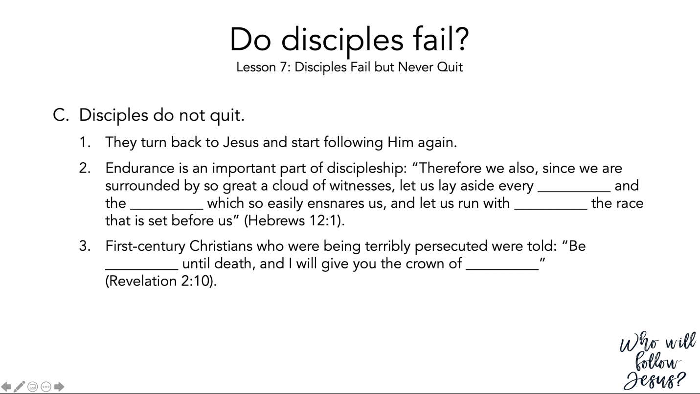

Hebrews 12:1–3 (NASB95) – Jesus, the Example
¹ Therefore, since we have so great a cloud of witnesses surrounding us, let us also lay aside every encumbrance and the sin which so easily entangles us, and let us run with endurance the race that is set before us, ² fixing our eyes on Jesus, the author and perfecter of faith, who for the joy set before Him endured the cross, despising the shame, and has sat down at the right hand of the throne of God. ³ For consider Him who has endured such hostility by sinners against Himself, so that you will not grow weary and lose heart.

Revelation 2:8–11 (NASB95) – Message to Smyrna
⁸ “And to the angel of the church in Smyrna write: The first and the last, who was dead, and has come to life, says this: ⁹ ‘I know your tribulation and your poverty (but you are rich), and the blasphemy by those who say they are Jews and are not, but are a synagogue of Satan. ¹⁰ ‘Do not fear what you are about to suffer. Behold, the devil is about to cast some of you into prison, so that you will be tested, and you will have tribulation for ten days. Be faithful until death, and I will give you the crown of life. ¹¹ ‘He who has an ear, let him hear what the Spirit says to the churches. He who overcomes will not be hurt by the second death.’

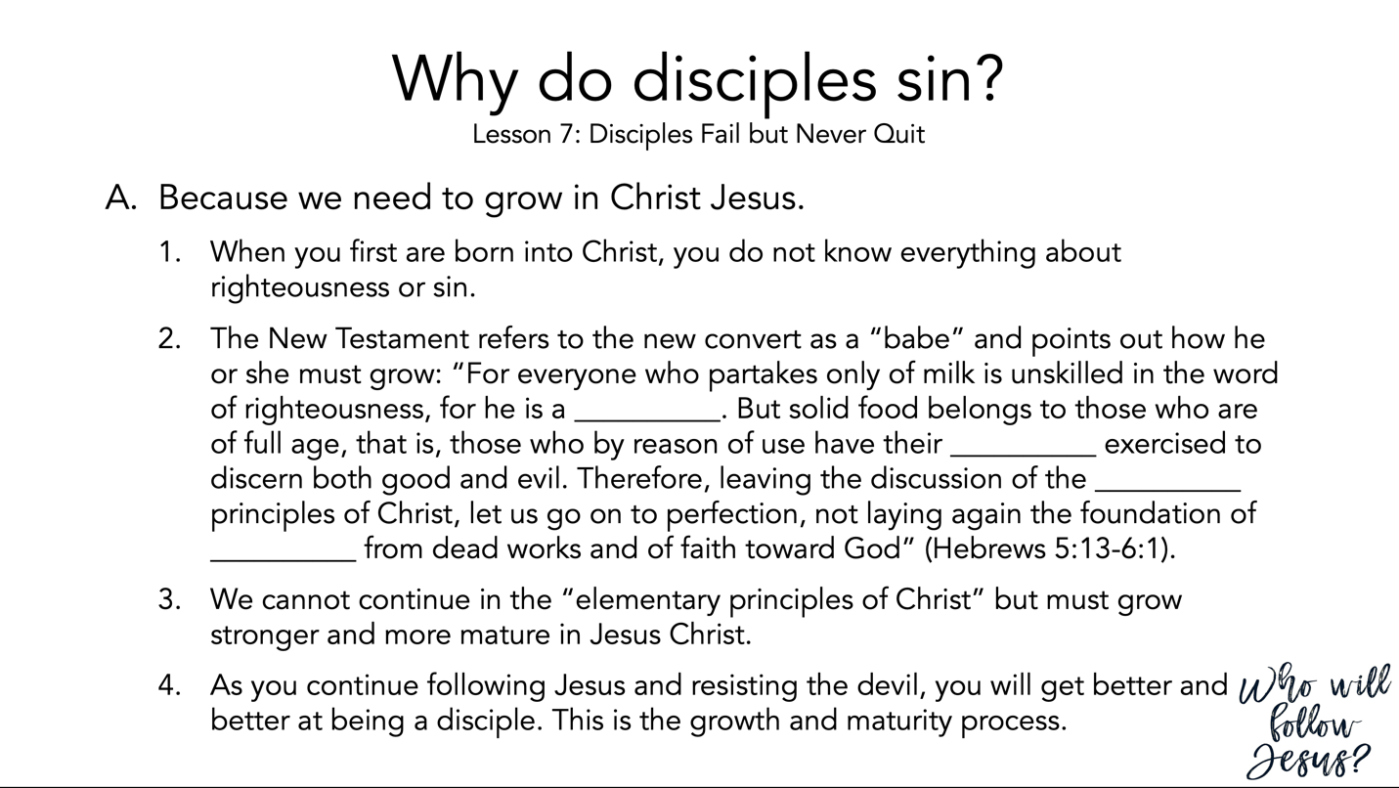

Hebrews 5:11–6:12 (NASB95) – A Warning Against Falling Away
¹¹ Concerning him we have much to say, and it is hard to explain, since you have become dull of hearing. ¹² For though by this time you ought to be teachers, you have need again for someone to teach you the elementary principles of the oracles of God, and you have come to need milk and not solid food. ¹³ For everyone who partakes only of milk is not accustomed to the word of righteousness, for he is an infant. ¹⁴ But solid food is for the mature, who because of practice have their senses trained to discern good and evil. ¹ Therefore leaving the elementary teaching about the Christ, let us press on to maturity, not laying again a foundation of repentance from dead works and of faith toward God, ² of instruction about washings and laying on of hands, and the resurrection of the dead and eternal judgment. ³ And this we will do, if God permits. ⁴ For in the case of those who have once been enlightened and have tasted of the heavenly gift and have been made partakers of the Holy Spirit, ⁵ and have tasted the good word of God and the powers of the age to come, ⁶ and then have fallen away, it is impossible to renew them again to repentance, since they again crucify to themselves the Son of God and put Him to open shame. ⁷ For ground that drinks the rain which often falls on it and brings forth vegetation useful to those for whose sake it is also tilled, receives a blessing from God; ⁸ but if it yields thorns and thistles, it is worthless and close to being cursed, and it ends up being burned. ⁹ But, beloved, we are convinced of better things concerning you, and things that accompany salvation, though we are speaking in this way. ¹⁰ For God is not unjust so as to forget your work and the love which you have shown toward His name, in having ministered and in still ministering to the saints. ¹¹ And we desire that each one of you show the same diligence so as to realize the full assurance of hope until the end, ¹² so that you will not be sluggish, but imitators of those who through faith and patience inherit the promises.

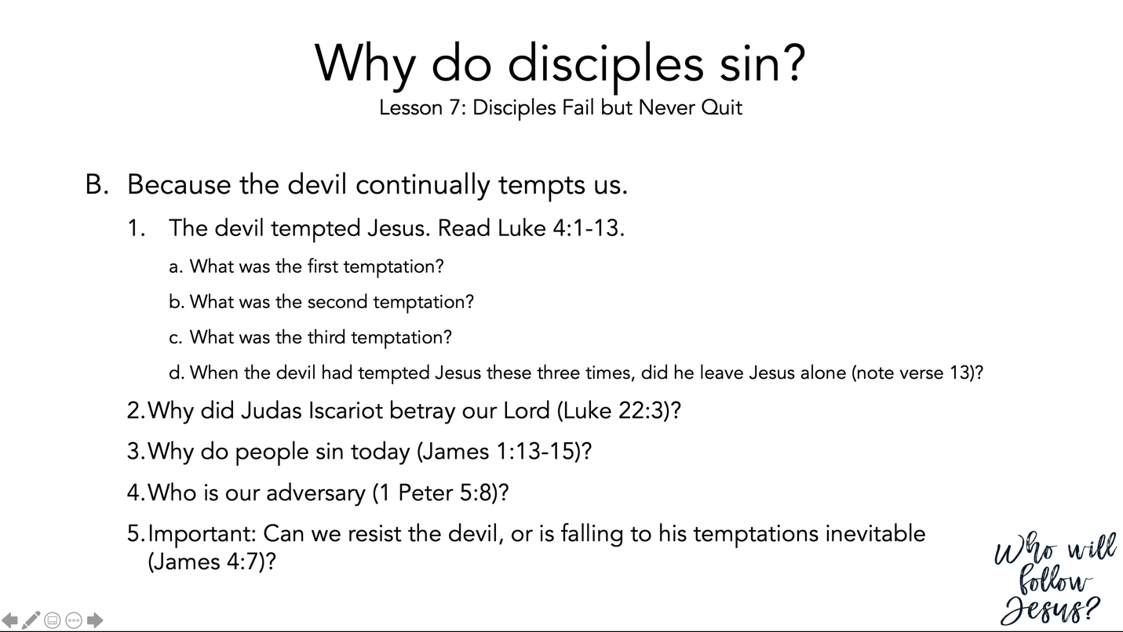

Luke 4:1–13 (NASB95) – The Temptation of Jesus
¹ Jesus, full of the Holy Spirit, returned from the Jordan and was led around by the Spirit in the wilderness ² for forty days, being tempted by the devil. And He ate nothing during those days, and when they had ended, He became hungry. ³ And the devil said to Him, “If You are the Son of God, tell this stone to become bread.” ⁴ And Jesus answered him, “It is written, ‘Man shall not live on bread alone.’ ” ⁵ And he led Him up and showed Him all the kingdoms of the world in a moment of time. ⁶ And the devil said to Him, “I will give You all this domain and its glory; for it has been handed over to me, and I give it to whomever I wish. ⁷ “Therefore if You worship before me, it shall all be Yours.” ⁸ Jesus answered him, “It is written, ‘You shall worship the Lord your God and serve Him only.’ ” ⁹ And he led Him to Jerusalem and had Him stand on the pinnacle of the temple, and said to Him, “If You are the Son of God, throw Yourself down from here; ¹⁰ for it is written, ‘He will command His angels concerning You to guard You,’ ¹¹ and, ‘On their hands they will bear You up, So that You will not strike Your foot against a stone.’ ” ¹² And Jesus answered and said to him, “It is said, ‘You shall not put the Lord your God to the test.’ ” ¹³ When the devil had finished every temptation, he left Him until an opportune time.

Luke 22:1–6 (NASB95) – Judas Arranges to Betray Christ
¹ Now the Feast of Unleavened Bread, which is called the Passover, was approaching. ² The chief priests and the scribes were seeking how they might put Him to death; for they were afraid of the people. ³ And Satan entered into Judas who was called Iscariot, belonging to the number of the twelve. ⁴ And he went away and discussed with the chief priests and officers how he might betray Him to them. ⁵ They were glad and agreed to give him money. ⁶ So he consented, and began seeking a good opportunity to betray Him to them apart from the crowd.

James 1:12–15 (NASB95) – Trial and Temptation
¹² Blessed is a man who perseveres under trial; for once he has been approved, he will receive the crown of life which the Lord has promised to those who love Him. ¹³ Let no one say when he is tempted, “I am being tempted by God”; for God cannot be tempted by evil, and He Himself does not tempt anyone. ¹⁴ But each one is tempted when he is carried away and enticed by his own lust. ¹⁵ Then when lust has conceived, it gives birth to sin; and when sin is accomplished, it brings forth death.

1 Peter 5:5–11 (NASB95) – Submit to God and Resist the Devil
⁵ You younger men, likewise, be subject to your elders; and all of you, clothe yourselves with humility toward one another, for God is opposed to the proud, but gives grace to the humble. ⁶ Therefore humble yourselves under the mighty hand of God, that He may exalt you at the proper time, ⁷ casting all your anxiety on Him, because He cares for you. ⁸ Be of sober spirit, be on the alert. Your adversary, the devil, prowls around like a roaring lion, seeking someone to devour. ⁹ But resist him, firm in your faith, knowing that the same experiences of suffering are being accomplished by your brethren who are in the world. ¹⁰ After you have suffered for a little while, the God of all grace, who called you to His eternal glory in Christ, will Himself perfect, confirm, strengthen and establish you. ¹¹ To Him be dominion forever and ever. Amen.

James 4:1–12 (NASB95) – Obey God
¹ What is the source of quarrels and conflicts among you? Is not the source your pleasures that wage war in your members? ² You lust and do not have; so you commit murder. You are envious and cannot obtain; so you fight and quarrel. You do not have because you do not ask. ³ You ask and do not receive, because you ask with wrong motives, so that you may spend it on your pleasures. ⁴ You adulteresses, do you not know that friendship with the world is hostility toward God? Therefore whoever wishes to be a friend of the world makes himself an enemy of God. ⁵ Or do you think that the Scripture speaks to no purpose: “He jealously desires the Spirit which He has made to dwell in us”? ⁶ But He gives a greater grace. Therefore it says, “God is opposed to the proud, but gives grace to the humble.” ⁷ Submit therefore to God. Resist the devil and he will flee from you. ⁸ Draw near to God and He will draw near to you. Cleanse your hands, you sinners; and purify your hearts, you double-minded. ⁹ Be miserable and mourn and weep; let your laughter be turned into mourning and your joy to gloom. ¹⁰ Humble yourselves in the presence of the Lord, and He will exalt you. ¹¹ Do not speak against one another, brethren. He who speaks against a brother or judges his brother, speaks against the law and judges the law; but if you judge the law, you are not a doer of the law but a judge of it. ¹² There is only one Lawgiver and Judge, the One who is able to save and to destroy; but who are you who judge your neighbor?

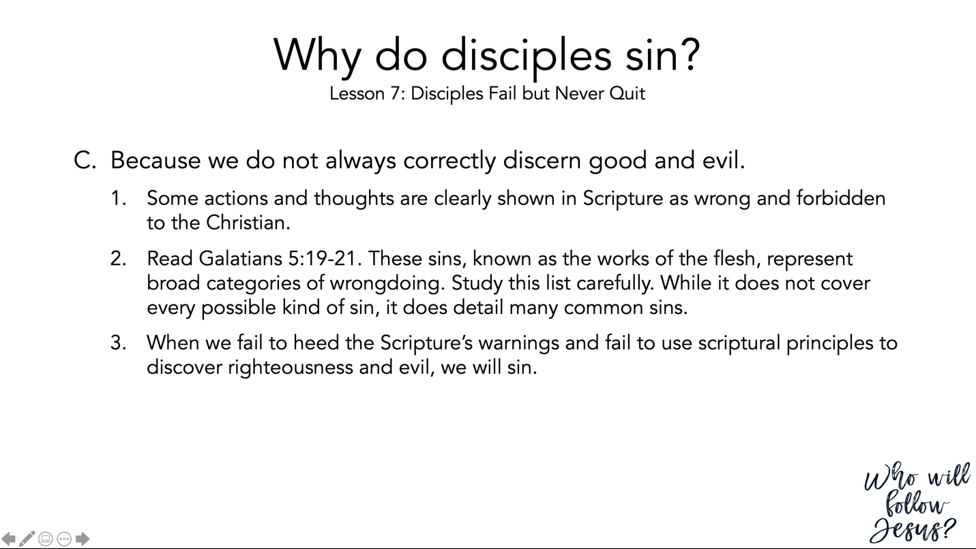

Galatians 5:16–21 (NASB95) – The Works of the Flesh
¹⁶ But I say, walk by the Spirit, and you will not carry out the desire of the flesh. ¹⁷ For the flesh sets its desire against the Spirit, and the Spirit against the flesh; for these are in opposition to one another, so that you may not do the things that you please. ¹⁸ But if you are led by the Spirit, you are not under the Law. ¹⁹ Now the deeds of the flesh are evident, which are: immorality, impurity, sensuality, ²⁰ idolatry, sorcery, enmities, strife, jealousy, outbursts of anger, disputes, dissensions, factions, ²¹ envying, drunkenness, carousing, and things like these, of which I forewarn you, just as I have forewarned you, that those who practice such things will not inherit the kingdom of God.

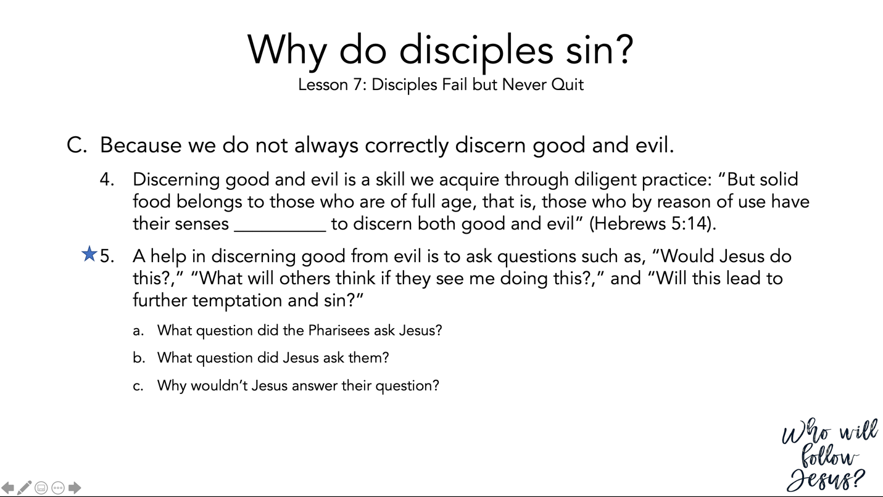

Hebrews 5:11–14 (NASB95) – Spiritual Immaturity
¹¹ Concerning him we have much to say, and it is hard to explain, since you have become dull of hearing. ¹² For though by this time you ought to be teachers, you have need again for someone to teach you the elementary principles of the oracles of God, and you have come to need milk and not solid food. ¹³ For everyone who partakes only of milk is not accustomed to the word of righteousness, for he is an infant. ¹⁴ But solid food is for the mature, who because of practice have their senses trained to discern good and evil.

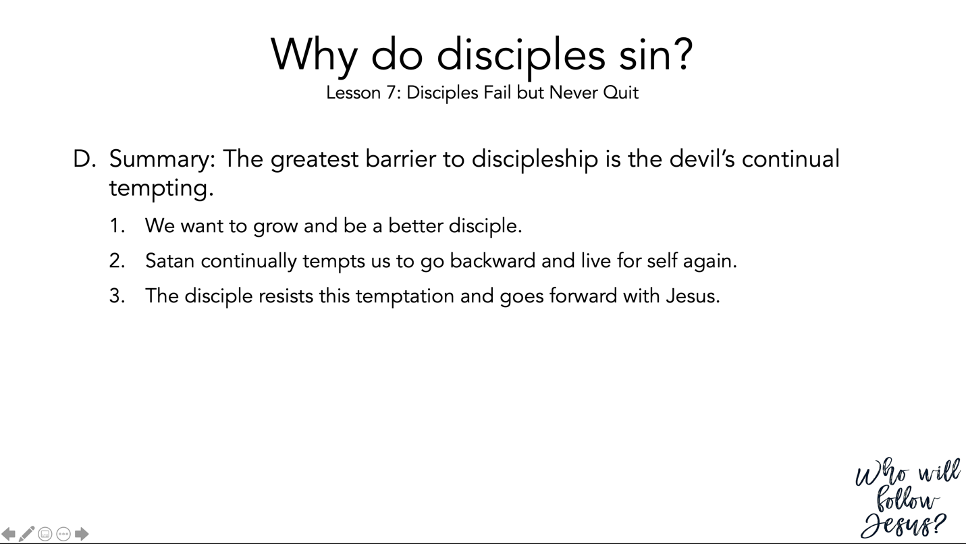

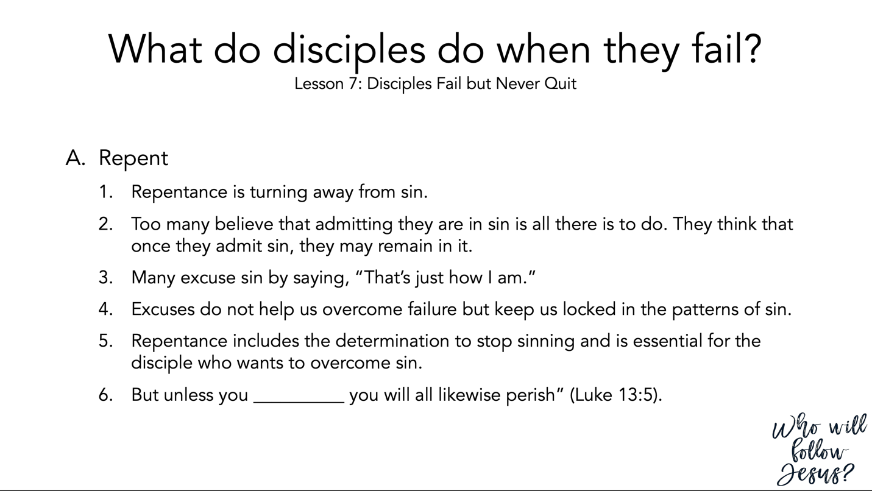

Luke 13:1–9 (NASB95) – Call to Repent
¹ Now on the same occasion there were some present who reported to Him about the Galileans whose blood Pilate had mixed with their sacrifices. ² And Jesus said to them, “Do you suppose that these Galileans were greater sinners than all other Galileans because they suffered this fate? ³ “I tell you, no, but unless you repent, you will all likewise perish. ⁴ “Or do you suppose that those eighteen on whom the tower in Siloam fell and killed them were worse culprits than all the men who live in Jerusalem? ⁵ “I tell you, no, but unless you repent, you will all likewise perish.” ⁶ And He began telling this parable: “A man had a fig tree which had been planted in his vineyard; and he came looking for fruit on it and did not find any. ⁷ “And he said to the vineyard-keeper, ‘Behold, for three years I have come looking for fruit on this fig tree without finding any. Cut it down! Why does it even use up the ground?’ ⁸ “And he answered and said to him, ‘Let it alone, sir, for this year too, until I dig around it and put in fertilizer; ⁹ and if it bears fruit next year, fine; but if not, cut it down.’ ”

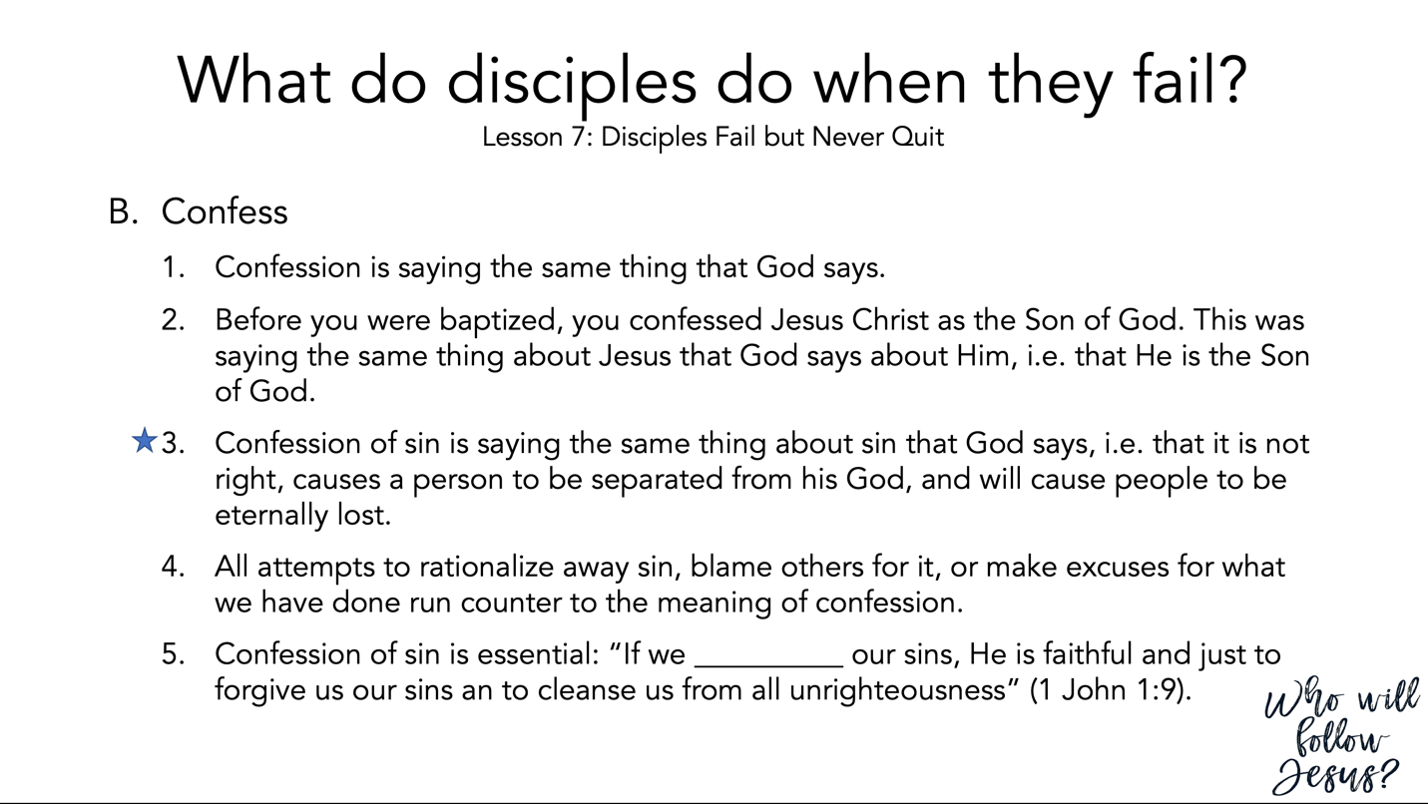

1 John 1:5–10 (NASB95) – God is Light
⁵ This is the message we have heard from Him and announce to you, that God is Light, and in Him there is no darkness at all. ⁶ If we say that we have fellowship with Him and yet walk in the darkness, we lie and do not practice the truth; ⁷ but if we walk in the Light as He Himself is in the Light, we have fellowship with one another, and the blood of Jesus His Son cleanses us from all sin. ⁸ If we say that we have no sin, we are deceiving ourselves and the truth is not in us. ⁹ If we confess our sins, He is faithful and righteous to forgive us our sins and to cleanse us from all unrighteousness. ¹⁰ If we say that we have not sinned, we make Him a liar and His word is not in us.

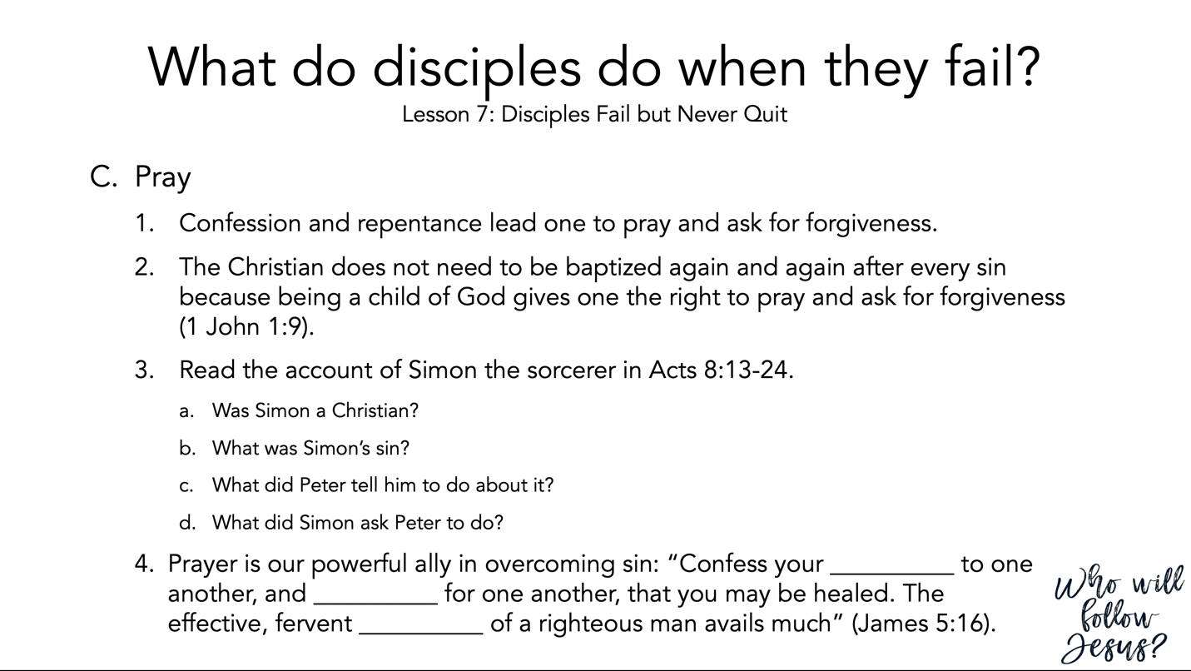

1 John 1:5–10 (NASB95) – God is Light
⁵ This is the message we have heard from Him and announce to you, that God is Light, and in Him there is no darkness at all. ⁶ If we say that we have fellowship with Him and yet walk in the darkness, we lie and do not practice the truth; ⁷ but if we walk in the Light as He Himself is in the Light, we have fellowship with one another, and the blood of Jesus His Son cleanses us from all sin. ⁸ If we say that we have no sin, we are deceiving ourselves and the truth is not in us. ⁹ If we confess our sins, He is faithful and righteous to forgive us our sins and to cleanse us from all unrighteousness. ¹⁰ If we say that we have not sinned, we make Him a liar and His word is not in us.

Acts 8:9–25 (NASB95) – Simon the Evil Magician
⁹ Now there was a man named Simon, who formerly was practicing magic in the city and astonishing the people of Samaria, claiming to be someone great; ¹⁰ and they all, from smallest to greatest, were giving attention to him, saying, “This man is what is called the Great Power of God.” ¹¹ And they were giving him attention because he had for a long time astonished them with his magic arts. ¹² But when they believed Philip preaching the good news about the kingdom of God and the name of Jesus Christ, they were being baptized, men and women alike. ¹³ Even Simon himself believed; and after being baptized, he continued on with Philip, and as he observed signs and great miracles taking place, he was constantly amazed. ¹⁴ Now when the apostles in Jerusalem heard that Samaria had received the word of God, they sent them Peter and John, ¹⁵ who came down and prayed for them that they might receive the Holy Spirit. ¹⁶ For He had not yet fallen upon any of them; they had simply been baptized in the name of the Lord Jesus. ¹⁷ Then they began laying their hands on them, and they were receiving the Holy Spirit. ¹⁸ Now when Simon saw that the Spirit was bestowed through the laying on of the apostles’ hands, he offered them money, ¹⁹ saying, “Give this authority to me as well, so that everyone on whom I lay my hands may receive the Holy Spirit.” ²⁰ But Peter said to him, “May your silver perish with you, because you thought you could obtain the gift of God with money! ²¹ “You have no part or portion in this matter, for your heart is not right before God. ²² “Therefore repent of this wickedness of yours, and pray the Lord that, if possible, the intention of your heart may be forgiven you. ²³ “For I see that you are in the gall of bitterness and in the bondage of iniquity.” ²⁴ But Simon answered and said, “Pray to the Lord for me yourselves, so that nothing of what you have said may come upon me.” ²⁵ So, when they had solemnly testified and spoken the word of the Lord, they started back to Jerusalem, and were preaching the gospel to many villages of the Samaritans.

James 5:13–18 (NASB95) – The Effective Prayer of Faith
¹³ Is anyone among you suffering? Then he must pray. Is anyone cheerful? He is to sing praises. ¹⁴ Is anyone among you sick? Then he must call for the elders of the church and they are to pray over him, anointing him with oil in the name of the Lord; ¹⁵ and the prayer offered in faith will restore the one who is sick, and the Lord will raise him up, and if he has committed sins, they will be forgiven him. ¹⁶ Therefore, confess your sins to one another, and pray for one another so that you may be healed. The effective prayer of a righteous man can accomplish much. ¹⁷ Elijah was a man with a nature like ours, and he prayed earnestly that it would not rain, and it did not rain on the earth for three years and six months. ¹⁸ Then he prayed again, and the sky poured rain and the earth produced its fruit.

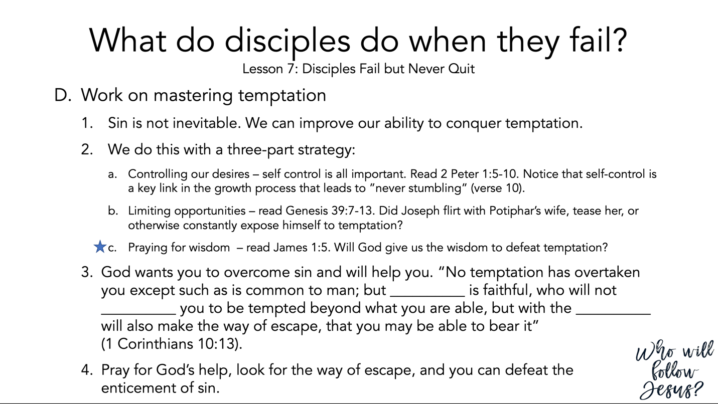
2 Peter 1:3–11 (NASB95) – Fruitful Growth in the Faith
³ seeing that His divine power has granted to us everything pertaining to life and godliness, through the true knowledge of Him who called us by His own glory and excellence. ⁴ For by these He has granted to us His precious and magnificent promises, so that by them you may become partakers of the divine nature, having escaped the corruption that is in the world by lust. ⁵ Now for this very reason also, applying all diligence, in your faith supply moral excellence, and in your moral excellence, knowledge, ⁶ and in your knowledge, self-control, and in your self-control, perseverance, and in your perseverance, godliness, ⁷ and in your godliness, brotherly kindness, and in your brotherly kindness, love. ⁸ For if these qualities are yours and are increasing, they render you neither useless nor unfruitful in the true knowledge of our Lord Jesus Christ. ⁹ For he who lacks these qualities is blind or short-sighted, having forgotten his purification from his former sins. ¹⁰ Therefore, brethren, be all the more diligent to make certain about His calling and choosing you; for as long as you practice these things, you will never stumble; ¹¹ for in this way the entrance into the eternal kingdom of our Lord and Savior Jesus Christ will be abundantly supplied to you.

Genesis 39:1–20 (NASB95) – Joseph in Potiphar’s House
¹ Now Joseph had been taken down to Egypt; and Potiphar, an Egyptian officer of Pharaoh, the captain of the bodyguard, bought him from the Ishmaelites, who had taken him down there. ² The Lord was with Joseph, so he became a successful man. And he was in the house of his master, the Egyptian. ³ Now his master saw that the Lord was with him and how the Lord caused all that he did to prosper in his hand. ⁴ So Joseph found favor in his sight and became his personal servant; and he made him overseer over his house, and all that he owned he put in his charge. ⁵ It came about that from the time he made him overseer in his house and over all that he owned, the Lord blessed the Egyptian’s house on account of Joseph; thus the Lord’s blessing was upon all that he owned, in the house and in the field. ⁶ So he left everything he owned in Joseph’s charge; and with him there he did not concern himself with anything except the food which he ate. Now Joseph was handsome in form and appearance. ⁷ It came about after these events that his master’s wife looked with desire at Joseph, and she said, “Lie with me.” ⁸ But he refused and said to his master’s wife, “Behold, with me here, my master does not concern himself with anything in the house, and he has put all that he owns in my charge. ⁹ “There is no one greater in this house than I, and he has withheld nothing from me except you, because you are his wife. How then could I do this great evil and sin against God?” ¹⁰ As she spoke to Joseph day after day, he did not listen to her to lie beside her or be with her. ¹¹ Now it happened one day that he went into the house to do his work, and none of the men of the household was there inside. ¹² She caught him by his garment, saying, “Lie with me!” And he left his garment in her hand and fled, and went outside. ¹³ When she saw that he had left his garment in her hand and had fled outside, ¹⁴ she called to the men of her household and said to them, “See, he has brought in a Hebrew to us to make sport of us; he came in to me to lie with me, and I screamed. ¹⁵ “When he heard that I raised my voice and screamed, he left his garment beside me and fled and went outside.” ¹⁶ So she left his garment beside her until his master came home. ¹⁷ Then she spoke to him with these words, “The Hebrew slave, whom you brought to us, came in to me to make sport of me; ¹⁸ and as I raised my voice and screamed, he left his garment beside me and fled outside.” ¹⁹ Now when his master heard the words of his wife, which she spoke to him, saying, “This is what your slave did to me,” his anger burned. ²⁰ So Joseph’s master took him and put him into the jail, the place where the king’s prisoners were confined; and he was there in the jail.
James 1:5–8 (NASB95) – Prayer with Confidence
⁵ But if any of you lacks wisdom, let him ask of God, who gives to all generously and without reproach, and it will be given to him. ⁶ But he must ask in faith without any doubting, for the one who doubts is like the surf of the sea, driven and tossed by the wind. ⁷ For that man ought not to expect that he will receive anything from the Lord, ⁸ being a double-minded man, unstable in all his ways.

1 Corinthians 10:1–13 (NASB95) – Learn from Old Testament Examples
¹ For I do not want you to be unaware, brethren, that our fathers were all under the cloud and all passed through the sea; ² and all were baptized into Moses in the cloud and in the sea; ³ and all ate the same spiritual food; ⁴ and all drank the same spiritual drink, for they were drinking from a spiritual rock which followed them; and the rock was Christ. ⁵ Nevertheless, with most of them God was not well-pleased; for they were laid low in the wilderness. ⁶ Now these things happened as examples for us, so that we would not crave evil things as they also craved. ⁷ Do not be idolaters, as some of them were; as it is written, “The people sat down to eat and drink, and stood up to play.” ⁸ Nor let us act immorally, as some of them did, and twenty-three thousand fell in one day. ⁹ Nor let us try the Lord, as some of them did, and were destroyed by the serpents. ¹⁰ Nor grumble, as some of them did, and were destroyed by the destroyer. ¹¹ Now these things happened to them as an example, and they were written for our instruction, upon whom the ends of the ages have come. ¹² Therefore let him who thinks he stands take heed that he does not fall. ¹³ No temptation has overtaken you but such as is common to man; and God is faithful, who will not allow you to be tempted beyond what you are able, but with the temptation will provide the way of escape also, so that you will be able to endure it.

