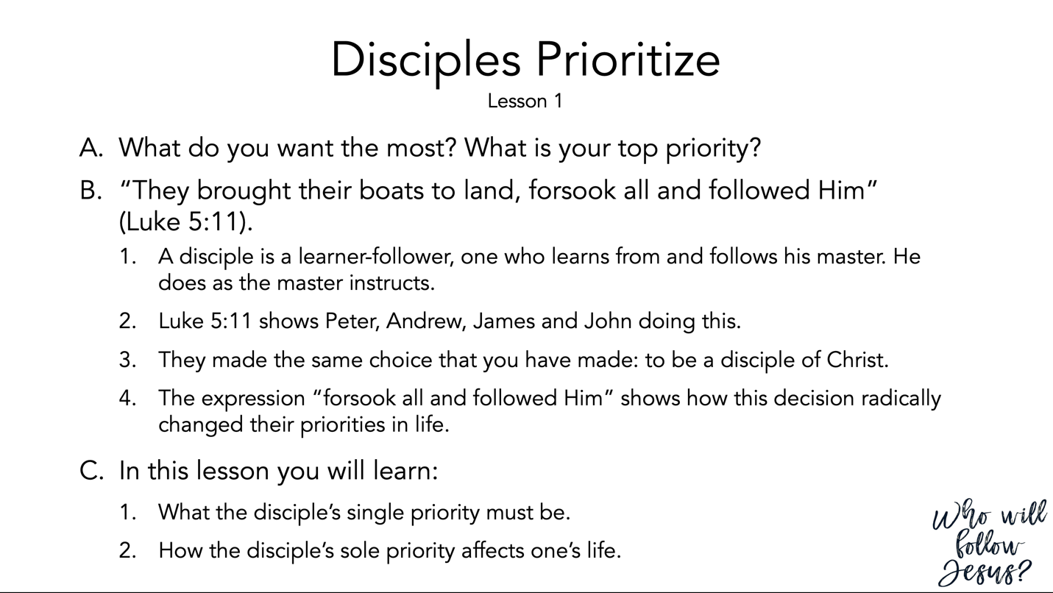

Luke 5:1–11 (NASB95) – The First Disciples
¹ Now it happened that while the crowd was pressing around Him and listening to the word of God, He was standing by the lake of Gennesaret; ² and He saw two boats lying at the edge of the lake; but the fishermen had gotten out of them and were washing their nets. ³ And He got into one of the boats, which was Simon’s, and asked him to put out a little way from the land. And He sat down and began teaching the people from the boat. ⁴ When He had finished speaking, He said to Simon, “Put out into the deep water and let down your nets for a catch.” ⁵ Simon answered and said, “Master, we worked hard all night and caught nothing, but I will do as You say and let down the nets.” ⁶ When they had done this, they enclosed a great quantity of fish, and their nets began to break; ⁷ so they signaled to their partners in the other boat for them to come and help them. And they came and filled both of the boats, so that they began to sink. ⁸ But when Simon Peter saw that, he fell down at Jesus’ feet, saying, “Go away from me Lord, for I am a sinful man!” ⁹ For amazement had seized him and all his companions because of the catch of fish which they had taken; ¹⁰ and so also were James and John, sons of Zebedee, who were partners with Simon. And Jesus said to Simon, “Do not fear, from now on you will be catching men.” ¹¹ When they had brought their boats to land, they left everything and followed Him.

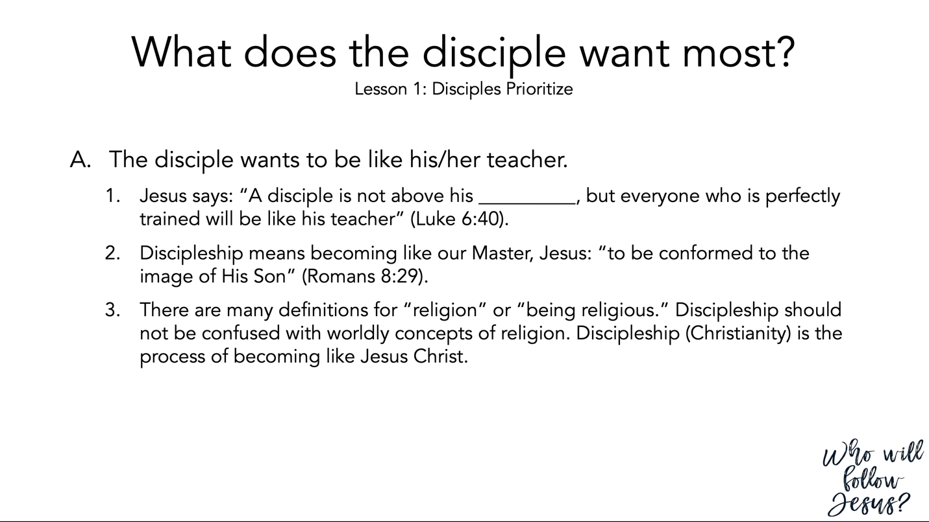

Luke 6:20–45 (NASB95) – The Beatitudes
²⁰ And turning His gaze toward His disciples, He began to say, “Blessed are you who are poor, for yours is the kingdom of God. ²¹ “Blessed are you who hunger now, for you shall be satisfied. Blessed are you who weep now, for you shall laugh. ²² “Blessed are you when men hate you, and ostracize you, and insult you, and scorn your name as evil, for the sake of the Son of Man. ²³ “Be glad in that day and leap for joy, for behold, your reward is great in heaven. For in the same way their fathers used to treat the prophets. ²⁴ “But woe to you who are rich, for you are receiving your comfort in full. ²⁵ “Woe to you who are well-fed now, for you shall be hungry. Woe to you who laugh now, for you shall mourn and weep. ²⁶ “Woe to you when all men speak well of you, for their fathers used to treat the false prophets in the same way. ²⁷ “But I say to you who hear, love your enemies, do good to those who hate you, ²⁸ bless those who curse you, pray for those who mistreat you. ²⁹ “Whoever hits you on the cheek, offer him the other also; and whoever takes away your coat, do not withhold your shirt from him either. ³⁰ “Give to everyone who asks of you, and whoever takes away what is yours, do not demand it back. ³¹ “Treat others the same way you want them to treat you. ³² “If you love those who love you, what credit is that to you? For even sinners love those who love them. ³³ “If you do good to those who do good to you, what credit is that to you? For even sinners do the same. ³⁴ “If you lend to those from whom you expect to receive, what credit is that to you? Even sinners lend to sinners in order to receive back the same amount. ³⁵ “But love your enemies, and do good, and lend, expecting nothing in return; and your reward will be great, and you will be sons of the Most High; for He Himself is kind to ungrateful and evil men. ³⁶ “Be merciful, just as your Father is merciful. ³⁷ “Do not judge, and you will not be judged; and do not condemn, and you will not be condemned; pardon, and you will be pardoned. ³⁸ “Give, and it will be given to you. They will pour into your lap a good measure—pressed down, shaken together, and running over. For by your standard of measure it will be measured to you in return.” ³⁹ And He also spoke a parable to them: “A blind man cannot guide a blind man, can he? Will they not both fall into a pit? ⁴⁰ “A pupil is not above his teacher; but everyone, after he has been fully trained, will be like his teacher. ⁴¹ “Why do you look at the speck that is in your brother’s eye, but do not notice the log that is in your own eye? ⁴² “Or how can you say to your brother, ‘Brother, let me take out the speck that is in your eye,’ when you yourself do not see the log that is in your own eye? You hypocrite, first take the log out of your own eye, and then you will see clearly to take out the speck that is in your brother’s eye. ⁴³ “For there is no good tree which produces bad fruit, nor, on the other hand, a bad tree which produces good fruit. ⁴⁴ “For each tree is known by its own fruit. For men do not gather figs from thorns, nor do they pick grapes from a briar bush. ⁴⁵ “The good man out of the good treasure of his heart brings forth what is good; and the evil man out of the evil treasure brings forth what is evil; for his mouth speaks from that which fills his heart.

Romans 8:26–39 (NASB95) – Our Victory in Christ
²⁶ In the same way the Spirit also helps our weakness; for we do not know how to pray as we should, but the Spirit Himself intercedes for us with groanings too deep for words; ²⁷ and He who searches the hearts knows what the mind of the Spirit is, because He intercedes for the saints according to the will of God. ²⁸ And we know that God causes all things to work together for good to those who love God, to those who are called according to His purpose. ²⁹ For those whom He foreknew, He also predestined to become conformed to the image of His Son, so that He would be the firstborn among many brethren; ³⁰ and these whom He predestined, He also called; and these whom He called, He also justified; and these whom He justified, He also glorified. ³¹ What then shall we say to these things? If God is for us, who is against us? ³² He who did not spare His own Son, but delivered Him over for us all, how will He not also with Him freely give us all things? ³³ Who will bring a charge against God’s elect? God is the one who justifies; ³⁴ who is the one who condemns? Christ Jesus is He who died, yes, rather who was raised, who is at the right hand of God, who also intercedes for us. ³⁵ Who will separate us from the love of Christ? Will tribulation, or distress, or persecution, or famine, or nakedness, or peril, or sword? ³⁶ Just as it is written, “For Your sake we are being put to death all day long; We were considered as sheep to be slaughtered.” ³⁷ But in all these things we overwhelmingly conquer through Him who loved us. ³⁸ For I am convinced that neither death, nor life, nor angels, nor principalities, nor things present, nor things to come, nor powers, ³⁹ nor height, nor depth, nor any other created thing, will be able to separate us from the love of God, which is in Christ Jesus our Lord.

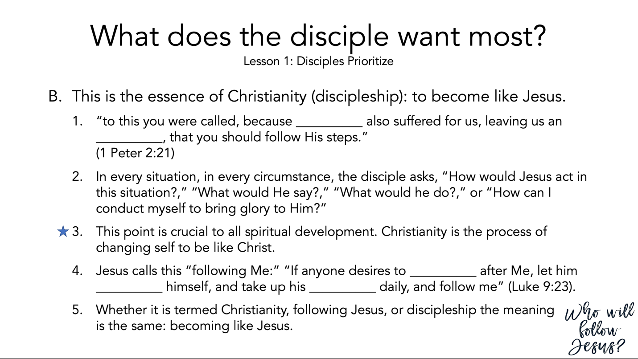

- Peter 2:13–25 (NASB95)
- Honor Authority
¹³ Submit yourselves for the Lord’s sake to every human institution, whether to a king as the one in authority, ¹⁴ or to governors as sent by him for the punishment of evildoers and the praise of those who do right. ¹⁵ For such is the will of God that by doing right you may silence the ignorance of foolish men. ¹⁶ Act as free men, and do not use your freedom as a covering for evil, but use it as bondslaves of God. ¹⁷ Honor all people, love the brotherhood, fear God, honor the king. ¹⁸ Servants, be submissive to your masters with all respect, not only to those who are good and gentle, but also to those who are unreasonable. ¹⁹ For this finds favor, if for the sake of conscience toward God a person bears up under sorrows when suffering unjustly. ²⁰ For what credit is there if, when you sin and are harshly treated, you endure it with patience? But if when you do what is right and suffer for it you patiently endure it, this finds favor with God.

- Christ Is Our Example
²¹ For you have been called for this purpose, since Christ also suffered for you, leaving you an example for you to follow in His steps, ²² who committed no sin, nor was any deceit found in His mouth; ²³ and while being reviled, He did not revile in return; while suffering, He uttered no threats, but kept entrusting Himself to Him who judges righteously; ²⁴ and He Himself bore our sins in His body on the cross, so that we might die to sin and live to righteousness; for by His wounds you were healed. ²⁵ For you were continually straying like sheep, but now you have returned to the Shepherd and Guardian of your souls.

Luke 9:12–27 (NASB95) – Five Thousand Fed
¹² Now the day was ending, and the twelve came and said to Him, “Send the crowd away, that they may go into the surrounding villages and countryside and find lodging and get something to eat; for here we are in a desolate place.” ¹³ But He said to them, “You give them something to eat!” And they said, “We have no more than five loaves and two fish, unless perhaps we go and buy food for all these people.” ¹⁴ (For there were about five thousand men.) And He said to His disciples, “Have them sit down to eat in groups of about fifty each.” ¹⁵ They did so, and had them all sit down. ¹⁶ Then He took the five loaves and the two fish, and looking up to heaven, He blessed them, and broke them, and kept giving them to the disciples to set before the people. ¹⁷ And they all ate and were satisfied; and the broken pieces which they had left over were picked up, twelve baskets full. ¹⁸ And it happened that while He was praying alone, the disciples were with Him, and He questioned them, saying, “Who do the people say that I am?” ¹⁹ They answered and said, “John the Baptist, and others say Elijah; but others, that one of the prophets of old has risen again.” ²⁰ And He said to them, “But who do you say that I am?” And Peter answered and said, “The Christ of God.” ²¹ But He warned them and instructed them not to tell this to anyone, ²² saying, “The Son of Man must suffer many things and be rejected by the elders and chief priests and scribes, and be killed and be raised up on the third day.” ²³ And He was saying to them all, “If anyone wishes to come after Me, he must deny himself, and take up his cross daily and follow Me. ²⁴ “For whoever wishes to save his life will lose it, but whoever loses his life for My sake, he is the one who will save it. ²⁵ “For what is a man profited if he gains the whole world, and loses or forfeits himself? ²⁶ “For whoever is ashamed of Me and My words, the Son of Man will be ashamed of him when He comes in His glory, and the glory of the Father and of the holy angels. ²⁷ “But I say to you truthfully, there are some of those standing here who will not taste death until they see the kingdom of God.”

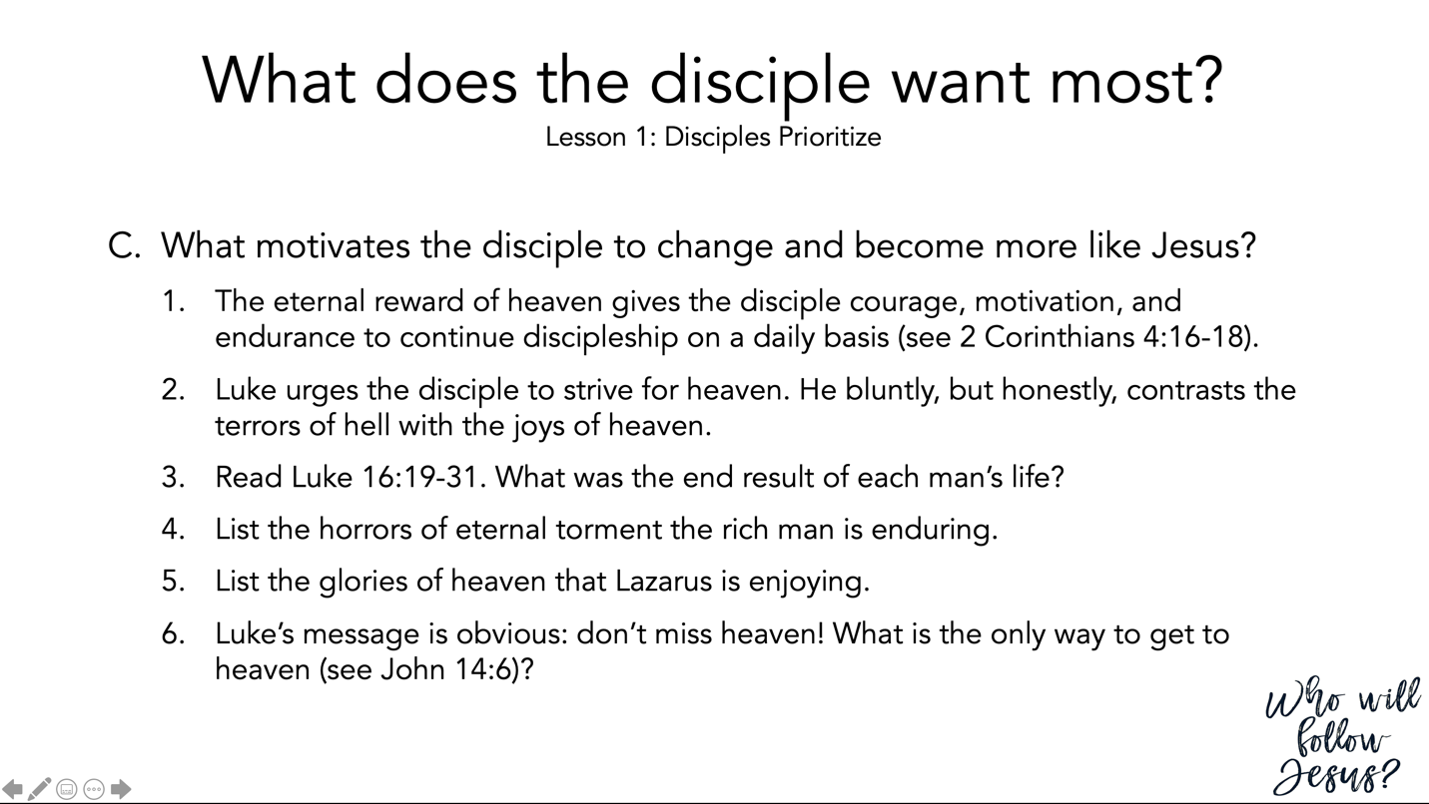

2 Corinthians 4 (NASB95) – Paul’s Apostolic Ministry
¹ Therefore, since we have this ministry, as we received mercy, we do not lose heart, ² but we have renounced the things hidden because of shame, not walking in craftiness or adulterating the word of God, but by the manifestation of truth commending ourselves to every man’s conscience in the sight of God. ³ And even if our gospel is veiled, it is veiled to those who are perishing, ⁴ in whose case the god of this world has blinded the minds of the unbelieving so that they might not see the light of the gospel of the glory of Christ, who is the image of God. ⁵ For we do not preach ourselves but Christ Jesus as Lord, and ourselves as your bond-servants for Jesus’ sake. ⁶ For God, who said, “Light shall shine out of darkness,” is the One who has shone in our hearts to give the Light of the knowledge of the glory of God in the face of Christ. ⁷ But we have this treasure in earthen vessels, so that the surpassing greatness of the power will be of God and not from ourselves; ⁸ we are afflicted in every way, but not crushed; perplexed, but not despairing; ⁹ persecuted, but not forsaken; struck down, but not destroyed; ¹⁰ always carrying about in the body the dying of Jesus, so that the life of Jesus also may be manifested in our body. ¹¹ For we who live are constantly being delivered over to death for Jesus’ sake, so that the life of Jesus also may be manifested in our mortal flesh. ¹² So death works in us, but life in you. ¹³ But having the same spirit of faith, according to what is written, “I believed, therefore I spoke,” we also believe, therefore we also speak, ¹⁴ knowing that He who raised the Lord Jesus will raise us also with Jesus and will present us with you. ¹⁵ For all things are for your sakes, so that the grace which is spreading to more and more people may cause the giving of thanks to abound to the glory of God. ¹⁶ Therefore we do not lose heart, but though our outer man is decaying, yet our inner man is being renewed day by day. ¹⁷ For momentary, light affliction is producing for us an eternal weight of glory far beyond all comparison, ¹⁸ while we look not at the things which are seen, but at the things which are not seen; for the things which are seen are temporal, but the things which are not seen are eternal.

Luke 16:19–31 (NASB95) – The Rich Man and Lazarus
¹⁹ “Now there was a rich man, and he habitually dressed in purple and fine linen, joyously living in splendor every day. ²⁰ “And a poor man named Lazarus was laid at his gate, covered with sores, ²¹ and longing to be fed with the crumbs which were falling from the rich man’s table; besides, even the dogs were coming and licking his sores. ²² “Now the poor man died and was carried away by the angels to Abraham’s bosom; and the rich man also died and was buried. ²³ “In Hades he lifted up his eyes, being in torment, and saw Abraham far away and Lazarus in his bosom. ²⁴ “And he cried out and said, ‘Father Abraham, have mercy on me, and send Lazarus so that he may dip the tip of his finger in water and cool off my tongue, for I am in agony in this flame.’ ²⁵ “But Abraham said, ‘Child, remember that during your life you received your good things, and likewise Lazarus bad things; but now he is being comforted here, and you are in agony. ²⁶ ‘And besides all this, between us and you there is a great chasm fixed, so that those who wish to come over from here to you will not be able, and that none may cross over from there to us.’ ²⁷ “And he said, ‘Then I beg you, father, that you send him to my father’s house— ²⁸ for I have five brothers—in order that he may warn them, so that they will not also come to this place of torment.’ ²⁹ “But Abraham said, ‘They have Moses and the Prophets; let them hear them.’ ³⁰ “But he said, ‘No, father Abraham, but if someone goes to them from the dead, they will repent!’ ³¹ “But he said to him, ‘If they do not listen to Moses and the Prophets, they will not be persuaded even if someone rises from the dead.’ ”

John 14:1–6 (NASB95) – Jesus Comforts His Disciples
¹ “Do not let your heart be troubled; believe in God, believe also in Me. ² “In My Father’s house are many dwelling places; if it were not so, I would have told you; for I go to prepare a place for you. ³ “If I go and prepare a place for you, I will come again and receive you to Myself, that where I am, there you may be also. ⁴ “And you know the way where I am going.” ⁵ Thomas said to Him, “Lord, we do not know where You are going, how do we know the way?” ⁶ Jesus said to him, “I am the way, and the truth, and the life; no one comes to the Father but through Me.

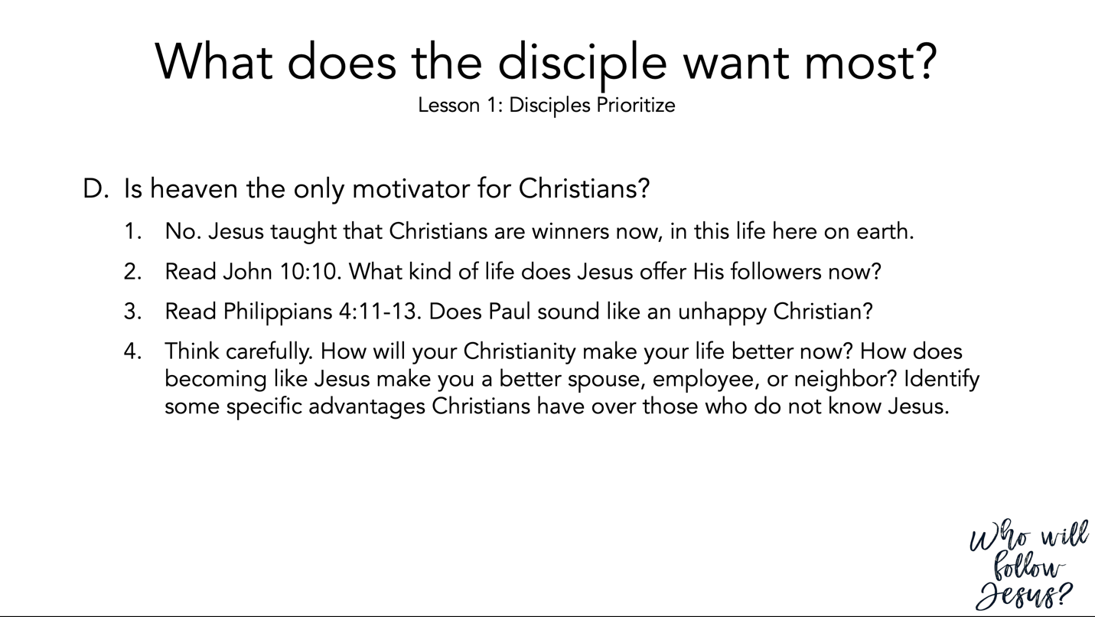

John 10:1–21 (NASB95) – Parable of the Good Shepherd
¹ “Truly, truly, I say to you, he who does not enter by the door into the fold of the sheep, but climbs up some other way, he is a thief and a robber. ² “But he who enters by the door is a shepherd of the sheep. ³ “To him the doorkeeper opens, and the sheep hear his voice, and he calls his own sheep by name and leads them out. ⁴ “When he puts forth all his own, he goes ahead of them, and the sheep follow him because they know his voice. ⁵ “A stranger they simply will not follow, but will flee from him, because they do not know the voice of strangers.” ⁶ This figure of speech Jesus spoke to them, but they did not understand what those things were which He had been saying to them. ⁷ So Jesus said to them again, “Truly, truly, I say to you, I am the door of the sheep. ⁸ “All who came before Me are thieves and robbers, but the sheep did not hear them. ⁹ “I am the door; if anyone enters through Me, he will be saved, and will go in and out and find pasture. ¹⁰ “The thief comes only to steal and kill and destroy; I came that they may have life, and have it abundantly. ¹¹ “I am the good shepherd; the good shepherd lays down His life for the sheep. ¹² “He who is a hired hand, and not a shepherd, who is not the owner of the sheep, sees the wolf coming, and leaves the sheep and flees, and the wolf snatches them and scatters them. ¹³ “He flees because he is a hired hand and is not concerned about the sheep. ¹⁴ “I am the good shepherd, and I know My own and My own know Me, ¹⁵ even as the Father knows Me and I know the Father; and I lay down My life for the sheep. ¹⁶ “I have other sheep, which are not of this fold; I must bring them also, and they will hear My voice; and they will become one flock with one shepherd. ¹⁷ “For this reason the Father loves Me, because I lay down My life so that I may take it again. ¹⁸ “No one has taken it away from Me, but I lay it down on My own initiative. I have authority to lay it down, and I have authority to take it up again. This commandment I received from My Father.” ¹⁹ A division occurred again among the Jews because of these words. ²⁰ Many of them were saying, “He has a demon and is insane. Why do you listen to Him?” ²¹ Others were saying, “These are not the sayings of one demon-possessed. A demon cannot open the eyes of the blind, can he?”

Philippians 4:10–23 (NASB95) – God’s Provisions
¹⁰ But I rejoiced in the Lord greatly, that now at last you have revived your concern for me; indeed, you were concerned before, but you lacked opportunity. ¹¹ Not that I speak from want, for I have learned to be content in whatever circumstances I am. ¹² I know how to get along with humble means, and I also know how to live in prosperity; in any and every circumstance I have learned the secret of being filled and going hungry, both of having abundance and suffering need. ¹³ I can do all things through Him who strengthens me. ¹⁴ Nevertheless, you have done well to share with me in my affliction. ¹⁵ You yourselves also know, Philippians, that at the first preaching of the gospel, after I left Macedonia, no church shared with me in the matter of giving and receiving but you alone; ¹⁶ for even in Thessalonica you sent a gift more than once for my needs. ¹⁷ Not that I seek the gift itself, but I seek for the profit which increases to your account. ¹⁸ But I have received everything in full and have an abundance; I am amply supplied, having received from Epaphroditus what you have sent, a fragrant aroma, an acceptable sacrifice, well-pleasing to God. ¹⁹ And my God will supply all your needs according to His riches in glory in Christ Jesus. ²⁰ Now to our God and Father be the glory forever and ever. Amen. ²¹ Greet every saint in Christ Jesus. The brethren who are with me greet you. ²² All the saints greet you, especially those of Caesar’s household. ²³ The grace of the Lord Jesus Christ be with your spirit.

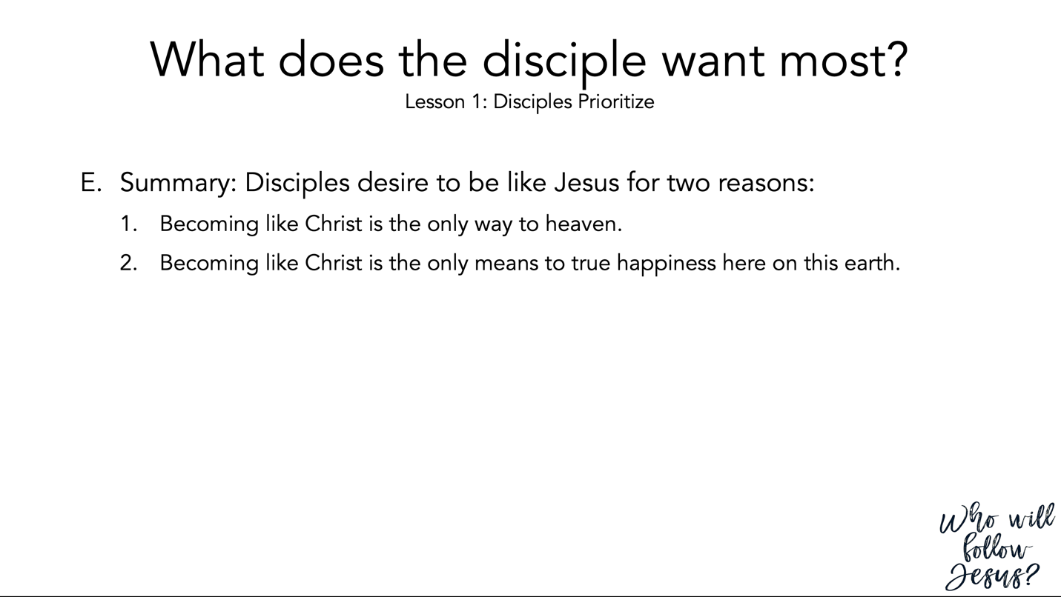

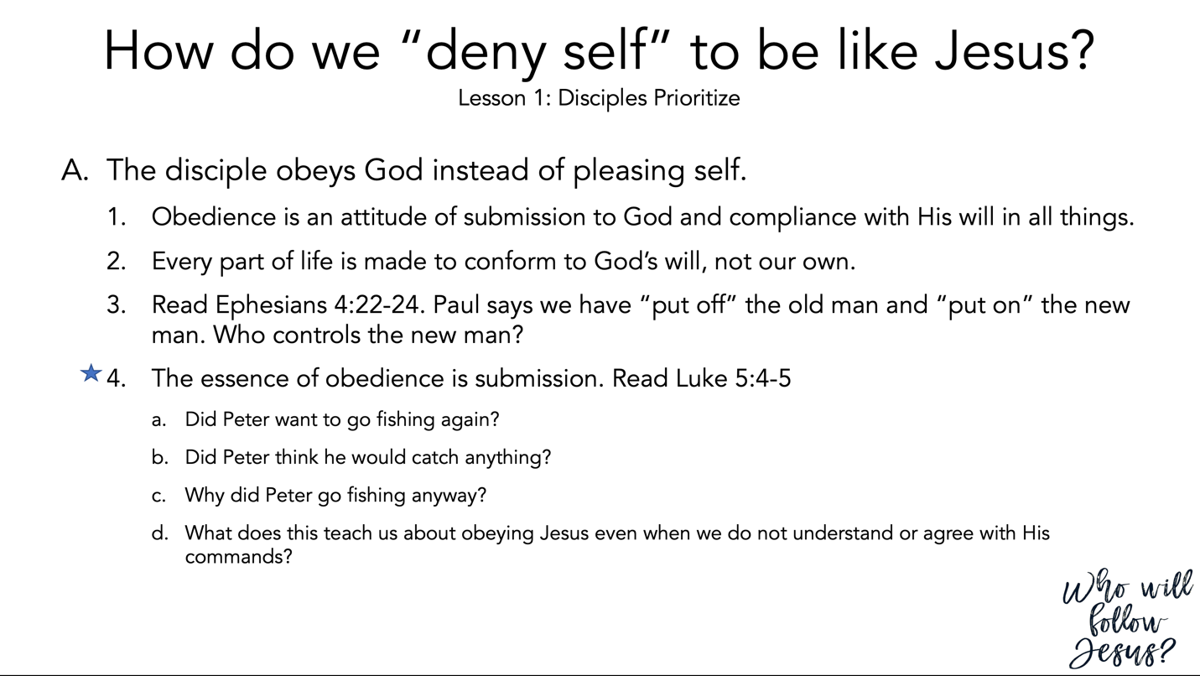

Ephesians 4:17–32 (NASB95) – The Christian’s Walk
¹⁷ So this I say, and affirm together with the Lord, that you walk no longer just as the Gentiles also walk, in the futility of their mind, ¹⁸ being darkened in their understanding, excluded from the life of God because of the ignorance that is in them, because of the hardness of their heart; ¹⁹ and they, having become callous, have given themselves over to sensuality for the practice of every kind of impurity with greediness. ²⁰ But you did not learn Christ in this way, ²¹ if indeed you have heard Him and have been taught in Him, just as truth is in Jesus, ²² that, in reference to your former manner of life, you lay aside the old self, which is being corrupted in accordance with the lusts of deceit, ²³ and that you be renewed in the spirit of your mind, ²⁴ and put on the new self, which in the likeness of God has been created in righteousness and holiness of the truth. ²⁵ Therefore, laying aside falsehood, speak truth each one of you with his neighbor, for we are members of one another. ²⁶ Be angry, and yet do not sin; do not let the sun go down on your anger, ²⁷ and do not give the devil an opportunity. ²⁸ He who steals must steal no longer; but rather he must labor, performing with his own hands what is good, so that he will have something to share with one who has need. ²⁹ Let no unwholesome word proceed from your mouth, but only such a word as is good for edification according to the need of the moment, so that it will give grace to those who hear. ³⁰ Do not grieve the Holy Spirit of God, by whom you were sealed for the day of redemption. ³¹ Let all bitterness and wrath and anger and clamor and slander be put away from you, along with all malice. ³² Be kind to one another, tender-hearted, forgiving each other, just as God in Christ also has forgiven you.

Luke 5:1–11 (NASB95) – The First Disciples
¹ Now it happened that while the crowd was pressing around Him and listening to the word of God, He was standing by the lake of Gennesaret; ² and He saw two boats lying at the edge of the lake; but the fishermen had gotten out of them and were washing their nets. ³ And He got into one of the boats, which was Simon’s, and asked him to put out a little way from the land. And He sat down and began teaching the people from the boat. ⁴ When He had finished speaking, He said to Simon, “Put out into the deep water and let down your nets for a catch.” ⁵ Simon answered and said, “Master, we worked hard all night and caught nothing, but I will do as You say and let down the nets.” ⁶ When they had done this, they enclosed a great quantity of fish, and their nets began to break; ⁷ so they signaled to their partners in the other boat for them to come and help them. And they came and filled both of the boats, so that they began to sink. ⁸ But when Simon Peter saw that, he fell down at Jesus’ feet, saying, “Go away from me Lord, for I am a sinful man!” ⁹ For amazement had seized him and all his companions because of the catch of fish which they had taken; ¹⁰ and so also were James and John, sons of Zebedee, who were partners with Simon. And Jesus said to Simon, “Do not fear, from now on you will be catching men.” ¹¹ When they had brought their boats to land, they left everything and followed Him.

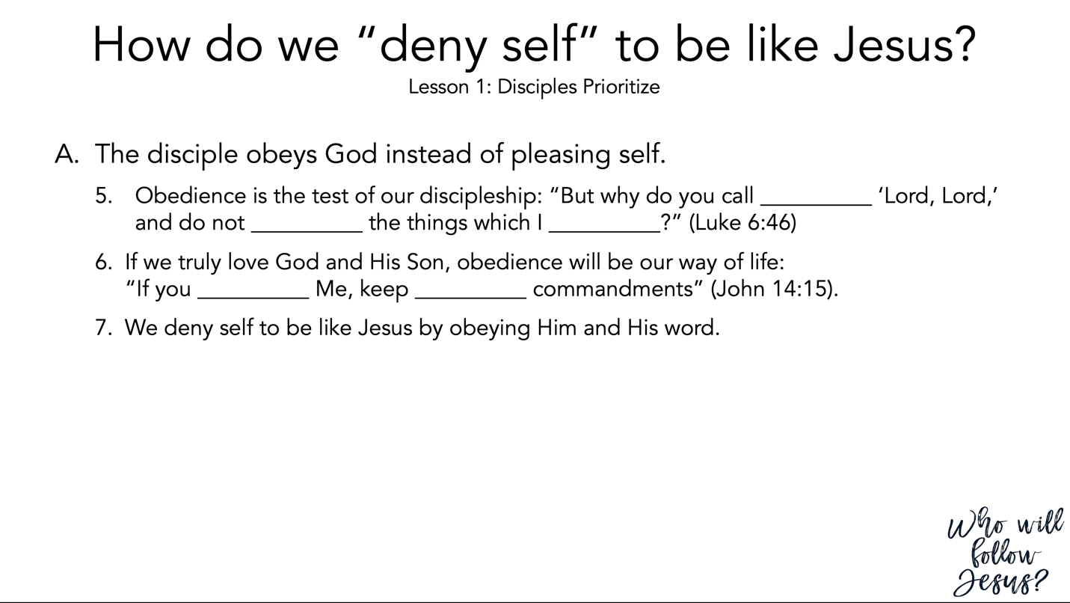

Luke 6:39–49 (NASB95)
³⁹ And He also spoke a parable to them: “A blind man cannot guide a blind man, can he? Will they not both fall into a pit? ⁴⁰ “A pupil is not above his teacher; but everyone, after he has been fully trained, will be like his teacher. ⁴¹ “Why do you look at the speck that is in your brother’s eye, but do not notice the log that is in your own eye? ⁴² “Or how can you say to your brother, ‘Brother, let me take out the speck that is in your eye,’ when you yourself do not see the log that is in your own eye? You hypocrite, first take the log out of your own eye, and then you will see clearly to take out the speck that is in your brother’s eye. ⁴³ “For there is no good tree which produces bad fruit, nor, on the other hand, a bad tree which produces good fruit. ⁴⁴ “For each tree is known by its own fruit. For men do not gather figs from thorns, nor do they pick grapes from a briar bush. ⁴⁵ “The good man out of the good treasure of his heart brings forth what is good; and the evil man out of the evil treasure brings forth what is evil; for his mouth speaks from that which fills his heart.

- Builders and Foundations
⁴⁶ “Why do you call Me, ‘Lord, Lord,’ and do not do what I say? ⁴⁷ “Everyone who comes to Me and hears My words and acts on them, I will show you whom he is like: ⁴⁸ he is like a man building a house, who dug deep and laid a foundation on the rock; and when a flood occurred, the torrent burst against that house and could not shake it, because it had been well built. ⁴⁹ “But the one who has heard and has not acted accordingly, is like a man who built a house on the ground without any foundation; and the torrent burst against it and immediately it collapsed, and the ruin of that house was great.”

John 14:1–15 (NASB95) – Jesus Comforts His Disciples
¹ “Do not let your heart be troubled; believe in God, believe also in Me. ² “In My Father’s house are many dwelling places; if it were not so, I would have told you; for I go to prepare a place for you. ³ “If I go and prepare a place for you, I will come again and receive you to Myself, that where I am, there you may be also. ⁴ “And you know the way where I am going.” ⁵ Thomas said to Him, “Lord, we do not know where You are going, how do we know the way?” ⁶ Jesus said to him, “I am the way, and the truth, and the life; no one comes to the Father but through Me.

- Oneness with the Father
⁷ “If you had known Me, you would have known My Father also; from now on you know Him, and have seen Him.” ⁸ Philip said to Him, “Lord, show us the Father, and it is enough for us.” ⁹ Jesus said to him, “Have I been so long with you, and yet you have not come to know Me, Philip? He who has seen Me has seen the Father; how can you say, ‘Show us the Father’? ¹⁰ “Do you not believe that I am in the Father, and the Father is in Me? The words that I say to you I do not speak on My own initiative, but the Father abiding in Me does His works. ¹¹ “Believe Me that I am in the Father and the Father is in Me; otherwise believe because of the works themselves. ¹² “Truly, truly, I say to you, he who believes in Me, the works that I do, he will do also; and greater works than these he will do; because I go to the Father. ¹³ “Whatever you ask in My name, that will I do, so that the Father may be glorified in the Son. ¹⁴ “If you ask Me anything in My name, I will do it. ¹⁵ “If you love Me, you will keep My commandments.

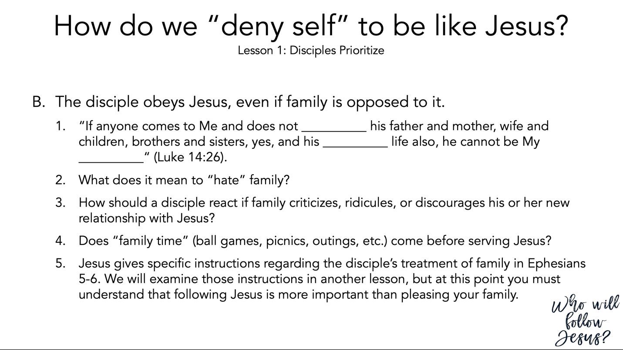

Luke 14:25–35 (NASB95) – Discipleship Tested
²⁵ Now large crowds were going along with Him; and He turned and said to them, ²⁶ “If anyone comes to Me, and does not hate his own father and mother and wife and children and brothers and sisters, yes, and even his own life, he cannot be My disciple. ²⁷ “Whoever does not carry his own cross and come after Me cannot be My disciple. ²⁸ “For which one of you, when he wants to build a tower, does not first sit down and calculate the cost to see if he has enough to complete it? ²⁹ “Otherwise, when he has laid a foundation and is not able to finish, all who observe it begin to ridicule him, ³⁰ saying, ‘This man began to build and was not able to finish.’ ³¹ “Or what king, when he sets out to meet another king in battle, will not first sit down and consider whether he is strong enough with ten thousand men to encounter the one coming against him with twenty thousand? ³² “Or else, while the other is still far away, he sends a delegation and asks for terms of peace. ³³ “So then, none of you can be My disciple who does not give up all his own possessions. ³⁴ “Therefore, salt is good; but if even salt has become tasteless, with what will it be seasoned? ³⁵ “It is useless either for the soil or for the manure pile; it is thrown out. He who has ears to hear, let him hear.”

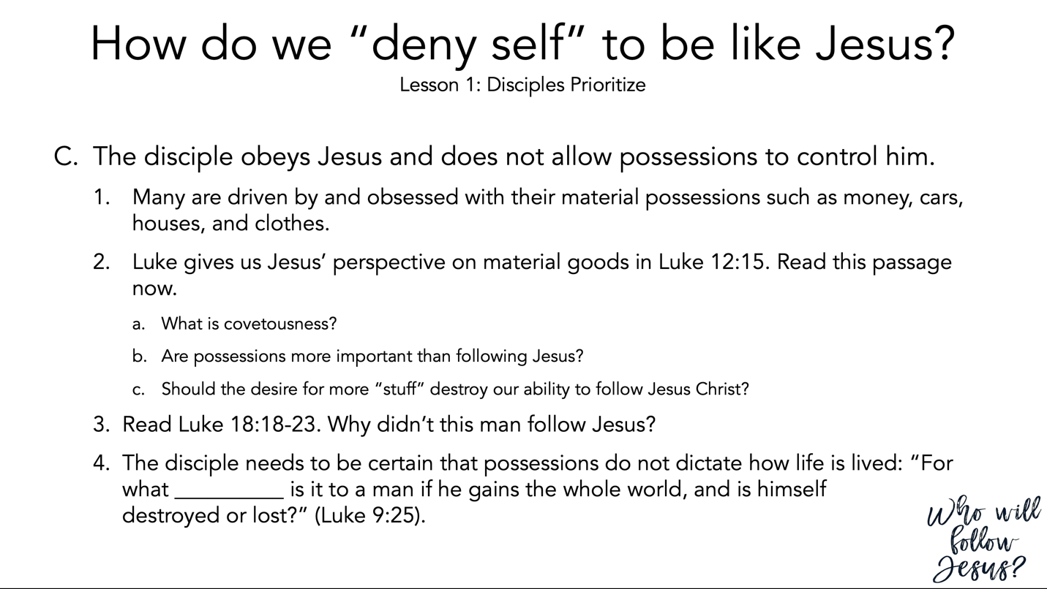

Luke 12:1–34 (NASB95) – God Knows and Cares
¹ Under these circumstances, after so many thousands of people had gathered together that they were stepping on one another, He began saying to His disciples first of all, “Beware of the leaven of the Pharisees, which is hypocrisy. ² “But there is nothing covered up that will not be revealed, and hidden that will not be known. ³ “Accordingly, whatever you have said in the dark will be heard in the light, and what you have whispered in the inner rooms will be proclaimed upon the housetops. ⁴ “I say to you, My friends, do not be afraid of those who kill the body and after that have no more that they can do. ⁵ “But I will warn you whom to fear: fear the One who, after He has killed, has authority to cast into hell; yes, I tell you, fear Him! ⁶ “Are not five sparrows sold for two cents? Yet not one of them is forgotten before God. ⁷ “Indeed, the very hairs of your head are all numbered. Do not fear; you are more valuable than many sparrows. ⁸ “And I say to you, everyone who confesses Me before men, the Son of Man will confess him also before the angels of God; ⁹ but he who denies Me before men will be denied before the angels of God. ¹⁰ “And everyone who speaks a word against the Son of Man, it will be forgiven him; but he who blasphemes against the Holy Spirit, it will not be forgiven him. ¹¹ “When they bring you before the synagogues and the rulers and the authorities, do not worry about how or what you are to speak in your defense, or what you are to say; ¹² for the Holy Spirit will teach you in that very hour what you ought to say.”

- Covetousness Denounced
¹³ Someone in the crowd said to Him, “Teacher, tell my brother to divide the family inheritance with me.” ¹⁴ But He said to him, “Man, who appointed Me a judge or arbitrator over you?” ¹⁵ Then He said to them, “Beware, and be on your guard against every form of greed; for not even when one has an abundance does his life consist of his possessions.” ¹⁶ And He told them a parable, saying, “The land of a rich man was very productive. ¹⁷ “And he began reasoning to himself, saying, ‘What shall I do, since I have no place to store my crops?’ ¹⁸ “Then he said, ‘This is what I will do: I will tear down my barns and build larger ones, and there I will store all my grain and my goods. ¹⁹ ‘And I will say to my soul, “Soul, you have many goods laid up for many years to come; take your ease, eat, drink and be merry.” ’ ²⁰ “But God said to him, ‘You fool! This very night your soul is required of you; and now who will own what you have prepared?’ ²¹ “So is the man who stores up treasure for himself, and is not rich toward God.” ²² And He said to His disciples, “For this reason I say to you, do not worry about your life, as to what you will eat; nor for your body, as to what you will put on. ²³ “For life is more than food, and the body more than clothing. ²⁴ “Consider the ravens, for they neither sow nor reap; they have no storeroom nor barn, and yet God feeds them; how much more valuable you are than the birds! ²⁵ “And which of you by worrying can add a single hour to his life’s span? ²⁶ “If then you cannot do even a very little thing, why do you worry about other matters? ²⁷ “Consider the lilies, how they grow: they neither toil nor spin; but I tell you, not even Solomon in all his glory clothed himself like one of these. ²⁸ “But if God so clothes the grass in the field, which is alive today and tomorrow is thrown into the furnace, how much more will He clothe you? You men of little faith! ²⁹ “And do not seek what you will eat and what you will drink, and do not keep worrying. ³⁰ “For all these things the nations of the world eagerly seek; but your Father knows that you need these things. ³¹ “But seek His kingdom, and these things will be added to you. ³² “Do not be afraid, little flock, for your Father has chosen gladly to give you the kingdom. ³³ “Sell your possessions and give to charity; make yourselves money belts which do not wear out, an unfailing treasure in heaven, where no thief comes near nor moth destroys. ³⁴ “For where your treasure is, there your heart will be also.

Luke 18:18–34 (NASB95) – The Rich Young Ruler
¹⁸ A ruler questioned Him, saying, “Good Teacher, what shall I do to inherit eternal life?” ¹⁹ And Jesus said to him, “Why do you call Me good? No one is good except God alone. ²⁰ “You know the commandments, ‘Do not commit adultery, Do not murder, Do not steal, Do not bear false witness, Honor your father and mother.’ ” ²¹ And he said, “All these things I have kept from my youth.” ²² When Jesus heard this, He said to him, “One thing you still lack; sell all that you possess and distribute it to the poor, and you shall have treasure in heaven; and come, follow Me.” ²³ But when he had heard these things, he became very sad, for he was extremely rich. ²⁴ And Jesus looked at him and said, “How hard it is for those who are wealthy to enter the kingdom of God! ²⁵ “For it is easier for a camel to go through the eye of a needle than for a rich man to enter the kingdom of God.” ²⁶ They who heard it said, “Then who can be saved?” ²⁷ But He said, “The things that are impossible with people are possible with God.” ²⁸ Peter said, “Behold, we have left our own homes and followed You.” ²⁹ And He said to them, “Truly I say to you, there is no one who has left house or wife or brothers or parents or children, for the sake of the kingdom of God, ³⁰ who will not receive many times as much at this time and in the age to come, eternal life.” ³¹ Then He took the twelve aside and said to them, “Behold, we are going up to Jerusalem, and all things which are written through the prophets about the Son of Man will be accomplished. ³² “For He will be handed over to the Gentiles, and will be mocked and mistreated and spit upon, ³³ and after they have scourged Him, they will kill Him; and the third day He will rise again.” ³⁴ But the disciples understood none of these things, and the meaning of this statement was hidden from them, and they did not comprehend the things that were said.

Luke 9:12–27 (NASB95) – Five Thousand Fed
¹² Now the day was ending, and the twelve came and said to Him, “Send the crowd away, that they may go into the surrounding villages and countryside and find lodging and get something to eat; for here we are in a desolate place.” ¹³ But He said to them, “You give them something to eat!” And they said, “We have no more than five loaves and two fish, unless perhaps we go and buy food for all these people.” ¹⁴ (For there were about five thousand men.) And He said to His disciples, “Have them sit down to eat in groups of about fifty each.” ¹⁵ They did so, and had them all sit down. ¹⁶ Then He took the five loaves and the two fish, and looking up to heaven, He blessed them, and broke them, and kept giving them to the disciples to set before the people. ¹⁷ And they all ate and were satisfied; and the broken pieces which they had left over were picked up, twelve baskets full. ¹⁸ And it happened that while He was praying alone, the disciples were with Him, and He questioned them, saying, “Who do the people say that I am?” ¹⁹ They answered and said, “John the Baptist, and others say Elijah; but others, that one of the prophets of old has risen again.” ²⁰ And He said to them, “But who do you say that I am?” And Peter answered and said, “The Christ of God.” ²¹ But He warned them and instructed them not to tell this to anyone, ²² saying, “The Son of Man must suffer many things and be rejected by the elders and chief priests and scribes, and be killed and be raised up on the third day.” ²³ And He was saying to them all, “If anyone wishes to come after Me, he must deny himself, and take up his cross daily and follow Me. ²⁴ “For whoever wishes to save his life will lose it, but whoever loses his life for My sake, he is the one who will save it. ²⁵ “For what is a man profited if he gains the whole world, and loses or forfeits himself? ²⁶ “For whoever is ashamed of Me and My words, the Son of Man will be ashamed of him when He comes in His glory, and the glory of the Father and of the holy angels. ²⁷ “But I say to you truthfully, there are some of those standing here who will not taste death until they see the kingdom of God.”

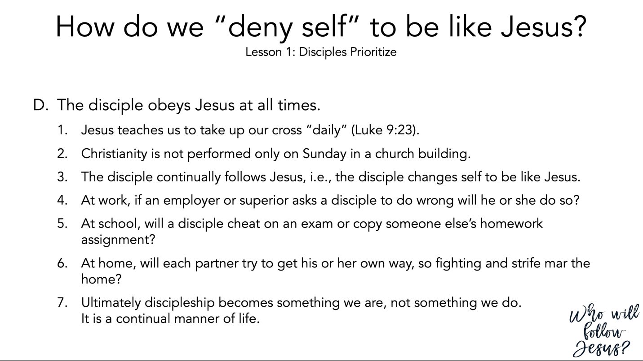

Luke 9:12–27 (NASB95) - Five Thousand Fed
¹² Now the day was ending, and the twelve came and said to Him, “Send the crowd away, that they may go into the surrounding villages and countryside and find lodging and get something to eat; for here we are in a desolate place.” ¹³ But He said to them, “You give them something to eat!” And they said, “We have no more than five loaves and two fish, unless perhaps we go and buy food for all these people.” ¹⁴ (For there were about five thousand men.) And He said to His disciples, “Have them sit down to eat in groups of about fifty each.” ¹⁵ They did so, and had them all sit down. ¹⁶ Then He took the five loaves and the two fish, and looking up to heaven, He blessed them, and broke them, and kept giving them to the disciples to set before the people. ¹⁷ And they all ate and were satisfied; and the broken pieces which they had left over were picked up, twelve baskets full. ¹⁸ And it happened that while He was praying alone, the disciples were with Him, and He questioned them, saying, “Who do the people say that I am?” ¹⁹ They answered and said, “John the Baptist, and others say Elijah; but others, that one of the prophets of old has risen again.” ²⁰ And He said to them, “But who do you say that I am?” And Peter answered and said, “The Christ of God.” ²¹ But He warned them and instructed them not to tell this to anyone, ²² saying, “The Son of Man must suffer many things and be rejected by the elders and chief priests and scribes, and be killed and be raised up on the third day.” ²³ And He was saying to them all, “If anyone wishes to come after Me, he must deny himself, and take up his cross daily and follow Me. ²⁴ “For whoever wishes to save his life will lose it, but whoever loses his life for My sake, he is the one who will save it. ²⁵ “For what is a man profited if he gains the whole world, and loses or forfeits himself? ²⁶ “For whoever is ashamed of Me and My words, the Son of Man will be ashamed of him when He comes in His glory, and the glory of the Father and of the holy angels. ²⁷ “But I say to you truthfully, there are some of those standing here who will not taste death until they see the kingdom of God.”

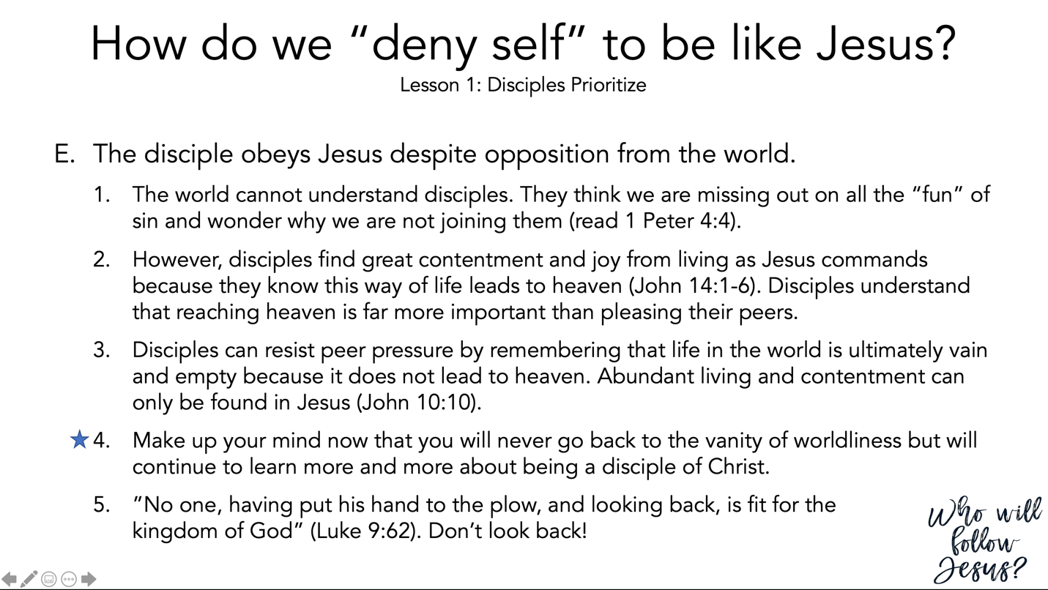

1 Peter 4:1–11 (NASB95) – Keep Fervent in Your Love
¹ Therefore, since Christ has suffered in the flesh, arm yourselves also with the same purpose, because he who has suffered in the flesh has ceased from sin, ² so as to live the rest of the time in the flesh no longer for the lusts of men, but for the will of God. ³ For the time already past is sufficient for you to have carried out the desire of the Gentiles, having pursued a course of sensuality, lusts, drunkenness, carousing, drinking parties and abominable idolatries. ⁴ In all this, they are surprised that you do not run with them into the same excesses of dissipation, and they malign you; ⁵ but they will give account to Him who is ready to judge the living and the dead. ⁶ For the gospel has for this purpose been preached even to those who are dead, that though they are judged in the flesh as men, they may live in the spirit according to the will of God. ⁷ The end of all things is near; therefore, be of sound judgment and sober spirit for the purpose of prayer. ⁸ Above all, keep fervent in your love for one another, because love covers a multitude of sins. ⁹ Be hospitable to one another without complaint. ¹⁰ As each one has received a special gift, employ it in serving one another as good stewards of the manifold grace of God. ¹¹ Whoever speaks, is to do so as one who is speaking the utterances of God; whoever serves is to do so as one who is serving by the strength which God supplies; so that in all things God may be glorified through Jesus Christ, to whom belongs the glory and dominion forever and ever. Amen.

John 14:1–6 (NASB95) – Jesus Comforts His Disciples
¹ “Do not let your heart be troubled; believe in God, believe also in Me. ² “In My Father’s house are many dwelling places; if it were not so, I would have told you; for I go to prepare a place for you. ³ “If I go and prepare a place for you, I will come again and receive you to Myself, that where I am, there you may be also. ⁴ “And you know the way where I am going.” ⁵ Thomas said to Him, “Lord, we do not know where You are going, how do we know the way?” ⁶ Jesus said to him, “I am the way, and the truth, and the life; no one comes to the Father but through Me.

John 10:1–21 (NASB95) – Parable of the Good Shepherd
¹ “Truly, truly, I say to you, he who does not enter by the door into the fold of the sheep, but climbs up some other way, he is a thief and a robber. ² “But he who enters by the door is a shepherd of the sheep. ³ “To him the doorkeeper opens, and the sheep hear his voice, and he calls his own sheep by name and leads them out. ⁴ “When he puts forth all his own, he goes ahead of them, and the sheep follow him because they know his voice. ⁵ “A stranger they simply will not follow, but will flee from him, because they do not know the voice of strangers.” ⁶ This figure of speech Jesus spoke to them, but they did not understand what those things were which He had been saying to them. ⁷ So Jesus said to them again, “Truly, truly, I say to you, I am the door of the sheep. ⁸ “All who came before Me are thieves and robbers, but the sheep did not hear them. ⁹ “I am the door; if anyone enters through Me, he will be saved, and will go in and out and find pasture. ¹⁰ “The thief comes only to steal and kill and destroy; I came that they may have life, and have it abundantly. ¹¹ “I am the good shepherd; the good shepherd lays down His life for the sheep. ¹² “He who is a hired hand, and not a shepherd, who is not the owner of the sheep, sees the wolf coming, and leaves the sheep and flees, and the wolf snatches them and scatters them. ¹³ “He flees because he is a hired hand and is not concerned about the sheep. ¹⁴ “I am the good shepherd, and I know My own and My own know Me, ¹⁵ even as the Father knows Me and I know the Father; and I lay down My life for the sheep. ¹⁶ “I have other sheep, which are not of this fold; I must bring them also, and they will hear My voice; and they will become one flock with one shepherd. ¹⁷ “For this reason the Father loves Me, because I lay down My life so that I may take it again. ¹⁸ “No one has taken it away from Me, but I lay it down on My own initiative. I have authority to lay it down, and I have authority to take it up again. This commandment I received from My Father.” ¹⁹ A division occurred again among the Jews because of these words. ²⁰ Many of them were saying, “He has a demon and is insane. Why do you listen to Him?” ²¹ Others were saying, “These are not the sayings of one demon-possessed. A demon cannot open the eyes of the blind, can he?”

Luke 9:57–62 (NASB95) – Exacting Discipleship
⁵⁷ As they were going along the road, someone said to Him, “I will follow You wherever You go.” ⁵⁸ And Jesus said to him, “The foxes have holes and the birds of the air have nests, but the Son of Man has nowhere to lay His head.” ⁵⁹ And He said to another, “Follow Me.” But he said, “Lord, permit me first to go and bury my father.” ⁶⁰ But He said to him, “Allow the dead to bury their own dead; but as for you, go and proclaim everywhere the kingdom of God.” ⁶¹ Another also said, “I will follow You, Lord; but first permit me to say good-bye to those at home.” ⁶² But Jesus said to him, “No one, after putting his hand to the plow and looking back, is fit for the kingdom of God.”

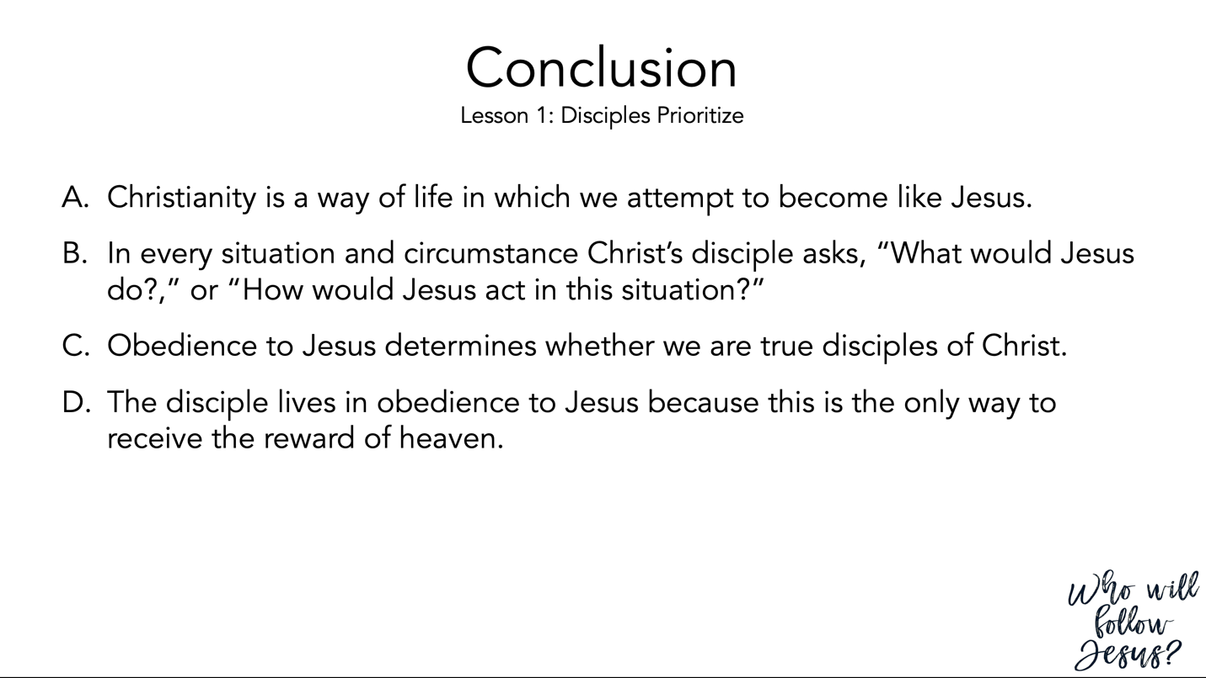

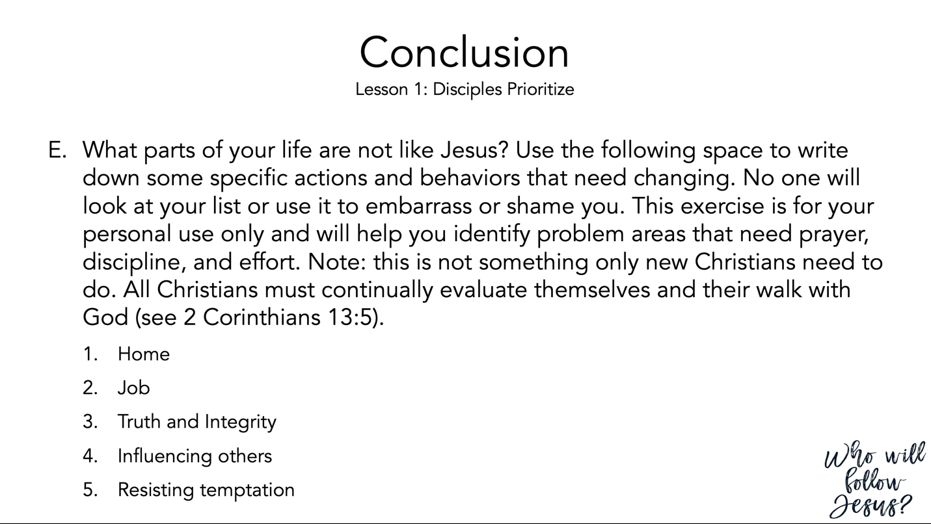

2 Corinthians 13 (NASB95) – Examine Yourselves
¹ This is the third time I am coming to you. Every fact is to be confirmed by the testimony of two or three witnesses. ² I have previously said when present the second time, and though now absent I say in advance to those who have sinned in the past and to all the rest as well, that if I come again I will not spare anyone, ³ since you are seeking for proof of the Christ who speaks in me, and who is not weak toward you, but mighty in you. ⁴ For indeed He was crucified because of weakness, yet He lives because of the power of God. For we also are weak in Him, yet we will live with Him because of the power of God directed toward you. ⁵ Test yourselves to see if you are in the faith; examine yourselves! Or do you not recognize this about yourselves, that Jesus Christ is in you—unless indeed you fail the test? ⁶ But I trust that you will realize that we ourselves do not fail the test. ⁷ Now we pray to God that you do no wrong; not that we ourselves may appear approved, but that you may do what is right, even though we may appear unapproved. ⁸ For we can do nothing against the truth, but only for the truth. ⁹ For we rejoice when we ourselves are weak but you are strong; this we also pray for, that you be made complete. ¹⁰ For this reason I am writing these things while absent, so that when present I need not use severity, in accordance with the authority which the Lord gave me for building up and not for tearing down. ¹¹ Finally, brethren, rejoice, be made complete, be comforted, be like-minded, live in peace; and the God of love and peace will be with you. ¹² Greet one another with a holy kiss. ¹³ All the saints greet you. ¹⁴ The grace of the Lord Jesus Christ, and the love of God, and the fellowship of the Holy Spirit, be with you all.

