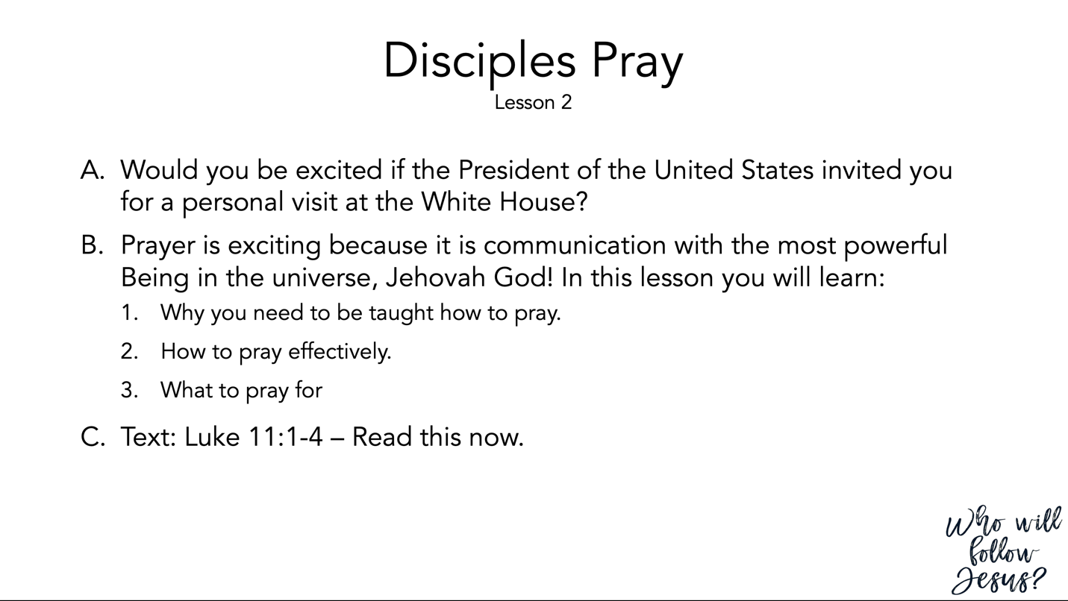

Luke 11:1–13 (NASB95) – Instruction about Prayer
¹ It happened that while Jesus was praying in a certain place, after He had finished, one of His disciples said to Him, “Lord, teach us to pray just as John also taught his disciples.” ² And He said to them, “When you pray, say: ‘Father, hallowed be Your name. Your kingdom come. ³ ‘Give us each day our daily bread. ⁴ ‘And forgive us our sins, For we ourselves also forgive everyone who is indebted to us. And lead us not into temptation.’ ” ⁵ Then He said to them, “Suppose one of you has a friend, and goes to him at midnight and says to him, ‘Friend, lend me three loaves; ⁶ for a friend of mine has come to me from a journey, and I have nothing to set before him’; ⁷ and from inside he answers and says, ‘Do not bother me; the door has already been shut and my children and I are in bed; I cannot get up and give you anything.’ ⁸ “I tell you, even though he will not get up and give him anything because he is his friend, yet because of his persistence he will get up and give him as much as he needs. ⁹ “So I say to you, ask, and it will be given to you; seek, and you will find; knock, and it will be opened to you. ¹⁰ “For everyone who asks, receives; and he who seeks, finds; and to him who knocks, it will be opened. ¹¹ “Now suppose one of you fathers is asked by his son for a fish; he will not give him a snake instead of a fish, will he? ¹² “Or if he is asked for an egg, he will not give him a scorpion, will he? ¹³ “If you then, being evil, know how to give good gifts to your children, how much more will your heavenly Father give the Holy Spirit to those who ask Him?”

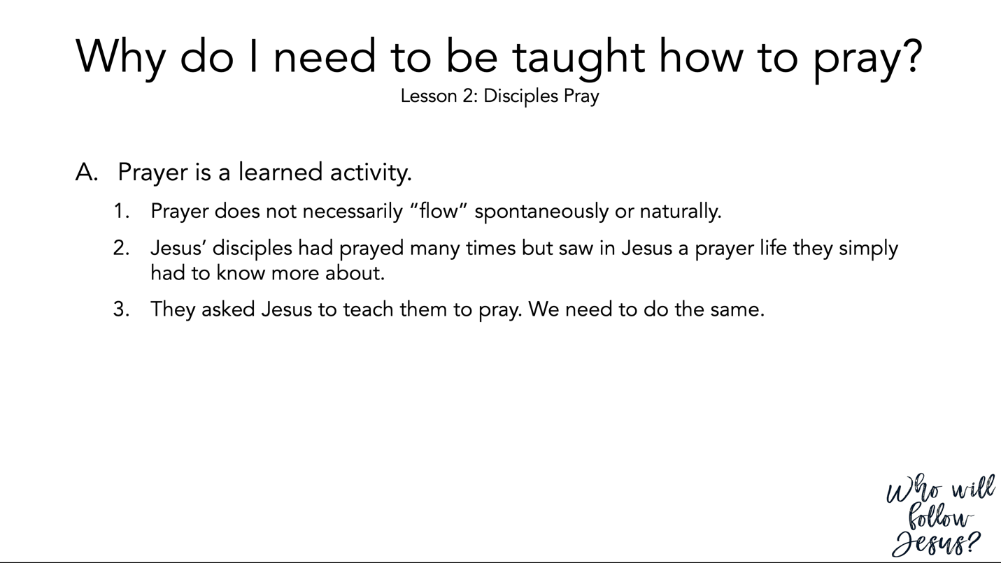

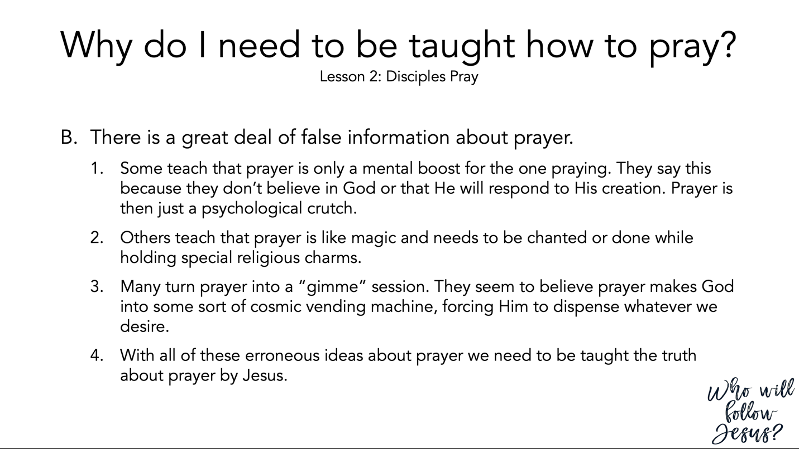

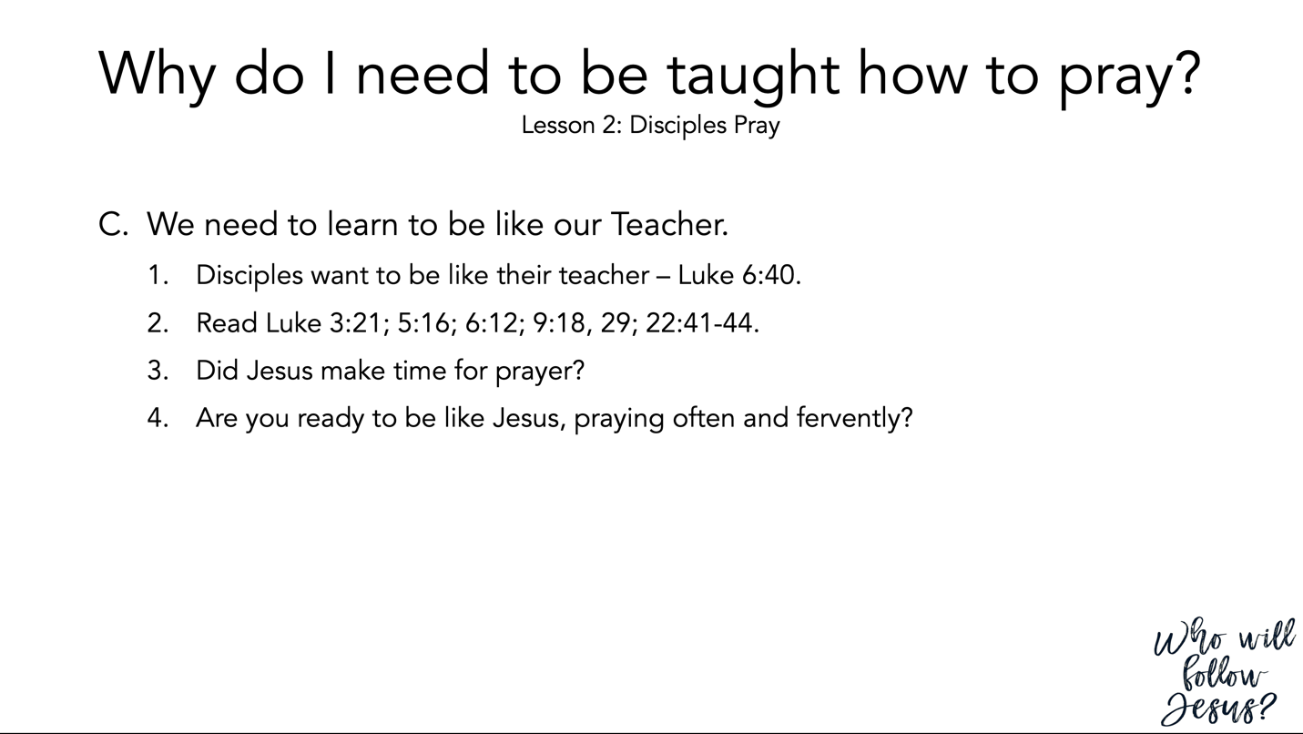

Luke 6:39–45 (NASB95) – The Sermon on the Plain – Parable of the Blind Leading the Blind
³⁹ And He also spoke a parable to them: “A blind man cannot guide a blind man, can he? Will they not both fall into a pit? ⁴⁰ “A pupil is not above his teacher; but everyone, after he has been fully trained, will be like his teacher. ⁴¹ “Why do you look at the speck that is in your brother’s eye, but do not notice the log that is in your own eye? ⁴² “Or how can you say to your brother, ‘Brother, let me take out the speck that is in your eye,’ when you yourself do not see the log that is in your own eye? You hypocrite, first take the log out of your own eye, and then you will see clearly to take out the speck that is in your brother’s eye. ⁴³ “For there is no good tree which produces bad fruit, nor, on the other hand, a bad tree which produces good fruit. ⁴⁴ “For each tree is known by its own fruit. For men do not gather figs from thorns, nor do they pick grapes from a briar bush. ⁴⁵ “The good man out of the good treasure of his heart brings forth what is good; and the evil man out of the evil treasure brings forth what is evil; for his mouth speaks from that which fills his heart.

Luke 3:21–22 (NASB95) – Jesus is Baptized
²¹ Now when all the people were baptized, Jesus was also baptized, and while He was praying, heaven was opened, ²² and the Holy Spirit descended upon Him in bodily form like a dove, and a voice came out of heaven, “You are My beloved Son, in You I am well-pleased.”

Luke 5:12–16 (NASB95) – The Leper
¹² While He was in one of the cities, behold, there was a man covered with leprosy; and when he saw Jesus, he fell on his face and implored Him, saying, “Lord, if You are willing, You can make me clean.” ¹³ And He stretched out His hand and touched him, saying, “I am willing; be cleansed.” And immediately the leprosy left him. ¹⁴ And He ordered him to tell no one, “But go and show yourself to the priest and make an offering for your cleansing, just as Moses commanded, as a testimony to them.” ¹⁵ But the news about Him was spreading even farther, and large crowds were gathering to hear Him and to be healed of their sicknesses. ¹⁶ But Jesus Himself would often slip away to the wilderness and pray.

Luke 6:12–19 (NASB95) – Choosing of the Twelve
¹² It was at this time that He went off to the mountain to pray, and He spent the whole night in prayer to God. ¹³ And when day came, He called His disciples to Him and chose twelve of them, whom He also named as apostles: ¹⁴ Simon, whom He also named Peter, and Andrew his brother; and James and John; and Philip and Bartholomew; ¹⁵ and Matthew and Thomas; James the son of Alphaeus, and Simon who was called the Zealot; ¹⁶ Judas the son of James, and Judas Iscariot, who became a traitor. ¹⁷ Jesus came down with them and stood on a level place; and there was a large crowd of His disciples, and a great throng of people from all Judea and Jerusalem and the coastal region of Tyre and Sidon, ¹⁸ who had come to hear Him and to be healed of their diseases; and those who were troubled with unclean spirits were being cured. ¹⁹ And all the people were trying to touch Him, for power was coming from Him and healing them all.

Luke 9:12–45 (NASB95)
- Five Thousand Fed
¹² Now the day was ending, and the twelve came and said to Him, “Send the crowd away, that they may go into the surrounding villages and countryside and find lodging and get something to eat; for here we are in a desolate place.” ¹³ But He said to them, “You give them something to eat!” And they said, “We have no more than five loaves and two fish, unless perhaps we go and buy food for all these people.” ¹⁴ (For there were about five thousand men.) And He said to His disciples, “Have them sit down to eat in groups of about fifty each.” ¹⁵ They did so, and had them all sit down. ¹⁶ Then He took the five loaves and the two fish, and looking up to heaven, He blessed them, and broke them, and kept giving them to the disciples to set before the people. ¹⁷ And they all ate and were satisfied; and the broken pieces which they had left over were picked up, twelve baskets full. ¹⁸ And it happened that while He was praying alone, the disciples were with Him, and He questioned them, saying, “Who do the people say that I am?” ¹⁹ They answered and said, “John the Baptist, and others say Elijah; but others, that one of the prophets of old has risen again.” ²⁰ And He said to them, “But who do you say that I am?” And Peter answered and said, “The Christ of God.” ²¹ But He warned them and instructed them not to tell this to anyone, ²² saying, “The Son of Man must suffer many things and be rejected by the elders and chief priests and scribes, and be killed and be raised up on the third day.” ²³ And He was saying to them all, “If anyone wishes to come after Me, he must deny himself, and take up his cross daily and follow Me. ²⁴ “For whoever wishes to save his life will lose it, but whoever loses his life for My sake, he is the one who will save it. ²⁵ “For what is a man profited if he gains the whole world, and loses or forfeits himself? ²⁶ “For whoever is ashamed of Me and My words, the Son of Man will be ashamed of him when He comes in His glory, and the glory of the Father and of the holy angels. ²⁷ “But I say to you truthfully, there are some of those standing here who will not taste death until they see the kingdom of God.”

- The Transfiguration
²⁸ Some eight days after these sayings, He took along Peter and John and James, and went up on the mountain to pray. ²⁹ And while He was praying, the appearance of His face became different, and His clothing became white and gleaming. ³⁰ And behold, two men were talking with Him; and they were Moses and Elijah, ³¹ who, appearing in glory, were speaking of His departure which He was about to accomplish at Jerusalem. ³² Now Peter and his companions had been overcome with sleep; but when they were fully awake, they saw His glory and the two men standing with Him. ³³ And as these were leaving Him, Peter said to Jesus, “Master, it is good for us to be here; let us make three tabernacles: one for You, and one for Moses, and one for Elijah”—not realizing what he was saying. ³⁴ While he was saying this, a cloud formed and began to overshadow them; and they were afraid as they entered the cloud. ³⁵ Then a voice came out of the cloud, saying, “This is My Son, My Chosen One; listen to Him!” ³⁶ And when the voice had spoken, Jesus was found alone. And they kept silent, and reported to no one in those days any of the things which they had seen. ³⁷ On the next day, when they came down from the mountain, a large crowd met Him. ³⁸ And a man from the crowd shouted, saying, “Teacher, I beg You to look at my son, for he is my only boy, ³⁹ and a spirit seizes him, and he suddenly screams, and it throws him into a convulsion with foaming at the mouth; and only with difficulty does it leave him, mauling him as it leaves. ⁴⁰ “I begged Your disciples to cast it out, and they could not.” ⁴¹ And Jesus answered and said, “You unbelieving and perverted generation, how long shall I be with you and put up with you? Bring your son here.” ⁴² While he was still approaching, the demon slammed him to the ground and threw him into a convulsion. But Jesus rebuked the unclean spirit, and healed the boy and gave him back to his father. ⁴³ And they were all amazed at the greatness of God. But while everyone was marveling at all that He was doing, He said to His disciples, ⁴⁴ “Let these words sink into your ears; for the Son of Man is going to be delivered into the hands of men.” ⁴⁵ But they did not understand this statement, and it was concealed from them so that they would not perceive it; and they were afraid to ask Him about this statement.

Luke 22:39–46 (NASB95) – The Garden of Gethsemane
³⁹ And He came out and proceeded as was His custom to the Mount of Olives; and the disciples also followed Him. ⁴⁰ When He arrived at the place, He said to them, “Pray that you may not enter into temptation.” ⁴¹ And He withdrew from them about a stone’s throw, and He knelt down and began to pray, ⁴² saying, “Father, if You are willing, remove this cup from Me; yet not My will, but Yours be done.” ⁴³ Now an angel from heaven appeared to Him, strengthening Him. ⁴⁴ And being in agony He was praying very fervently; and His sweat became like drops of blood, falling down upon the ground. ⁴⁵ When He rose from prayer, He came to the disciples and found them sleeping from sorrow, ⁴⁶ and said to them, “Why are you sleeping? Get up and pray that you may not enter into temptation.”

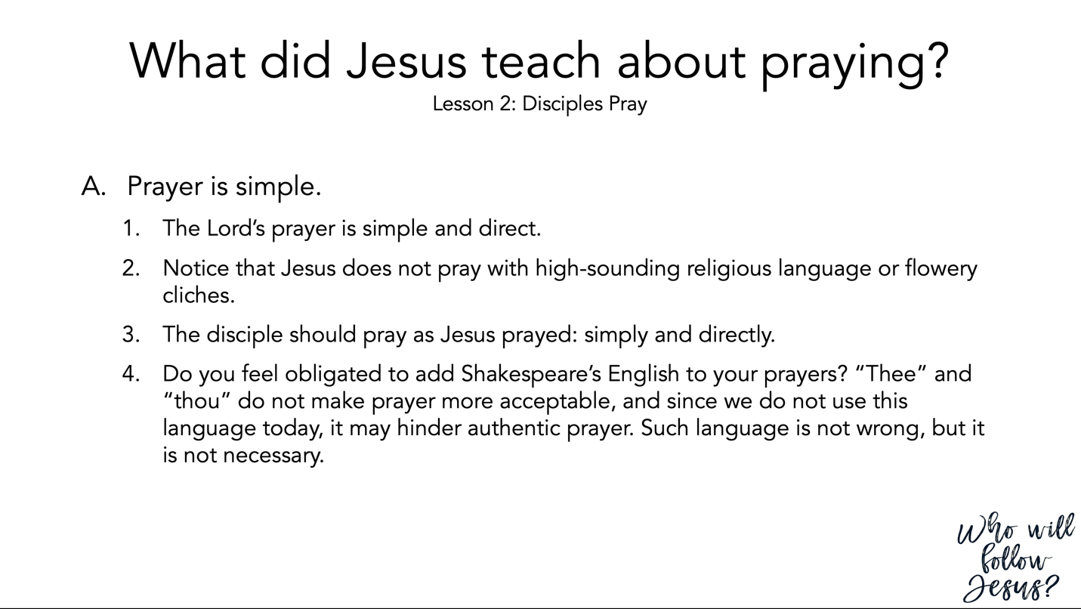

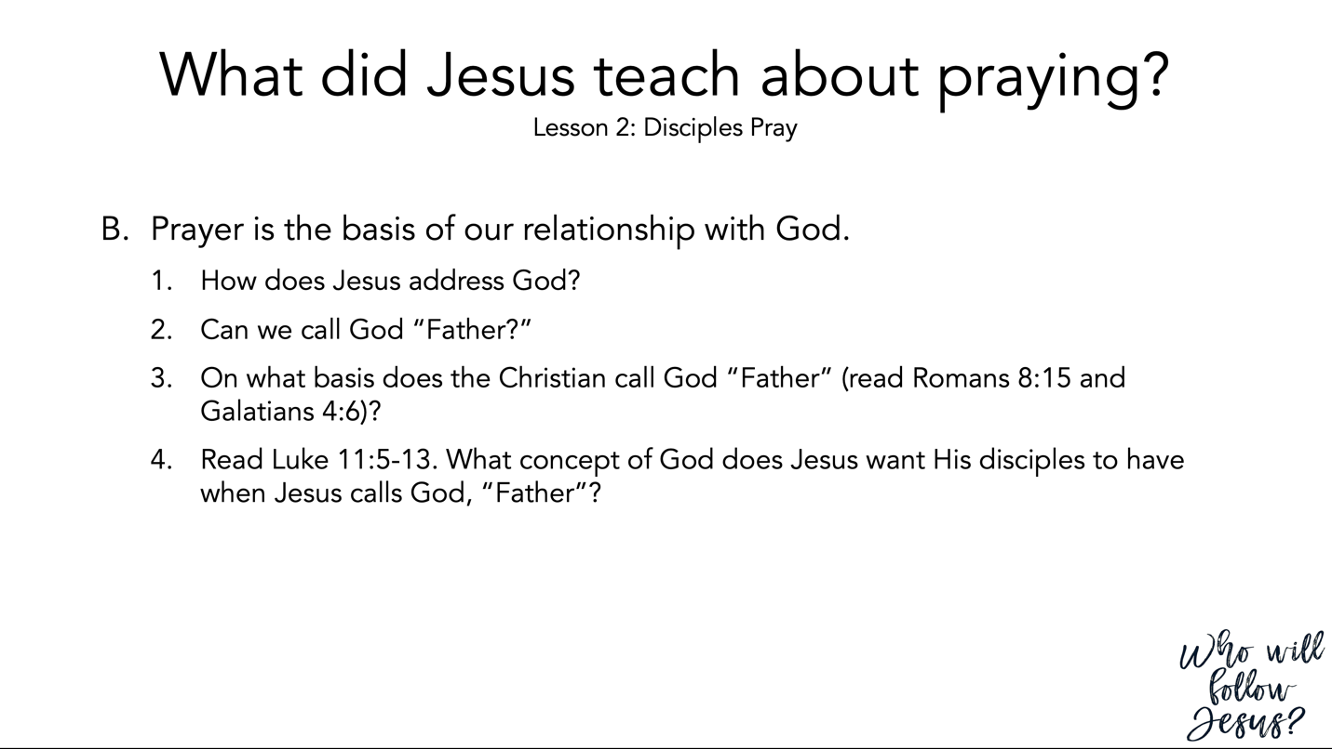

Romans 8:12–17 (NASB95) – Sonship is Realized Through the Same Spirit
¹² So then, brethren, we are under obligation, not to the flesh, to live according to the flesh— ¹³ for if you are living according to the flesh, you must die; but if by the Spirit you are putting to death the deeds of the body, you will live. ¹⁴ For all who are being led by the Spirit of God, these are sons of God. ¹⁵ For you have not received a spirit of slavery leading to fear again, but you have received a spirit of adoption as sons by which we cry out, “Abba! Father!” ¹⁶ The Spirit Himself testifies with our spirit that we are children of God, ¹⁷ and if children, heirs also, heirs of God and fellow heirs with Christ, if indeed we suffer with Him so that we may also be glorified with Him.

Galatians 4:1–7 (NASB95) – Sons versus Slaves
¹ Now I say, as long as the heir is a child, he does not differ at all from a slave although he is owner of everything, ² but he is under guardians and managers until the date set by the father. ³ So also we, while we were children, were held in bondage under the elemental things of the world. ⁴ But when the fullness of the time came, God sent forth His Son, born of a woman, born under the Law, ⁵ so that He might redeem those who were under the Law, that we might receive the adoption as sons. ⁶ Because you are sons, God has sent forth the Spirit of His Son into our hearts, crying, “Abba! Father!” ⁷ Therefore you are no longer a slave, but a son; and if a son, then an heir through God.

Luke 11:1–13 (NASB95) – Instruction about Prayer
¹ It happened that while Jesus was praying in a certain place, after He had finished, one of His disciples said to Him, “Lord, teach us to pray just as John also taught his disciples.” ² And He said to them, “When you pray, say: ‘Father, hallowed be Your name. Your kingdom come. ³ ‘Give us each day our daily bread. ⁴ ‘And forgive us our sins, For we ourselves also forgive everyone who is indebted to us. And lead us not into temptation.’ ” ⁵ Then He said to them, “Suppose one of you has a friend, and goes to him at midnight and says to him, ‘Friend, lend me three loaves; ⁶ for a friend of mine has come to me from a journey, and I have nothing to set before him’; ⁷ and from inside he answers and says, ‘Do not bother me; the door has already been shut and my children and I are in bed; I cannot get up and give you anything.’ ⁸ “I tell you, even though he will not get up and give him anything because he is his friend, yet because of his persistence he will get up and give him as much as he needs. ⁹ “So I say to you, ask, and it will be given to you; seek, and you will find; knock, and it will be opened to you. ¹⁰ “For everyone who asks, receives; and he who seeks, finds; and to him who knocks, it will be opened. ¹¹ “Now suppose one of you fathers is asked by his son for a fish; he will not give him a snake instead of a fish, will he? ¹² “Or if he is asked for an egg, he will not give him a scorpion, will he? ¹³ “If you then, being evil, know how to give good gifts to your children, how much more will your heavenly Father give the Holy Spirit to those who ask Him?”

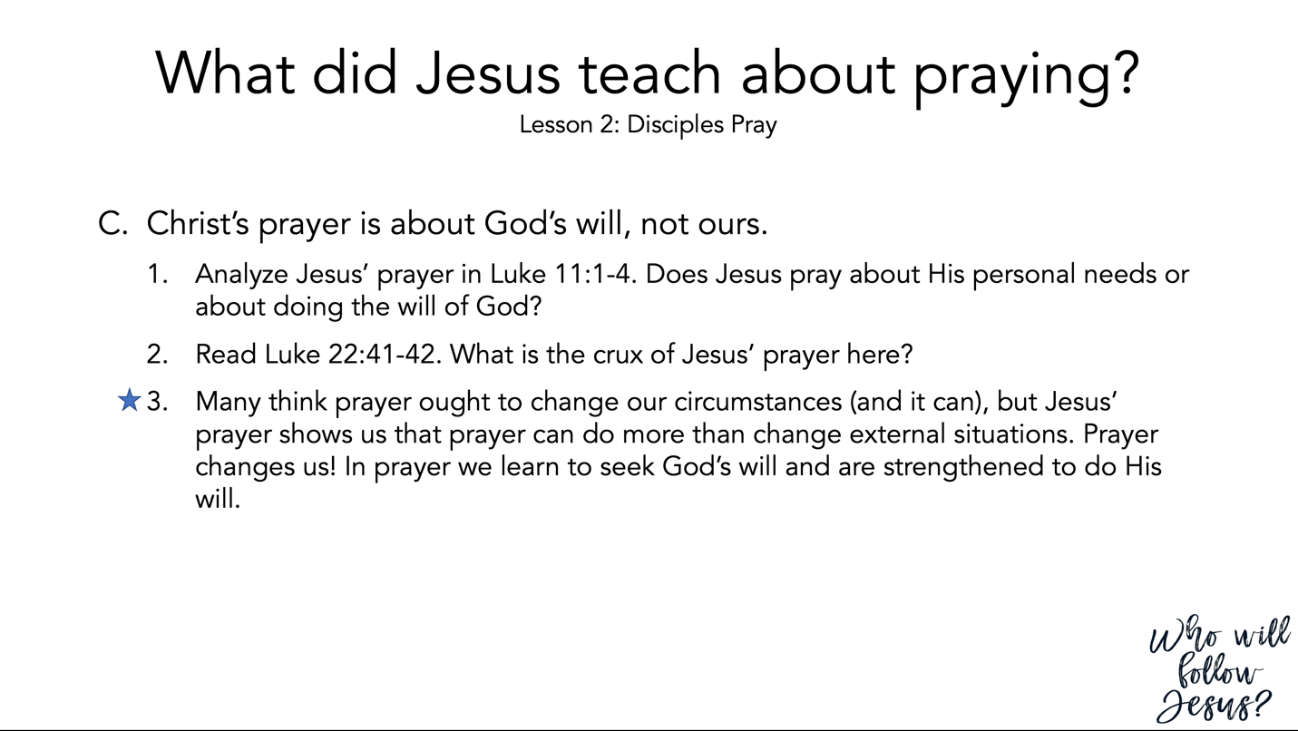

Luke 11:1–13 (NASB95) – Instruction about Prayer
¹ It happened that while Jesus was praying in a certain place, after He had finished, one of His disciples said to Him, “Lord, teach us to pray just as John also taught his disciples.” ² And He said to them, “When you pray, say: ‘Father, hallowed be Your name. Your kingdom come. ³ ‘Give us each day our daily bread. ⁴ ‘And forgive us our sins, For we ourselves also forgive everyone who is indebted to us. And lead us not into temptation.’ ” ⁵ Then He said to them, “Suppose one of you has a friend, and goes to him at midnight and says to him, ‘Friend, lend me three loaves; ⁶ for a friend of mine has come to me from a journey, and I have nothing to set before him’; ⁷ and from inside he answers and says, ‘Do not bother me; the door has already been shut and my children and I are in bed; I cannot get up and give you anything.’ ⁸ “I tell you, even though he will not get up and give him anything because he is his friend, yet because of his persistence he will get up and give him as much as he needs. ⁹ “So I say to you, ask, and it will be given to you; seek, and you will find; knock, and it will be opened to you. ¹⁰ “For everyone who asks, receives; and he who seeks, finds; and to him who knocks, it will be opened. ¹¹ “Now suppose one of you fathers is asked by his son for a fish; he will not give him a snake instead of a fish, will he? ¹² “Or if he is asked for an egg, he will not give him a scorpion, will he? ¹³ “If you then, being evil, know how to give good gifts to your children, how much more will your heavenly Father give the Holy Spirit to those who ask Him?”

Luke 22:39–46 (NASB95) – The Garden of Gethsemane
³⁹ And He came out and proceeded as was His custom to the Mount of Olives; and the disciples also followed Him. ⁴⁰ When He arrived at the place, He said to them, “Pray that you may not enter into temptation.” ⁴¹ And He withdrew from them about a stone’s throw, and He knelt down and began to pray, ⁴² saying, “Father, if You are willing, remove this cup from Me; yet not My will, but Yours be done.” ⁴³ Now an angel from heaven appeared to Him, strengthening Him. ⁴⁴ And being in agony He was praying very fervently; and His sweat became like drops of blood, falling down upon the ground. ⁴⁵ When He rose from prayer, He came to the disciples and found them sleeping from sorrow, ⁴⁶ and said to them, “Why are you sleeping? Get up and pray that you may not enter into temptation.”

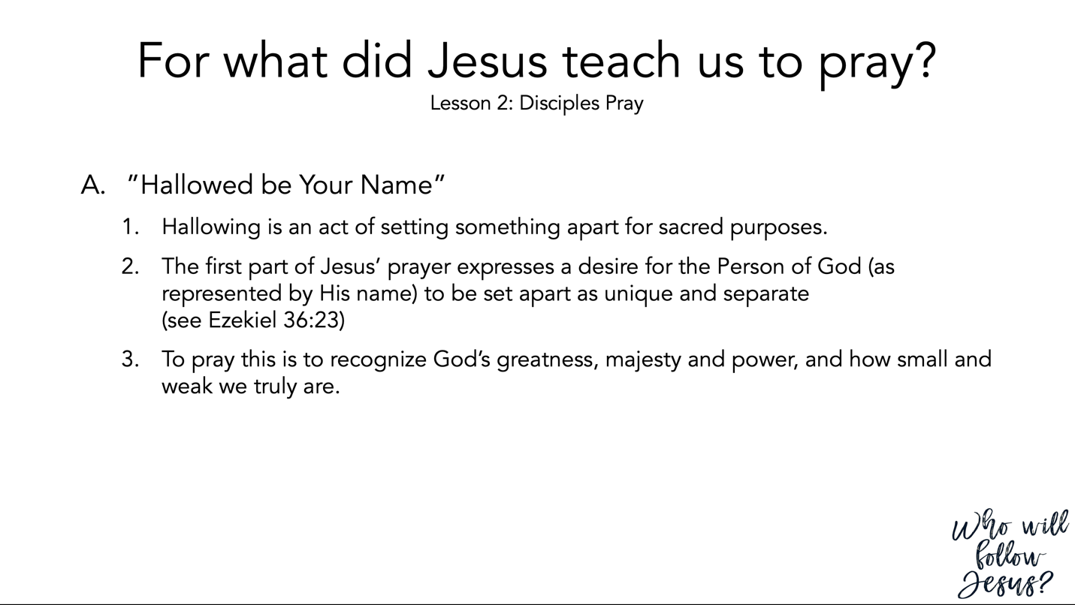

Ezekiel 36:22–32 (NASB95) – The Coming Renewal of Israel
²² “Therefore say to the house of Israel, ‘Thus says the Lord God, “It is not for your sake, O house of Israel, that I am about to act, but for My holy name, which you have profaned among the nations where you went. ²³ “I will vindicate the holiness of My great name which has been profaned among the nations, which you have profaned in their midst. Then the nations will know that I am the Lord,” declares the Lord God, “when I prove Myself holy among you in their sight. ²⁴ “For I will take you from the nations, gather you from all the lands and bring you into your own land. ²⁵ “Then I will sprinkle clean water on you, and you will be clean; I will cleanse you from all your filthiness and from all your idols. ²⁶ “Moreover, I will give you a new heart and put a new spirit within you; and I will remove the heart of stone from your flesh and give you a heart of flesh. ²⁷ “I will put My Spirit within you and cause you to walk in My statutes, and you will be careful to observe My ordinances. ²⁸ “You will live in the land that I gave to your forefathers; so you will be My people, and I will be your God. ²⁹ “Moreover, I will save you from all your uncleanness; and I will call for the grain and multiply it, and I will not bring a famine on you. ³⁰ “I will multiply the fruit of the tree and the produce of the field, so that you will not receive again the disgrace of famine among the nations. ³¹ “Then you will remember your evil ways and your deeds that were not good, and you will loathe yourselves in your own sight for your iniquities and your abominations. ³² “I am not doing this for your sake,” declares the Lord God, “let it be known to you. Be ashamed and confounded for your ways, O house of Israel!”

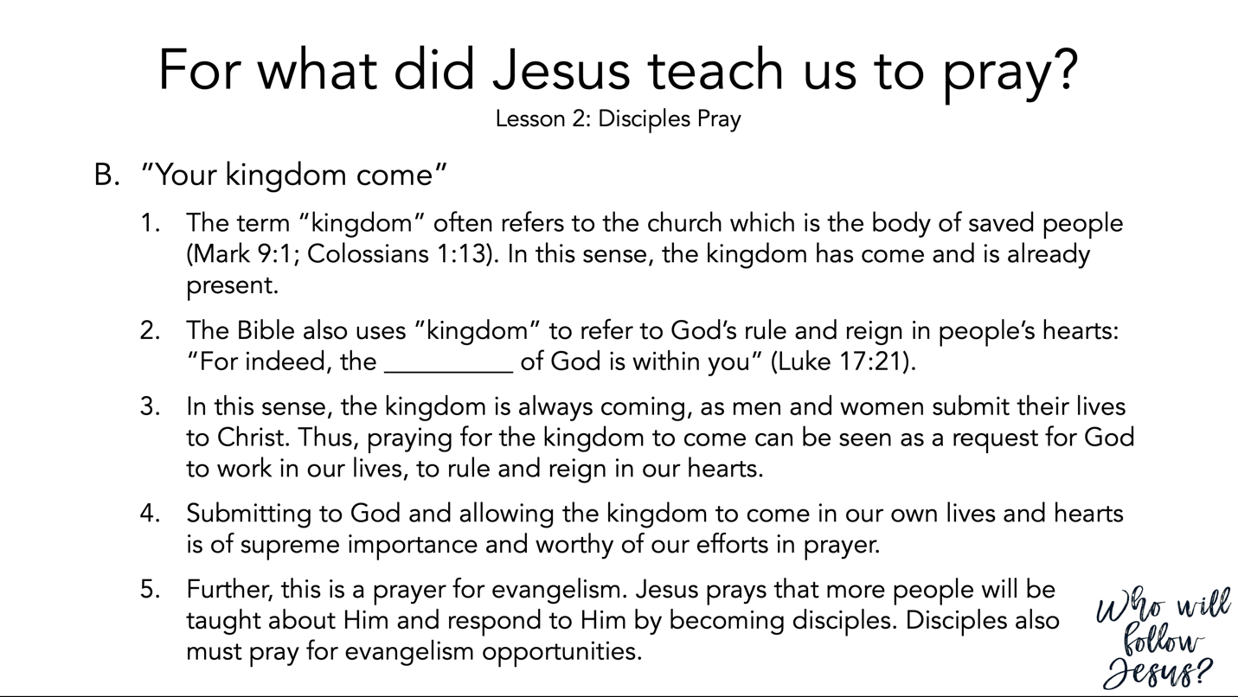

Mark 9:1–13 (NASB95) – The Transfiguration
¹ And Jesus was saying to them, “Truly I say to you, there are some of those who are standing here who will not taste death until they see the kingdom of God after it has come with power.” ² Six days later, Jesus took with Him Peter and James and John, and brought them up on a high mountain by themselves. And He was transfigured before them; ³ and His garments became radiant and exceedingly white, as no launderer on earth can whiten them. ⁴ Elijah appeared to them along with Moses; and they were talking with Jesus. ⁵ Peter said to Jesus, “Rabbi, it is good for us to be here; let us make three tabernacles, one for You, and one for Moses, and one for Elijah.” ⁶ For he did not know what to answer; for they became terrified. ⁷ Then a cloud formed, overshadowing them, and a voice came out of the cloud, “This is My beloved Son, listen to Him!” ⁸ All at once they looked around and saw no one with them anymore, except Jesus alone. ⁹ As they were coming down from the mountain, He gave them orders not to relate to anyone what they had seen, until the Son of Man rose from the dead. ¹⁰ They seized upon that statement, discussing with one another what rising from the dead meant. ¹¹ They asked Him, saying, “Why is it that the scribes say that Elijah must come first?” ¹² And He said to them, “Elijah does first come and restore all things. And yet how is it written of the Son of Man that He will suffer many things and be treated with contempt? ¹³ “But I say to you that Elijah has indeed come, and they did to him whatever they wished, just as it is written of him.”

Colossians 1:9–14 (NASB95) – Prayer for Spiritual Growth
⁹ For this reason also, since the day we heard of it, we have not ceased to pray for you and to ask that you may be filled with the knowledge of His will in all spiritual wisdom and understanding, ¹⁰ so that you will walk in a manner worthy of the Lord, to please Him in all respects, bearing fruit in every good work and increasing in the knowledge of God; ¹¹ strengthened with all power, according to His glorious might, for the attaining of all steadfastness and patience; joyously ¹² giving thanks to the Father, who has qualified us to share in the inheritance of the saints in Light. ¹³ For He rescued us from the domain of darkness, and transferred us to the kingdom of His beloved Son, ¹⁴ in whom we have redemption, the forgiveness of sins.

Luke 17:11–21 (NASB95) – Ten Lepers Cleansed
¹¹ While He was on the way to Jerusalem, He was passing between Samaria and Galilee. ¹² As He entered a village, ten leprous men who stood at a distance met Him; ¹³ and they raised their voices, saying, “Jesus, Master, have mercy on us!” ¹⁴ When He saw them, He said to them, “Go and show yourselves to the priests.” And as they were going, they were cleansed. ¹⁵ Now one of them, when he saw that he had been healed, turned back, glorifying God with a loud voice, ¹⁶ and he fell on his face at His feet, giving thanks to Him. And he was a Samaritan. ¹⁷ Then Jesus answered and said, “Were there not ten cleansed? But the nine—where are they? ¹⁸ “Was no one found who returned to give glory to God, except this foreigner?” ¹⁹ And He said to him, “Stand up and go; your faith has made you well.” ²⁰ Now having been questioned by the Pharisees as to when the kingdom of God was coming, He answered them and said, “The kingdom of God is not coming with signs to be observed; ²¹ nor will they say, ‘Look, here it is!’ or, ‘There it is!’ For behold, the kingdom of God is in your midst.”

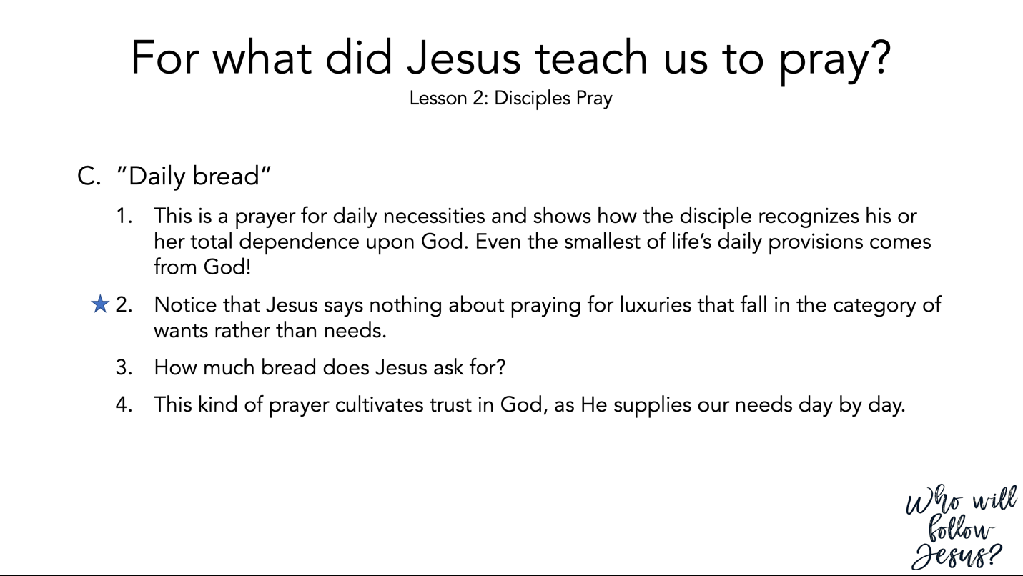

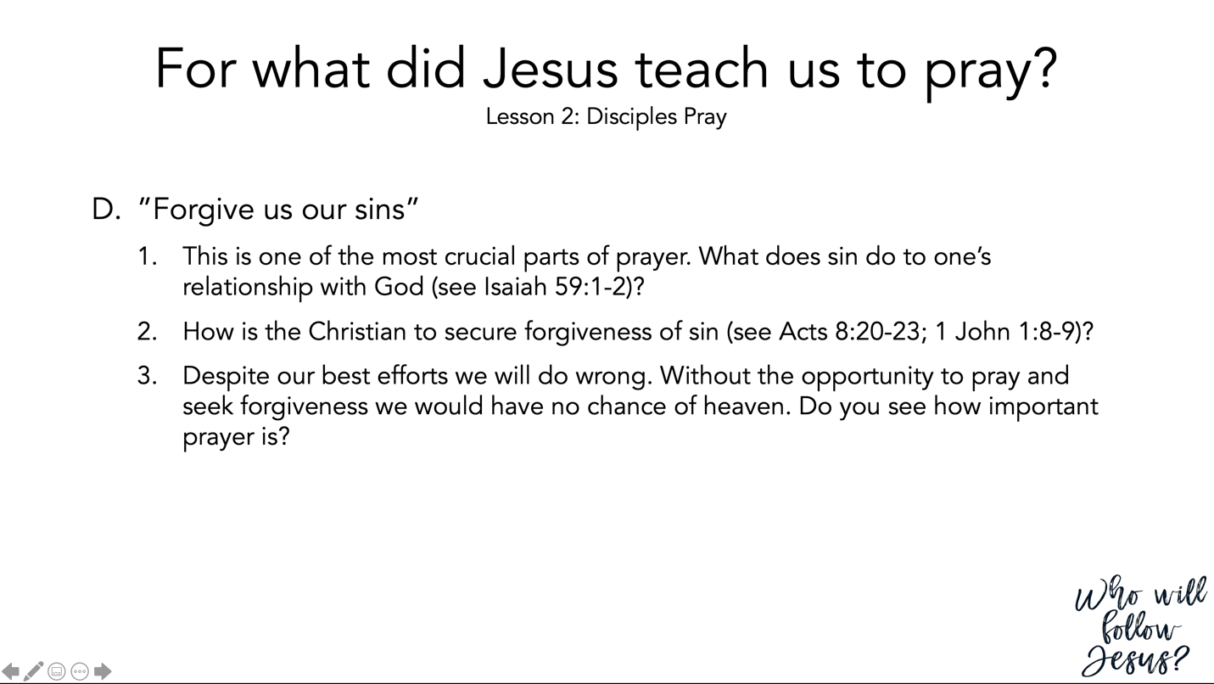

Isaiah 59:1–8 (NASB95) – Separation from God
¹ Behold, the Lord’s hand is not so short That it cannot save; Nor is His ear so dull That it cannot hear. ² But your iniquities have made a separation between you and your God, And your sins have hidden His face from you so that He does not hear. ³ For your hands are defiled with blood And your fingers with iniquity; Your lips have spoken falsehood, Your tongue mutters wickedness. ⁴ No one sues righteously and no one pleads honestly. They trust in confusion and speak lies; They conceive mischief and bring forth iniquity. ⁵ They hatch adders’ eggs and weave the spider’s web; He who eats of their eggs dies, And from that which is crushed a snake breaks forth. ⁶ Their webs will not become clothing, Nor will they cover themselves with their works; Their works are works of iniquity, And an act of violence is in their hands. ⁷ Their feet run to evil, And they hasten to shed innocent blood; Their thoughts are thoughts of iniquity, Devastation and destruction are in their highways. ⁸ They do not know the way of peace, And there is no justice in their tracks; They have made their paths crooked, Whoever treads on them does not know peace.

Acts 8:14–25 (NASB95) – Simon Sins Grievously
¹⁴ Now when the apostles in Jerusalem heard that Samaria had received the word of God, they sent them Peter and John, ¹⁵ who came down and prayed for them that they might receive the Holy Spirit. ¹⁶ For He had not yet fallen upon any of them; they had simply been baptized in the name of the Lord Jesus. ¹⁷ Then they began laying their hands on them, and they were receiving the Holy Spirit. ¹⁸ Now when Simon saw that the Spirit was bestowed through the laying on of the apostles’ hands, he offered them money, ¹⁹ saying, “Give this authority to me as well, so that everyone on whom I lay my hands may receive the Holy Spirit.” ²⁰ But Peter said to him, “May your silver perish with you, because you thought you could obtain the gift of God with money! ²¹ “You have no part or portion in this matter, for your heart is not right before God. ²² “Therefore repent of this wickedness of yours, and pray the Lord that, if possible, the intention of your heart may be forgiven you. ²³ “For I see that you are in the gall of bitterness and in the bondage of iniquity.” ²⁴ But Simon answered and said, “Pray to the Lord for me yourselves, so that nothing of what you have said may come upon me.” ²⁵ So, when they had solemnly testified and spoken the word of the Lord, they started back to Jerusalem, and were preaching the gospel to many villages of the Samaritans.

1 John 1:5–10 (NASB95) – God is Light
⁵ This is the message we have heard from Him and announce to you, that God is Light, and in Him there is no darkness at all. ⁶ If we say that we have fellowship with Him and yet walk in the darkness, we lie and do not practice the truth; ⁷ but if we walk in the Light as He Himself is in the Light, we have fellowship with one another, and the blood of Jesus His Son cleanses us from all sin. ⁸ If we say that we have no sin, we are deceiving ourselves and the truth is not in us. ⁹ If we confess our sins, He is faithful and righteous to forgive us our sins and to cleanse us from all unrighteousness. ¹⁰ If we say that we have not sinned, we make Him a liar and His word is not in us.

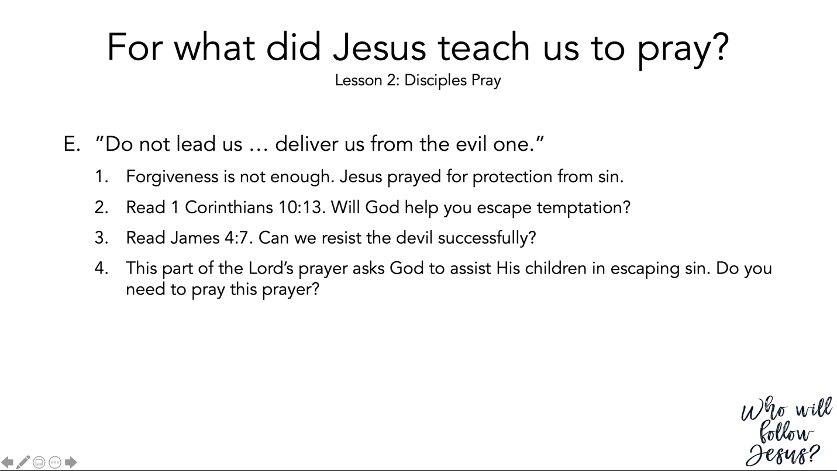

1 Corinthians 10:1–13 (NASB95) – Learn from Old Testament Examples
¹ For I do not want you to be unaware, brethren, that our fathers were all under the cloud and all passed through the sea; ² and all were baptized into Moses in the cloud and in the sea; ³ and all ate the same spiritual food; ⁴ and all drank the same spiritual drink, for they were drinking from a spiritual rock which followed them; and the rock was Christ. ⁵ Nevertheless, with most of them God was not well-pleased; for they were laid low in the wilderness. ⁶ Now these things happened as examples for us, so that we would not crave evil things as they also craved. ⁷ Do not be idolaters, as some of them were; as it is written, “The people sat down to eat and drink, and stood up to play.” ⁸ Nor let us act immorally, as some of them did, and twenty-three thousand fell in one day. ⁹ Nor let us try the Lord, as some of them did, and were destroyed by the serpents. ¹⁰ Nor grumble, as some of them did, and were destroyed by the destroyer. ¹¹ Now these things happened to them as an example, and they were written for our instruction, upon whom the ends of the ages have come. ¹² Therefore let him who thinks he stands take heed that he does not fall. ¹³ No temptation has overtaken you but such as is common to man; and God is faithful, who will not allow you to be tempted beyond what you are able, but with the temptation will provide the way of escape also, so that you will be able to endure it.

James 4:1–10 (NASB95) – Friendship with the World
¹ What is the source of quarrels and conflicts among you? Is not the source your pleasures that wage war in your members? ² You lust and do not have; so you commit murder. You are envious and cannot obtain; so you fight and quarrel. You do not have because you do not ask. ³ You ask and do not receive, because you ask with wrong motives, so that you may spend it on your pleasures. ⁴ You adulteresses, do you not know that friendship with the world is hostility toward God? Therefore whoever wishes to be a friend of the world makes himself an enemy of God. ⁵ Or do you think that the Scripture speaks to no purpose: “He jealously desires the Spirit which He has made to dwell in us”? ⁶ But He gives a greater grace. Therefore it says, “God is opposed to the proud, but gives grace to the humble.” ⁷ Submit therefore to God. Resist the devil and he will flee from you. ⁸ Draw near to God and He will draw near to you. Cleanse your hands, you sinners; and purify your hearts, you double-minded. ⁹ Be miserable and mourn and weep; let your laughter be turned into mourning and your joy to gloom. ¹⁰ Humble yourselves in the presence of the Lord, and He will exalt you.

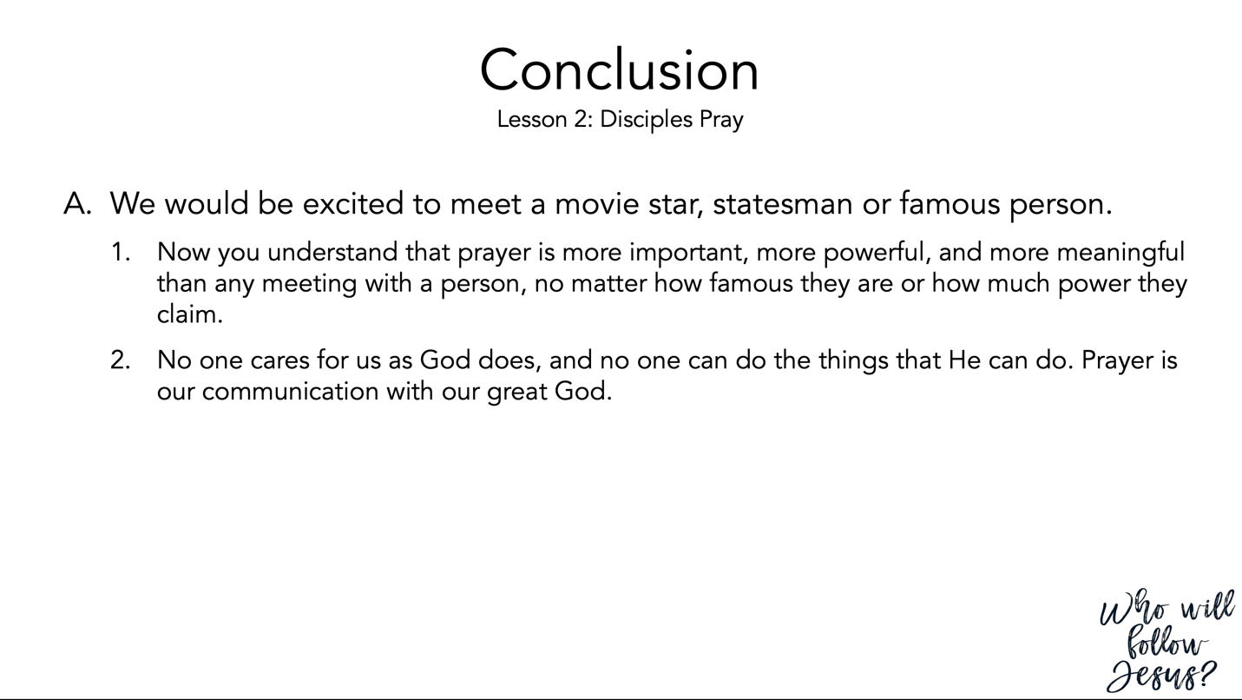

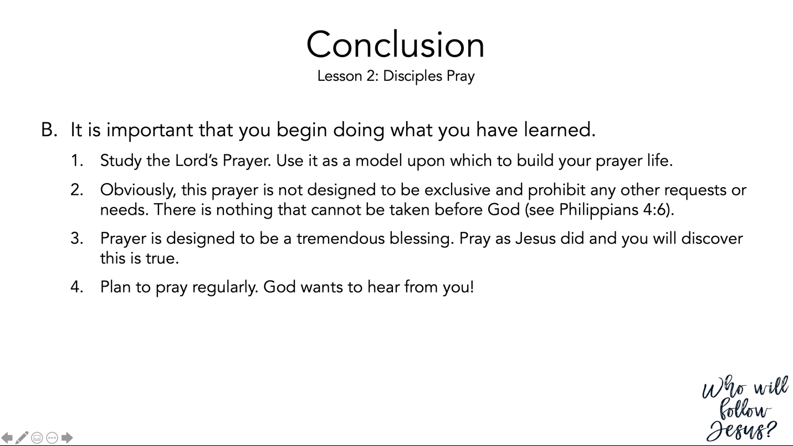

Philippians 4:1–9 (NASB95) – Think of Excellence
¹ Therefore, my beloved brethren whom I long to see, my joy and crown, in this way stand firm in the Lord, my beloved. ² I urge Euodia and I urge Syntyche to live in harmony in the Lord. ³ Indeed, true companion, I ask you also to help these women who have shared my struggle in the cause of the gospel, together with Clement also and the rest of my fellow workers, whose names are in the book of life. ⁴ Rejoice in the Lord always; again I will say, rejoice! ⁵ Let your gentle spirit be known to all men. The Lord is near. ⁶ Be anxious for nothing, but in everything by prayer and supplication with thanksgiving let your requests be made known to God. ⁷ And the peace of God, which surpasses all comprehension, will guard your hearts and your minds in Christ Jesus. ⁸ Finally, brethren, whatever is true, whatever is honorable, whatever is right, whatever is pure, whatever is lovely, whatever is of good repute, if there is any excellence and if anything worthy of praise, dwell on these things. ⁹ The things you have learned and received and heard and seen in me, practice these things, and the God of peace will be with you.

