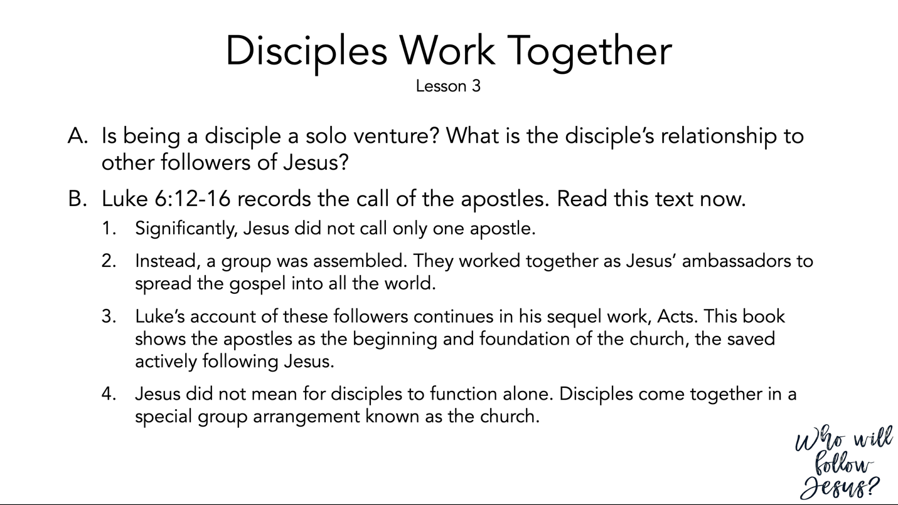

Luke 6:12–19 (NASB95) – Choosing the Twelve
¹² It was at this time that He went off to the mountain to pray, and He spent the whole night in prayer to God. ¹³ And when day came, He called His disciples to Him and chose twelve of them, whom He also named as apostles: ¹⁴ Simon, whom He also named Peter, and Andrew his brother; and James and John; and Philip and Bartholomew; ¹⁵ and Matthew and Thomas; James the son of Alphaeus, and Simon who was called the Zealot; ¹⁶ Judas the son of James, and Judas Iscariot, who became a traitor. ¹⁷ Jesus came down with them and stood on a level place; and there was a large crowd of His disciples, and a great throng of people from all Judea and Jerusalem and the coastal region of Tyre and Sidon, ¹⁸ who had come to hear Him and to be healed of their diseases; and those who were troubled with unclean spirits were being cured. ¹⁹ And all the people were trying to touch Him, for power was coming from Him and healing them all.

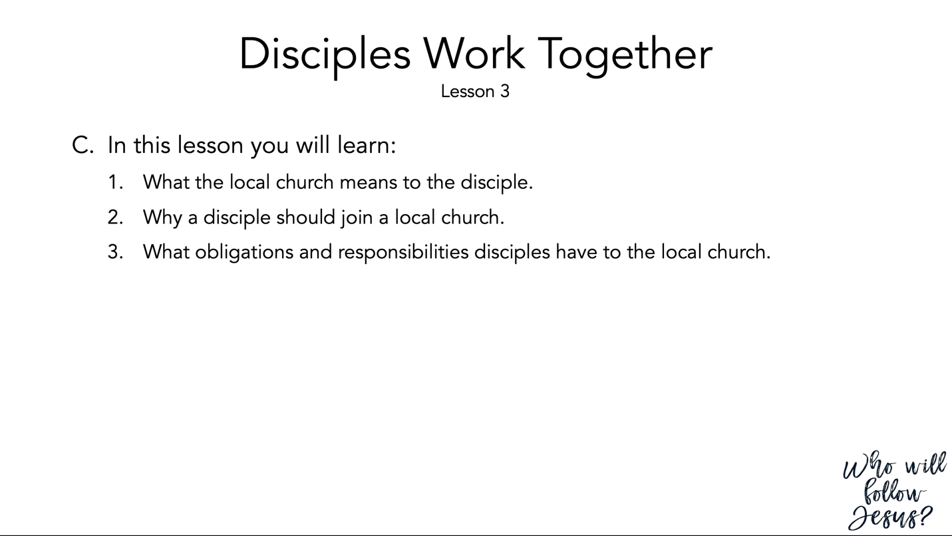

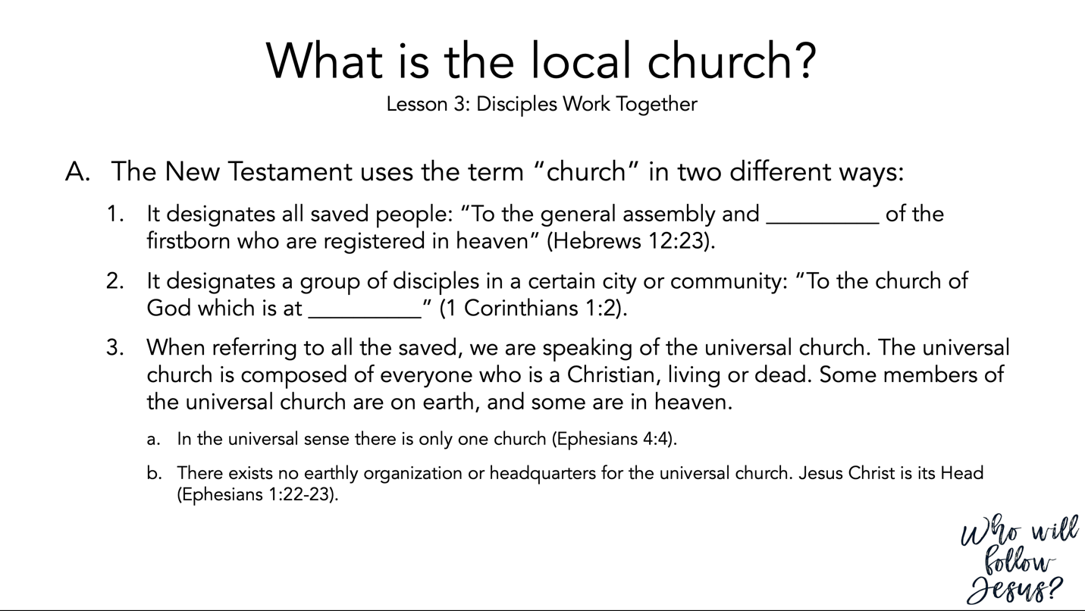

Hebrews 12:18–24 (NASB95) – Contrast of Siani and Zion
¹⁸ For you have not come to a mountain that can be touched and to a blazing fire, and to darkness and gloom and whirlwind, ¹⁹ and to the blast of a trumpet and the sound of words which sound was such that those who heard begged that no further word be spoken to them. ²⁰ For they could not bear the command, “If even a beast touches the mountain, it will be stoned.” ²¹ And so terrible was the sight, that Moses said, “I am full of fear and trembling.” ²² But you have come to Mount Zion and to the city of the living God, the heavenly Jerusalem, and to myriads of angels, ²³ to the general assembly and church of the firstborn who are enrolled in heaven, and to God, the Judge of all, and to the spirits of the righteous made perfect, ²⁴ and to Jesus, the mediator of a new covenant, and to the sprinkled blood, which speaks better than the blood of Abel.

1 Corinthians 1:1–3 (NASB95) – Paul Greets the Corinthians
¹ Paul, called as an apostle of Jesus Christ by the will of God, and Sosthenes our brother, ² To the church of God which is at Corinth, to those who have been sanctified in Christ Jesus, saints by calling, with all who in every place call on the name of our Lord Jesus Christ, their Lord and ours: ³ Grace to you and peace from God our Father and the Lord Jesus Christ.

Ephesians 4:1–6 (NASB95) – Walk in Unity
¹ Therefore I, the prisoner of the Lord, implore you to walk in a manner worthy of the calling with which you have been called, ² with all humility and gentleness, with patience, showing tolerance for one another in love, ³ being diligent to preserve the unity of the Spirit in the bond of peace. ⁴ There is one body and one Spirit, just as also you were called in one hope of your calling; ⁵ one Lord, one faith, one baptism, ⁶ one God and Father of all who is over all and through all and in all.

Ephesians 1:20–23 (NASB95) – God’s Power in Christ
²⁰ which He brought about in Christ, when He raised Him from the dead and seated Him at His right hand in the heavenly places, ²¹ far above all rule and authority and power and dominion, and every name that is named, not only in this age but also in the one to come. ²² And He put all things in subjection under His feet, and gave Him as head over all things to the church, ²³ which is His body, the fullness of Him who fills all in all.

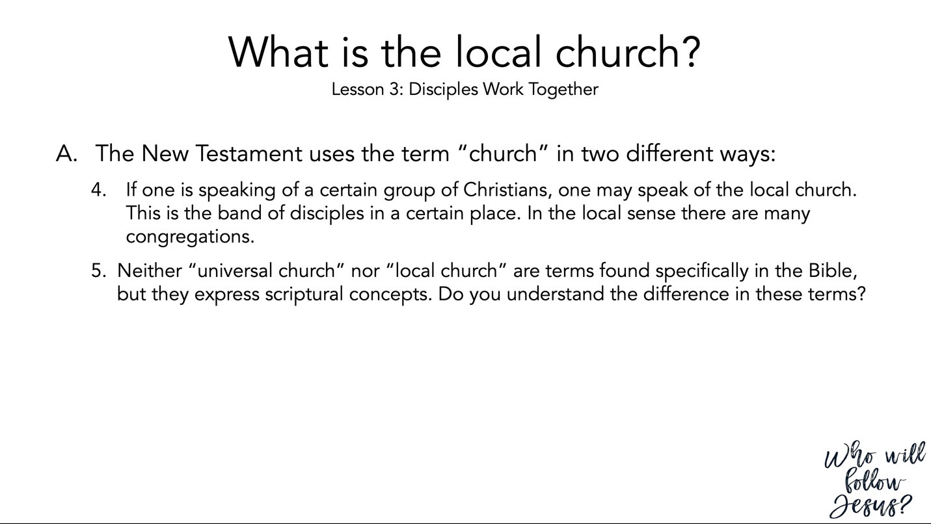

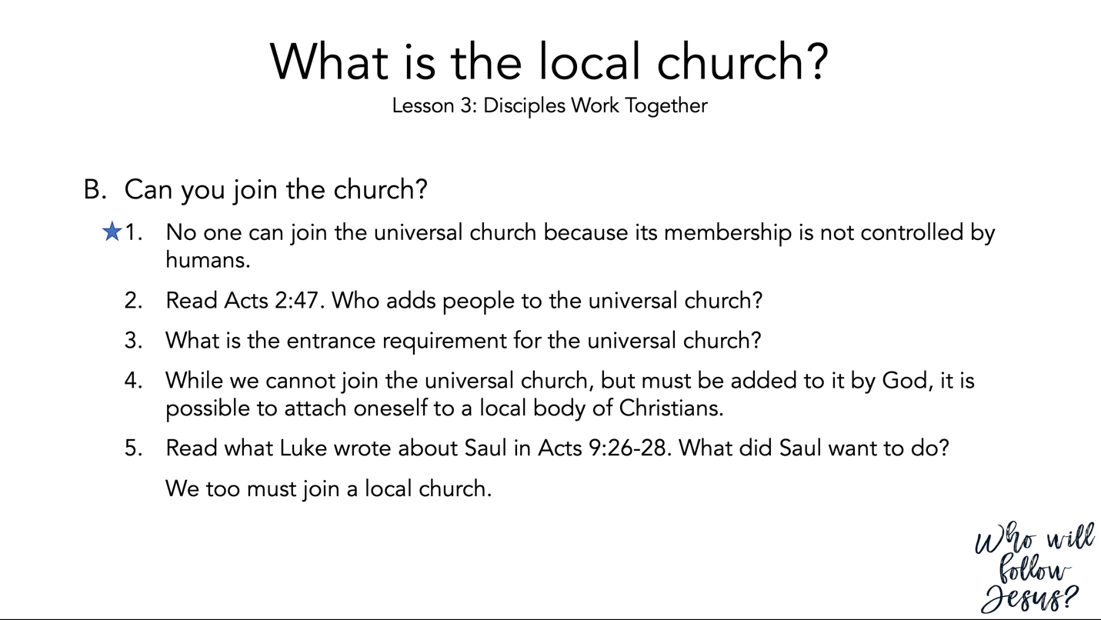

Acts 2:37–47 (NASB95) – The Ingathering
³⁷ Now when they heard this, they were pierced to the heart, and said to Peter and the rest of the apostles, “Brethren, what shall we do?” ³⁸ Peter said to them, “Repent, and each of you be baptized in the name of Jesus Christ for the forgiveness of your sins; and you will receive the gift of the Holy Spirit. ³⁹ “For the promise is for you and your children and for all who are far off, as many as the Lord our God will call to Himself.” ⁴⁰ And with many other words he solemnly testified and kept on exhorting them, saying, “Be saved from this perverse generation!” ⁴¹ So then, those who had received his word were baptized; and that day there were added about three thousand souls. ⁴² They were continually devoting themselves to the apostles’ teaching and to fellowship, to the breaking of bread and to prayer. ⁴³ Everyone kept feeling a sense of awe; and many wonders and signs were taking place through the apostles. ⁴⁴ And all those who had believed were together and had all things in common; ⁴⁵ and they began selling their property and possessions and were sharing them with all, as anyone might have need. ⁴⁶ Day by day continuing with one mind in the temple, and breaking bread from house to house, they were taking their meals together with gladness and sincerity of heart, ⁴⁷ praising God and having favor with all the people. And the Lord was adding to their number day by day those who were being saved.

Acts 9:19–31 (NASB95) – Paul Begins to Preach Christ
^{19b} … Now for several days he was with the disciples who were at Damascus, ²⁰ and immediately he began to proclaim Jesus in the synagogues, saying, “He is the Son of God.” ²¹ All those hearing him continued to be amazed, and were saying, “Is this not he who in Jerusalem destroyed those who called on this name, and who had come here for the purpose of bringing them bound before the chief priests?” ²² But Saul kept increasing in strength and confounding the Jews who lived at Damascus by proving that this Jesus is the Christ. ²³ When many days had elapsed, the Jews plotted together to do away with him, ²⁴ but their plot became known to Saul. They were also watching the gates day and night so that they might put him to death; ²⁵ but his disciples took him by night and let him down through an opening in the wall, lowering him in a large basket. ²⁶ When he came to Jerusalem, he was trying to associate with the disciples; but they were all afraid of him, not believing that he was a disciple. ²⁷ But Barnabas took hold of him and brought him to the apostles and described to them how he had seen the Lord on the road, and that He had talked to him, and how at Damascus he had spoken out boldly in the name of Jesus. ²⁸ And he was with them, moving about freely in Jerusalem, speaking out boldly in the name of the Lord. ²⁹ And he was talking and arguing with the Hellenistic Jews; but they were attempting to put him to death. ³⁰ But when the brethren learned of it, they brought him down to Caesarea and sent him away to Tarsus. ³¹ So the church throughout all Judea and Galilee and Samaria enjoyed peace, being built up; and going on in the fear of the Lord and in the comfort of the Holy Spirit, it continued to increase.

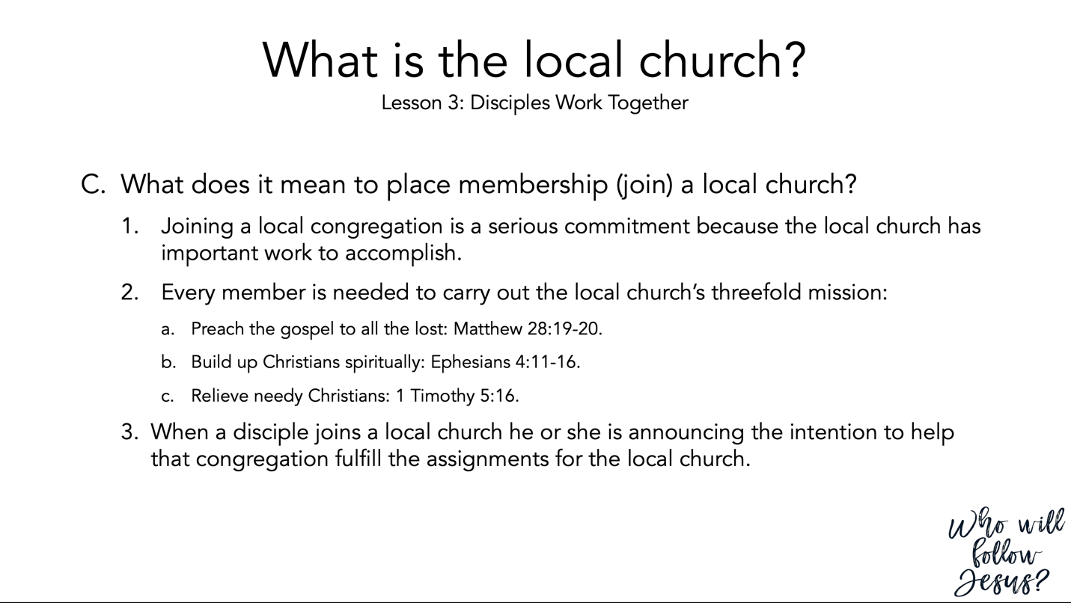

Matthew 28:16–20 (NASB95) – The Great Commission
¹⁶ But the eleven disciples proceeded to Galilee, to the mountain which Jesus had designated. ¹⁷ When they saw Him, they worshiped Him; but some were doubtful. ¹⁸ And Jesus came up and spoke to them, saying, “All authority has been given to Me in heaven and on earth. ¹⁹ “Go therefore and make disciples of all the nations, baptizing them in the name of the Father and the Son and the Holy Spirit, ²⁰ teaching them to observe all that I commanded you; and lo, I am with you always, even to the end of the age.”

Ephesians 4:7–16 (NASB95) – Each Believer Has a Spiritual Gift
⁷ But to each one of us grace was given according to the measure of Christ’s gift. ⁸ Therefore it says, “When He ascended on high, He led captive a host of captives, And He gave gifts to men.” ⁹ (Now this expression, “He ascended,” what does it mean except that He also had descended into the lower parts of the earth? ¹⁰ He who descended is Himself also He who ascended far above all the heavens, so that He might fill all things.) ¹¹ And He gave some as apostles, and some as prophets, and some as evangelists, and some as pastors and teachers, ¹² for the equipping of the saints for the work of service, to the building up of the body of Christ; ¹³ until we all attain to the unity of the faith, and of the knowledge of the Son of God, to a mature man, to the measure of the stature which belongs to the fullness of Christ. ¹⁴ As a result, we are no longer to be children, tossed here and there by waves and carried about by every wind of doctrine, by the trickery of men, by craftiness in deceitful scheming; ¹⁵ but speaking the truth in love, we are to grow up in all aspects into Him who is the head, even Christ, ¹⁶ from whom the whole body, being fitted and held together by what every joint supplies, according to the proper working of each individual part, causes the growth of the body for the building up of itself in love.

1 Timothy 5:1–16 (NASB95) – Honor Widows
¹ Do not sharply rebuke an older man, but rather appeal to him as a father, to the younger men as brothers, ² the older women as mothers, and the younger women as sisters, in all purity. ³ Honor widows who are widows indeed; ⁴ but if any widow has children or grandchildren, they must first learn to practice piety in regard to their own family and to make some return to their parents; for this is acceptable in the sight of God. ⁵ Now she who is a widow indeed and who has been left alone, has fixed her hope on God and continues in entreaties and prayers night and day. ⁶ But she who gives herself to wanton pleasure is dead even while she lives. ⁷ Prescribe these things as well, so that they may be above reproach. ⁸ But if anyone does not provide for his own, and especially for those of his household, he has denied the faith and is worse than an unbeliever. ⁹ A widow is to be put on the list only if she is not less than sixty years old, having been the wife of one man, ¹⁰ having a reputation for good works; and if she has brought up children, if she has shown hospitality to strangers, if she has washed the saints’ feet, if she has assisted those in distress, and if she has devoted herself to every good work. ¹¹ But refuse to put younger widows on the list, for when they feel sensual desires in disregard of Christ, they want to get married, ¹² thus incurring condemnation, because they have set aside their previous pledge. ¹³ At the same time they also learn to be idle, as they go around from house to house; and not merely idle, but also gossips and busybodies, talking about things not proper to mention. ¹⁴ Therefore, I want younger widows to get married, bear children, keep house, and give the enemy no occasion for reproach; ¹⁵ for some have already turned aside to follow Satan. ¹⁶ If any woman who is a believer has dependent widows, she must assist them and the church must not be burdened, so that it may assist those who are widows indeed.

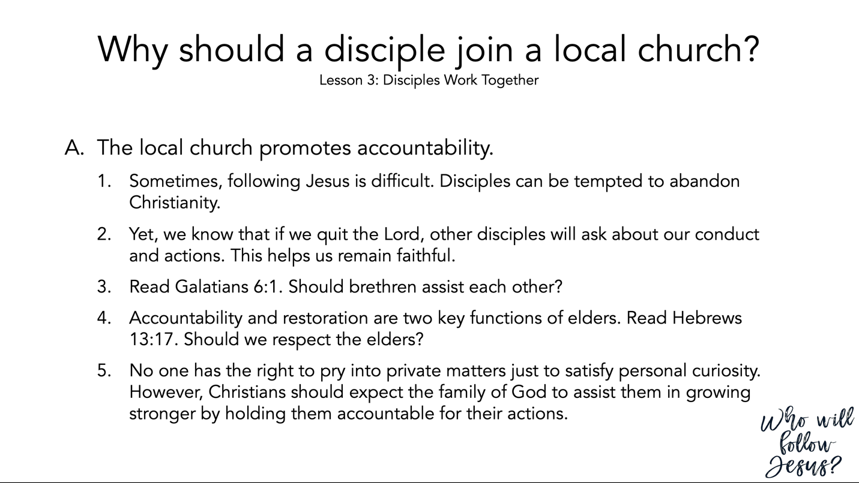

Galatians 6:1–5 (NASB95) – Bear and Share the Burdens
¹ Brethren, even if anyone is caught in any trespass, you who are spiritual, restore such a one in a spirit of gentleness; each one looking to yourself, so that you too will not be tempted. ² Bear one another’s burdens, and thereby fulfill the law of Christ. ³ For if anyone thinks he is something when he is nothing, he deceives himself. ⁴ But each one must examine his own work, and then he will have reason for boasting in regard to himself alone, and not in regard to another. ⁵ For each one will bear his own load.

Hebrews 13:7–17 (NASB95) – Concluding Religious Instructions
⁷ Remember those who led you, who spoke the word of God to you; and considering the result of their conduct, imitate their faith. ⁸ Jesus Christ is the same yesterday and today and forever. ⁹ Do not be carried away by varied and strange teachings; for it is good for the heart to be strengthened by grace, not by foods, through which those who were so occupied were not benefited. ¹⁰ We have an altar from which those who serve the tabernacle have no right to eat. ¹¹ For the bodies of those animals whose blood is brought into the holy place by the high priest as an offering for sin, are burned outside the camp. ¹² Therefore Jesus also, that He might sanctify the people through His own blood, suffered outside the gate. ¹³ So, let us go out to Him outside the camp, bearing His reproach. ¹⁴ For here we do not have a lasting city, but we are seeking the city which is to come. ¹⁵ Through Him then, let us continually offer up a sacrifice of praise to God, that is, the fruit of lips that give thanks to His name. ¹⁶ And do not neglect doing good and sharing, for with such sacrifices God is pleased. ¹⁷ Obey your leaders and submit to them, for they keep watch over your souls as those who will give an account. Let them do this with joy and not with grief, for this would be unprofitable for you.

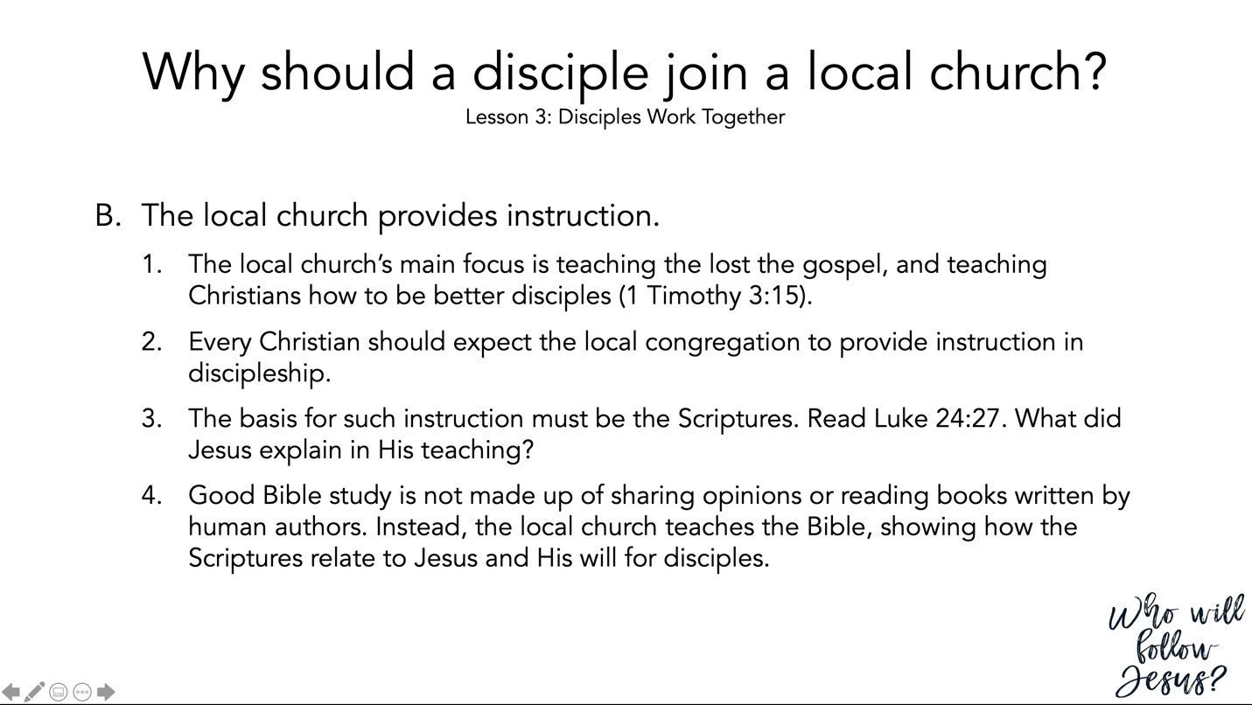

1 Timothy 3:14–16 (NASB95)
¹⁴ I am writing these things to you, hoping to come to you before long; ¹⁵ but in case I am delayed, I write so that you will know how one ought to conduct himself in the household of God, which is the church of the living God, the pillar and support of the truth. ¹⁶ By common confession, great is the mystery of godliness: He who was revealed in the flesh, Was vindicated in the Spirit, Seen by angels, Proclaimed among the nations, Believed on in the world, Taken up in glory.

Luke 24:13–35 (NASB95) – The Road to Emmaus
¹³ And behold, two of them were going that very day to a village named Emmaus, which was about seven miles from Jerusalem. ¹⁴ And they were talking with each other about all these things which had taken place. ¹⁵ While they were talking and discussing, Jesus Himself approached and began traveling with them. ¹⁶ But their eyes were prevented from recognizing Him. ¹⁷ And He said to them, “What are these words that you are exchanging with one another as you are walking?” And they stood still, looking sad. ¹⁸ One of them, named Cleopas, answered and said to Him, “Are You the only one visiting Jerusalem and unaware of the things which have happened here in these days?” ¹⁹ And He said to them, “What things?” And they said to Him, “The things about Jesus the Nazarene, who was a prophet mighty in deed and word in the sight of God and all the people, ²⁰ and how the chief priests and our rulers delivered Him to the sentence of death, and crucified Him. ²¹ “But we were hoping that it was He who was going to redeem Israel. Indeed, besides all this, it is the third day since these things happened. ²² “But also some women among us amazed us. When they were at the tomb early in the morning, ²³ and did not find His body, they came, saying that they had also seen a vision of angels who said that He was alive. ²⁴ “Some of those who were with us went to the tomb and found it just exactly as the women also had said; but Him they did not see.” ²⁵ And He said to them, “O foolish men and slow of heart to believe in all that the prophets have spoken! ²⁶ “Was it not necessary for the Christ to suffer these things and to enter into His glory?” ²⁷ Then beginning with Moses and with all the prophets, He explained to them the things concerning Himself in all the Scriptures. ²⁸ And they approached the village where they were going, and He acted as though He were going farther. ²⁹ But they urged Him, saying, “Stay with us, for it is getting toward evening, and the day is now nearly over.” So He went in to stay with them. ³⁰ When He had reclined at the table with them, He took the bread and blessed it, and breaking it, He began giving it to them. ³¹ Then their eyes were opened and they recognized Him; and He vanished from their sight. ³² They said to one another, “Were not our hearts burning within us while He was speaking to us on the road, while He was explaining the Scriptures to us?” ³³ And they got up that very hour and returned to Jerusalem, and found gathered together the eleven and those who were with them, ³⁴ saying, “The Lord has really risen and has appeared to Simon.” ³⁵ They began to relate their experiences on the road and how He was recognized by them in the breaking of the bread.

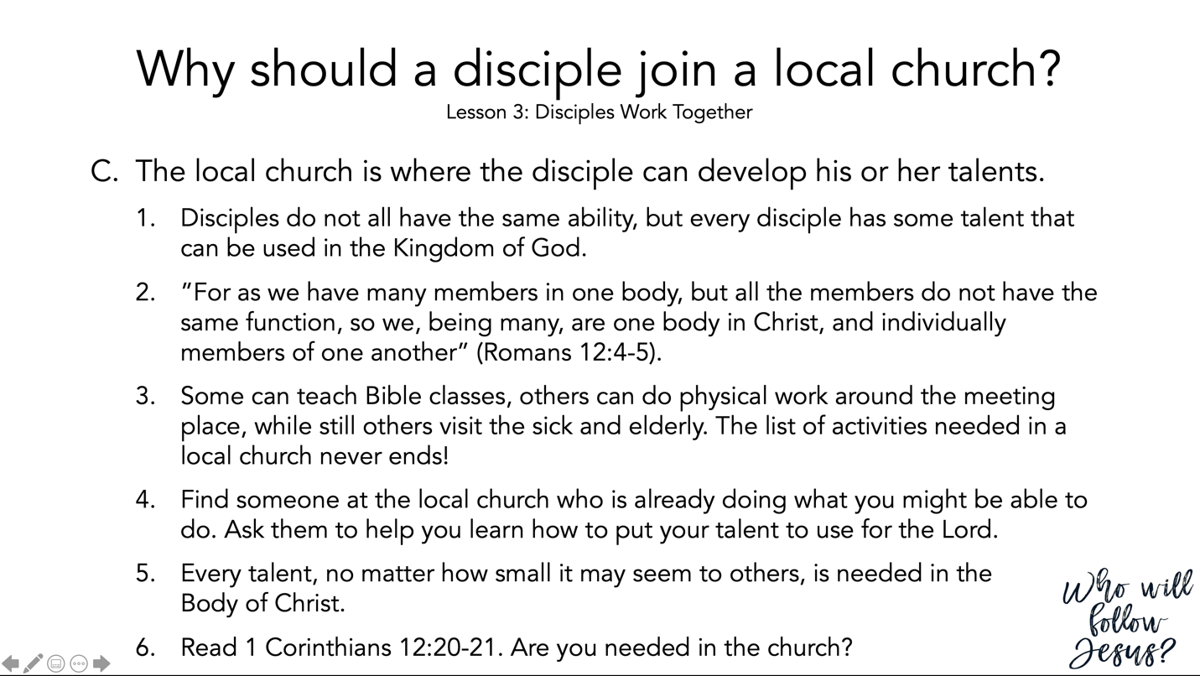

Romans 12:1–8 (NASB95) – Living for God
¹ Therefore I urge you, brethren, by the mercies of God, to present your bodies a living and holy sacrifice, acceptable to God, which is your spiritual service of worship. ² And do not be conformed to this world, but be transformed by the renewing of your mind, so that you may prove what the will of God is, that which is good and acceptable and perfect. ³ For through the grace given to me I say to everyone among you not to think more highly of himself than he ought to think; but to think so as to have sound judgment, as God has allotted to each a measure of faith. ⁴ For just as we have many members in one body and all the members do not have the same function, ⁵ so we, who are many, are one body in Christ, and individually members one of another. ⁶ Since we have gifts that differ according to the grace given to us, each of us is to exercise them accordingly: if prophecy, according to the proportion of his faith; ⁷ if service, in his serving; or he who teaches, in his teaching; ⁸ or he who exhorts, in his exhortation; he who gives, with liberality; he who leads, with diligence; he who shows mercy, with cheerfulness.

1 Corinthians 12:12–26 (NASB95) – One Body, Many Parts
¹² For even as the body is one and yet has many members, and all the members of the body, though they are many, are one body, so also is Christ. ¹³ For by one Spirit we were all baptized into one body, whether Jews or Greeks, whether slaves or free, and we were all made to drink of one Spirit. ¹⁴ For the body is not one member, but many. ¹⁵ If the foot says, “Because I am not a hand, I am not a part of the body,” it is not for this reason any the less a part of the body. ¹⁶ And if the ear says, “Because I am not an eye, I am not a part of the body,” it is not for this reason any the less a part of the body. ¹⁷ If the whole body were an eye, where would the hearing be? If the whole were hearing, where would the sense of smell be? ¹⁸ But now God has placed the members, each one of them, in the body, just as He desired. ¹⁹ If they were all one member, where would the body be? ²⁰ But now there are many members, but one body. ²¹ And the eye cannot say to the hand, “I have no need of you”; or again the head to the feet, “I have no need of you.” ²² On the contrary, it is much truer that the members of the body which seem to be weaker are necessary; ²³ and those members of the body which we deem less honorable, on these we bestow more abundant honor, and our less presentable members become much more presentable, ²⁴ whereas our more presentable members have no need of it. But God has so composed the body, giving more abundant honor to that member which lacked, ²⁵ so that there may be no division in the body, but that the members may have the same care for one another. ²⁶ And if one member suffers, all the members suffer with it; if one member is honored, all the members rejoice with it.

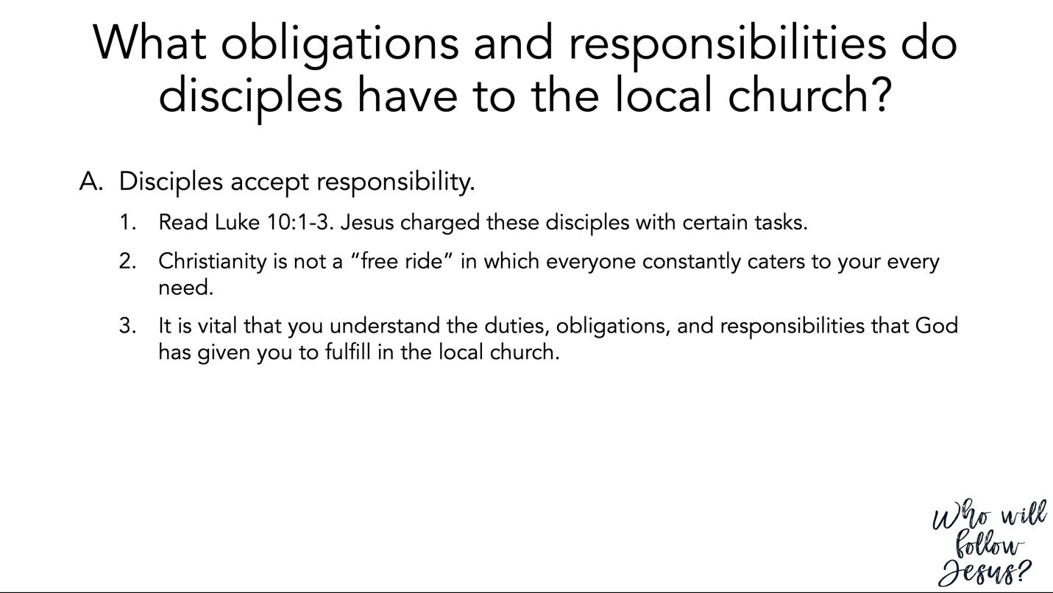

Luke 10:1–12 (NASB95) – Jesus Sends Out the Seventy
¹ Now after this the Lord appointed seventy others, and sent them in pairs ahead of Him to every city and place where He Himself was going to come. ² And He was saying to them, “The harvest is plentiful, but the laborers are few; therefore beseech the Lord of the harvest to send out laborers into His harvest. ³ “Go; behold, I send you out as lambs in the midst of wolves. ⁴ “Carry no money belt, no bag, no shoes; and greet no one on the way. ⁵ “Whatever house you enter, first say, ‘Peace be to this house.’ ⁶ “If a man of peace is there, your peace will rest on him; but if not, it will return to you. ⁷ “Stay in that house, eating and drinking what they give you; for the laborer is worthy of his wages. Do not keep moving from house to house. ⁸ “Whatever city you enter and they receive you, eat what is set before you; ⁹ and heal those in it who are sick, and say to them, ‘The kingdom of God has come near to you.’ ¹⁰ “But whatever city you enter and they do not receive you, go out into its streets and say, ¹¹ ‘Even the dust of your city which clings to our feet we wipe off in protest against you; yet be sure of this, that the kingdom of God has come near.’ ¹² “I say to you, it will be more tolerable in that day for Sodom than for that city.

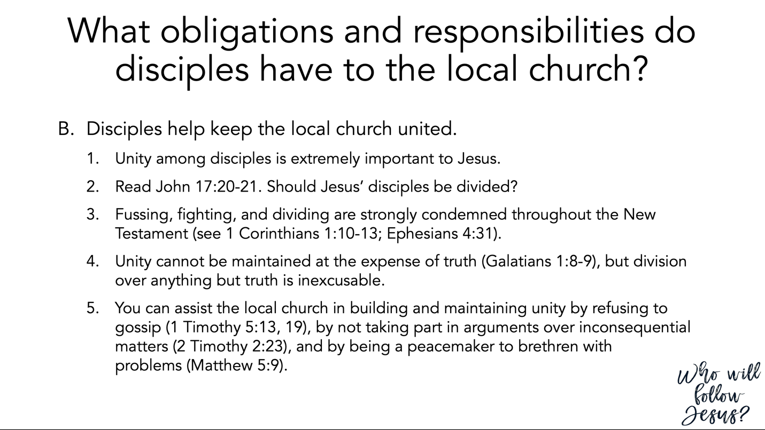

John 17:13–21 (NASB95) – The Disciples in the World
¹³ “But now I come to You; and these things I speak in the world so that they may have My joy made full in themselves. ¹⁴ “I have given them Your word; and the world has hated them, because they are not of the world, even as I am not of the world. ¹⁵ “I do not ask You to take them out of the world, but to keep them from the evil one. ¹⁶ “They are not of the world, even as I am not of the world. ¹⁷ “Sanctify them in the truth; Your word is truth. ¹⁸ “As You sent Me into the world, I also have sent them into the world. ¹⁹ “For their sakes I sanctify Myself, that they themselves also may be sanctified in truth. ²⁰ “I do not ask on behalf of these alone, but for those also who believe in Me through their word; ²¹ that they may all be one; even as You, Father, are in Me and I in You, that they also may be in Us, so that the world may believe that You sent Me.

1 Corinthians 1:10–17 (NASB95) – Sectarianism is Sin
¹⁰ Now I exhort you, brethren, by the name of our Lord Jesus Christ, that you all agree and that there be no divisions among you, but that you be made complete in the same mind and in the same judgment. ¹¹ For I have been informed concerning you, my brethren, by Chloe’s people, that there are quarrels among you. ¹² Now I mean this, that each one of you is saying, “I am of Paul,” and “I of Apollos,” and “I of Cephas,” and “I of Christ.” ¹³ Has Christ been divided? Paul was not crucified for you, was he? Or were you baptized in the name of Paul? ¹⁴ I thank God that I baptized none of you except Crispus and Gaius, ¹⁵ so that no one would say you were baptized in my name. ¹⁶ Now I did baptize also the household of Stephanas; beyond that, I do not know whether I baptized any other. ¹⁷ For Christ did not send me to baptize, but to preach the gospel, not in cleverness of speech, so that the cross of Christ would not be made void.

Ephesians 4:25–32 (NASB95) – Do Not Grieve the Spirit of God
²⁵ Therefore, laying aside falsehood, speak truth each one of you with his neighbor, for we are members of one another. ²⁶ Be angry, and yet do not sin; do not let the sun go down on your anger, ²⁷ and do not give the devil an opportunity. ²⁸ He who steals must steal no longer; but rather he must labor, performing with his own hands what is good, so that he will have something to share with one who has need. ²⁹ Let no unwholesome word proceed from your mouth, but only such a word as is good for edification according to the need of the moment, so that it will give grace to those who hear. ³⁰ Do not grieve the Holy Spirit of God, by whom you were sealed for the day of redemption. ³¹ Let all bitterness and wrath and anger and clamor and slander be put away from you, along with all malice. ³² Be kind to one another, tender-hearted, forgiving each other, just as God in Christ also has forgiven you.

Galatians 1:6–10 (NASB95) – Perversion of the Gospel
⁶ I am amazed that you are so quickly deserting Him who called you by the grace of Christ, for a different gospel; ⁷ which is really not another; only there are some who are disturbing you and want to distort the gospel of Christ. ⁸ But even if we, or an angel from heaven, should preach to you a gospel contrary to what we have preached to you, he is to be accursed! ⁹ As we have said before, so I say again now, if any man is preaching to you a gospel contrary to what you received, he is to be accursed! ¹⁰ For am I now seeking the favor of men, or of God? Or am I striving to please men? If I were still trying to please men, I would not be a bond-servant of Christ.

1 Timothy 5 (NASB95) – Honor Widows
¹ Do not sharply rebuke an older man, but rather appeal to him as a father, to the younger men as brothers, ² the older women as mothers, and the younger women as sisters, in all purity. ³ Honor widows who are widows indeed; ⁴ but if any widow has children or grandchildren, they must first learn to practice piety in regard to their own family and to make some return to their parents; for this is acceptable in the sight of God. ⁵ Now she who is a widow indeed and who has been left alone, has fixed her hope on God and continues in entreaties and prayers night and day. ⁶ But she who gives herself to wanton pleasure is dead even while she lives. ⁷ Prescribe these things as well, so that they may be above reproach. ⁸ But if anyone does not provide for his own, and especially for those of his household, he has denied the faith and is worse than an unbeliever. ⁹ A widow is to be put on the list only if she is not less than sixty years old, having been the wife of one man, ¹⁰ having a reputation for good works; and if she has brought up children, if she has shown hospitality to strangers, if she has washed the saints’ feet, if she has assisted those in distress, and if she has devoted herself to every good work. ¹¹ But refuse to put younger widows on the list, for when they feel sensual desires in disregard of Christ, they want to get married, ¹² thus incurring condemnation, because they have set aside their previous pledge. ¹³ At the same time they also learn to be idle, as they go around from house to house; and not merely idle, but also gossips and busybodies, talking about things not proper to mention. ¹⁴ Therefore, I want younger widows to get married, bear children, keep house, and give the enemy no occasion for reproach; ¹⁵ for some have already turned aside to follow Satan. ¹⁶ If any woman who is a believer has dependent widows, she must assist them and the church must not be burdened, so that it may assist those who are widows indeed.

- Concerning Elders
¹⁷ The elders who rule well are to be considered worthy of double honor, especially those who work hard at preaching and teaching. ¹⁸ For the Scripture says, “You shall not muzzle the ox while he is threshing,” and “The laborer is worthy of his wages.” ¹⁹ Do not receive an accusation against an elder except on the basis of two or three witnesses. ²⁰ Those who continue in sin, rebuke in the presence of all, so that the rest also will be fearful of sinning. ²¹ I solemnly charge you in the presence of God and of Christ Jesus and of His chosen angels, to maintain these principles without bias, doing nothing in a spirit of partiality. ²² Do not lay hands upon anyone too hastily and thereby share responsibility for the sins of others; keep yourself free from sin. ²³ No longer drink water exclusively, but use a little wine for the sake of your stomach and your frequent ailments. ²⁴ The sins of some men are quite evident, going before them to judgment; for others, their sins follow after. ²⁵ Likewise also, deeds that are good are quite evident, and those which are otherwise cannot be concealed.

2 Timothy 2:14–3:9 (NASB95) – Dealing with False Teachers
¹⁴ Remind them of these things, and solemnly charge them in the presence of God not to wrangle about words, which is useless and leads to the ruin of the hearers. ¹⁵ Be diligent to present yourself approved to God as a workman who does not need to be ashamed, accurately handling the word of truth. ¹⁶ But avoid worldly and empty chatter, for it will lead to further ungodliness, ¹⁷ and their talk will spread like gangrene. Among them are Hymenaeus and Philetus, ¹⁸ men who have gone astray from the truth saying that the resurrection has already taken place, and they upset the faith of some. ¹⁹ Nevertheless, the firm foundation of God stands, having this seal, “The Lord knows those who are His,” and, “Everyone who names the name of the Lord is to abstain from wickedness.” ²⁰ Now in a large house there are not only gold and silver vessels, but also vessels of wood and of earthenware, and some to honor and some to dishonor. ²¹ Therefore, if anyone cleanses himself from these things, he will be a vessel for honor, sanctified, useful to the Master, prepared for every good work. ²² Now flee from youthful lusts and pursue righteousness, faith, love and peace, with those who call on the Lord from a pure heart. ²³ But refuse foolish and ignorant speculations, knowing that they produce quarrels. ²⁴ The Lord’s bond-servant must not be quarrelsome, but be kind to all, able to teach, patient when wronged, ²⁵ with gentleness correcting those who are in opposition, if perhaps God may grant them repentance leading to the knowledge of the truth, ²⁶ and they may come to their senses and escape from the snare of the devil, having been held captive by him to do his will. ¹ But realize this, that in the last days difficult times will come. ² For men will be lovers of self, lovers of money, boastful, arrogant, revilers, disobedient to parents, ungrateful, unholy, ³ unloving, irreconcilable, malicious gossips, without self-control, brutal, haters of good, ⁴ treacherous, reckless, conceited, lovers of pleasure rather than lovers of God, ⁵ holding to a form of godliness, although they have denied its power; Avoid such men as these. ⁶ For among them are those who enter into households and captivate weak women weighed down with sins, led on by various impulses, ⁷ always learning and never able to come to the knowledge of the truth. ⁸ Just as Jannes and Jambres opposed Moses, so these men also oppose the truth, men of depraved mind, rejected in regard to the faith. ⁹ But they will not make further progress; for their folly will be obvious to all, just as Jannes’s and Jambres’s folly was also.

Matthew 5:9 (NASB95) – The Sermon on the Mount; The Beatitudes
⁹ “Blessed are the peacemakers, for they shall be called sons of God.

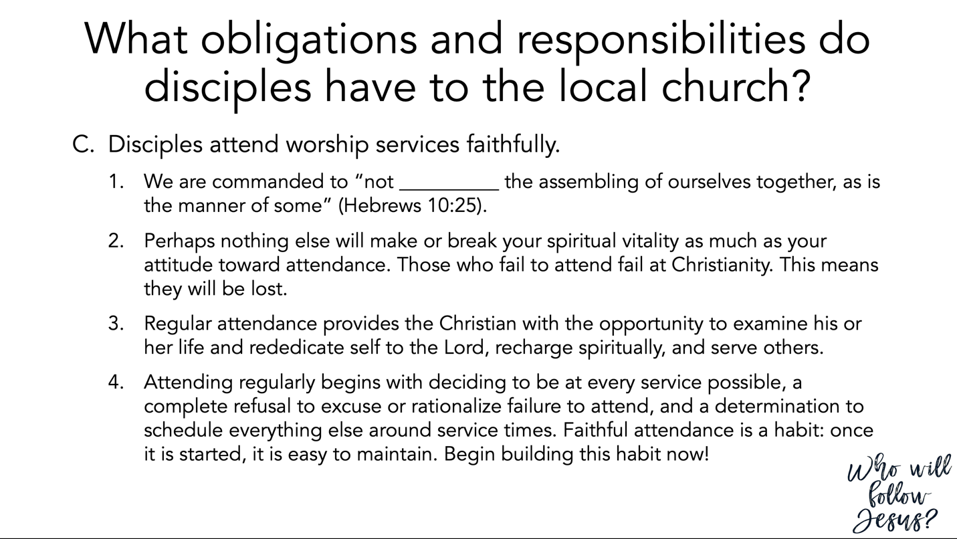

Hebrews 10:19–25 (NASB95) – A New and Living Way
¹⁹ Therefore, brethren, since we have confidence to enter the holy place by the blood of Jesus, ²⁰ by a new and living way which He inaugurated for us through the veil, that is, His flesh, ²¹ and since we have a great priest over the house of God, ²² let us draw near with a sincere heart in full assurance of faith, having our hearts sprinkled clean from an evil conscience and our bodies washed with pure water. ²³ Let us hold fast the confession of our hope without wavering, for He who promised is faithful; ²⁴ and let us consider how to stimulate one another to love and good deeds, ²⁵ not forsaking our own assembling together, as is the habit of some, but encouraging one another; and all the more as you see the day drawing near.

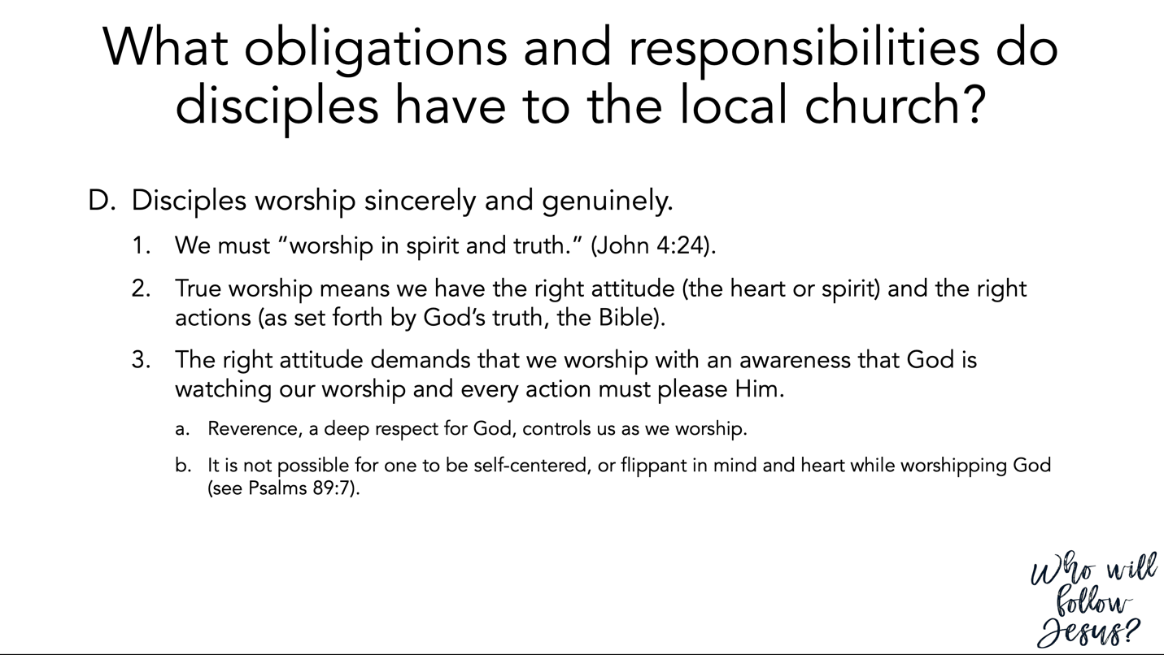

John 4:20–27 (NASB95) – The Woman of Samaria
²⁰ “Our fathers worshiped in this mountain, and you people say that in Jerusalem is the place where men ought to worship.” ²¹ Jesus said to her, “Woman, believe Me, an hour is coming when neither in this mountain nor in Jerusalem will you worship the Father. ²² “You worship what you do not know; we worship what we know, for salvation is from the Jews. ²³ “But an hour is coming, and now is, when the true worshipers will worship the Father in spirit and truth; for such people the Father seeks to be His worshipers. ²⁴ “God is spirit, and those who worship Him must worship in spirit and truth.” ²⁵ The woman said to Him, “I know that Messiah is coming (He who is called Christ); when that One comes, He will declare all things to us.” ²⁶ Jesus said to her, “I who speak to you am He.” ²⁷ At this point His disciples came, and they were amazed that He had been speaking with a woman, yet no one said, “What do You seek?” or, “Why do You speak with her?”

Psalm 89:1–10 (NASB95) – The LORD’s Covenant with David, and Israel’s Afflictions
¹ I will sing of the lovingkindness of the Lord forever; To all generations I will make known Your faithfulness with my mouth. ² For I have said, “Lovingkindness will be built up forever; In the heavens You will establish Your faithfulness.” ³ “I have made a covenant with My chosen; I have sworn to David My servant, ⁴ I will establish your seed forever And build up your throne to all generations.” Selah. ⁵ The heavens will praise Your wonders, O Lord; Your faithfulness also in the assembly of the holy ones. ⁶ For who in the skies is comparable to the Lord? Who among the sons of the mighty is like the Lord, ⁷ A God greatly feared in the council of the holy ones, And awesome above all those who are around Him? ⁸ O Lord God of hosts, who is like You, O mighty Lord? Your faithfulness also surrounds You. ⁹ You rule the swelling of the sea; When its waves rise, You still them. ¹⁰ You Yourself crushed Rahab like one who is slain; You scattered Your enemies with Your mighty arm.

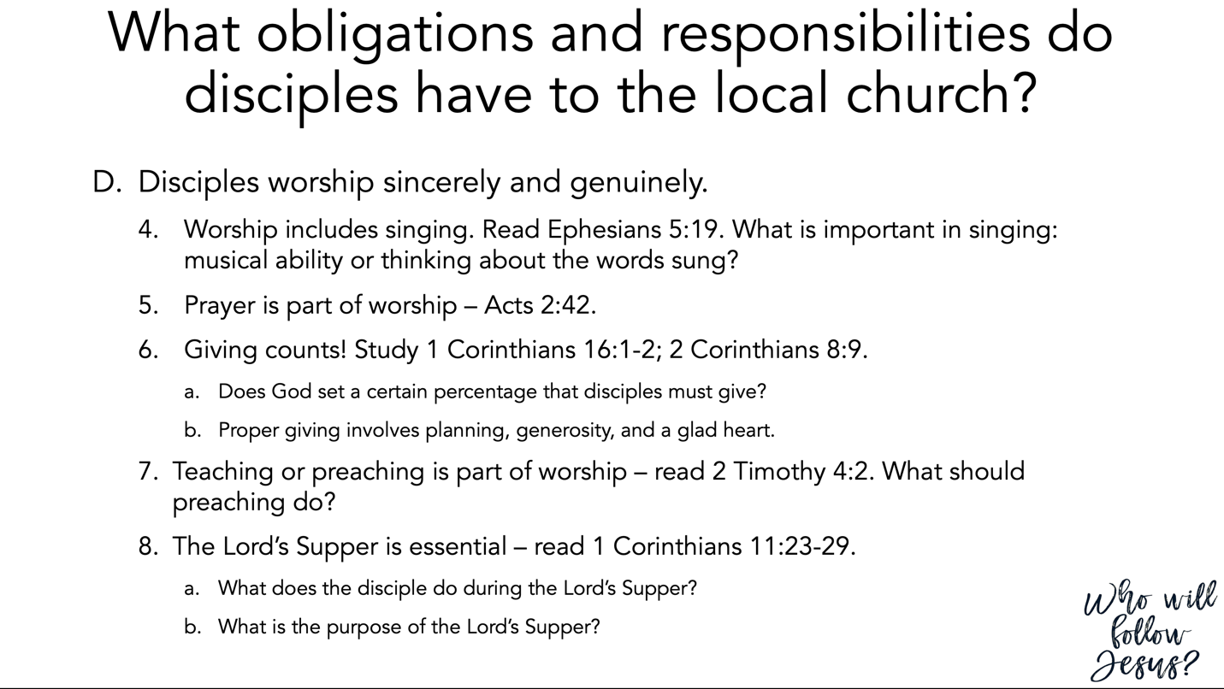

Ephesians 5:19 (NASB95)
¹⁹ speaking to one another in psalms and hymns and spiritual songs, singing and making melody with your heart to the Lord;

Colossians 3:16 (NASB95)
¹⁶ Let the word of Christ richly dwell within you, with all wisdom teaching and admonishing one another with psalms and hymns and spiritual songs, singing with thankfulness in your hearts to God.

Acts 2:42–47 (NASB95) – The Fellowship of the First Believers
⁴² They were continually devoting themselves to the apostles’ teaching and to fellowship, to the breaking of bread and to prayer. ⁴³ Everyone kept feeling a sense of awe; and many wonders and signs were taking place through the apostles. ⁴⁴ And all those who had believed were together and had all things in common; ⁴⁵ and they began selling their property and possessions and were sharing them with all, as anyone might have need. ⁴⁶ Day by day continuing with one mind in the temple, and breaking bread from house to house, they were taking their meals together with gladness and sincerity of heart, ⁴⁷ praising God and having favor with all the people. And the Lord was adding to their number day by day those who were being saved.

1 Corinthians 16:1–4 (NASB95) – The Collection for the Saints
¹ Now concerning the collection for the saints, as I directed the churches of Galatia, so do you also. ² On the first day of every week each one of you is to put aside and save, as he may prosper, so that no collections be made when I come. ³ When I arrive, whomever you may approve, I will send them with letters to carry your gift to Jerusalem; ⁴ and if it is fitting for me to go also, they will go with me.

2 Corinthians 8:8–15 (NASB95) – Christ: Our Pattern for Generous Giving
⁸ I am not speaking this as a command, but as proving through the earnestness of others the sincerity of your love also. ⁹ For you know the grace of our Lord Jesus Christ, that though He was rich, yet for your sake He became poor, so that you through His poverty might become rich. ¹⁰ I give my opinion in this matter, for this is to your advantage, who were the first to begin a year ago not only to do this, but also to desire to do it. ¹¹ But now finish doing it also, so that just as there was the readiness to desire it, so there may be also the completion of it by your ability. ¹² For if the readiness is present, it is acceptable according to what a person has, not according to what he does not have. ¹³ For this is not for the ease of others and for your affliction, but by way of equality— ¹⁴ at this present time your abundance being a supply for their need, so that their abundance also may become a supply for your need, that there may be equality; ¹⁵ as it is written, “He who gathered much did not have too much, and he who gathered little had no lack.”

2 Timothy 4:1–5 (NASB95) – Preach the Word
¹ I solemnly charge you in the presence of God and of Christ Jesus, who is to judge the living and the dead, and by His appearing and His kingdom: ² preach the word; be ready in season and out of season; reprove, rebuke, exhort, with great patience and instruction. ³ For the time will come when they will not endure sound doctrine; but wanting to have their ears tickled, they will accumulate for themselves teachers in accordance to their own desires, ⁴ and will turn away their ears from the truth and will turn aside to myths. ⁵ But you, be sober in all things, endure hardship, do the work of an evangelist, fulfill your ministry.

1 Corinthians 11:17–34 (NASB95) – The Lord’s Supper
¹⁷ But in giving this instruction, I do not praise you, because you come together not for the better but for the worse. ¹⁸ For, in the first place, when you come together as a church, I hear that divisions exist among you; and in part I believe it. ¹⁹ For there must also be factions among you, so that those who are approved may become evident among you. ²⁰ Therefore when you meet together, it is not to eat the Lord’s Supper, ²¹ for in your eating each one takes his own supper first; and one is hungry and another is drunk. ²² What! Do you not have houses in which to eat and drink? Or do you despise the church of God and shame those who have nothing? What shall I say to you? Shall I praise you? In this I will not praise you. ²³ For I received from the Lord that which I also delivered to you, that the Lord Jesus in the night in which He was betrayed took bread; ²⁴ and when He had given thanks, He broke it and said, “This is My body, which is for you; do this in remembrance of Me.” ²⁵ In the same way He took the cup also after supper, saying, “This cup is the new covenant in My blood; do this, as often as you drink it, in remembrance of Me.” ²⁶ For as often as you eat this bread and drink the cup, you proclaim the Lord’s death until He comes. ²⁷ Therefore whoever eats the bread or drinks the cup of the Lord in an unworthy manner, shall be guilty of the body and the blood of the Lord. ²⁸ But a man must examine himself, and in so doing he is to eat of the bread and drink of the cup. ²⁹ For he who eats and drinks, eats and drinks judgment to himself if he does not judge the body rightly. ³⁰ For this reason many among you are weak and sick, and a number sleep. ³¹ But if we judged ourselves rightly, we would not be judged. ³² But when we are judged, we are disciplined by the Lord so that we will not be condemned along with the world. ³³ So then, my brethren, when you come together to eat, wait for one another. ³⁴ If anyone is hungry, let him eat at home, so that you will not come together for judgment. The remaining matters I will arrange when I come.

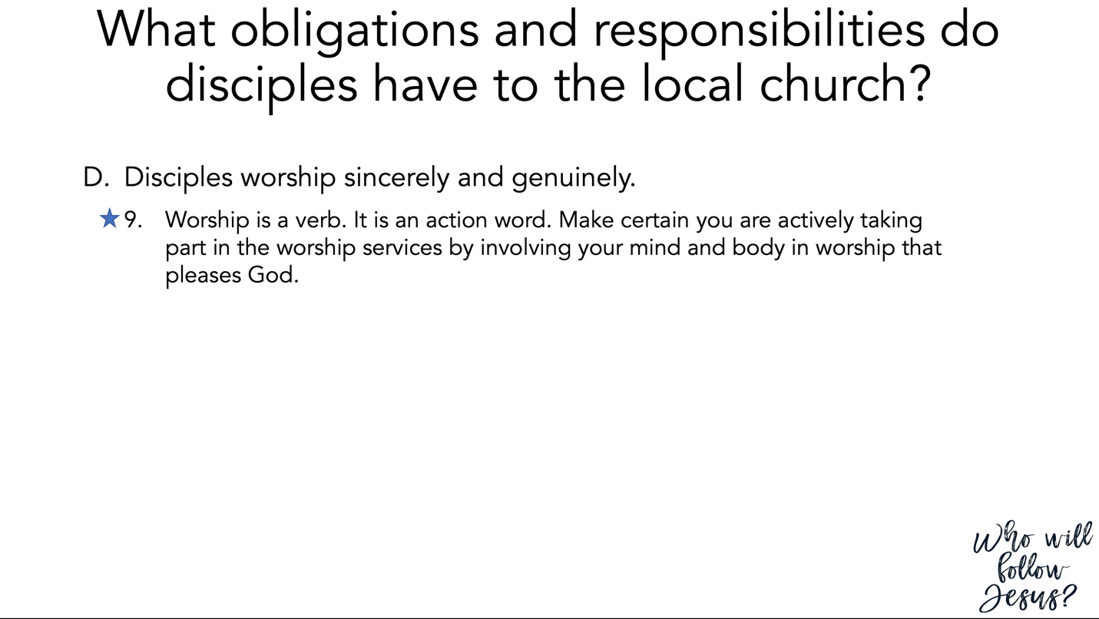

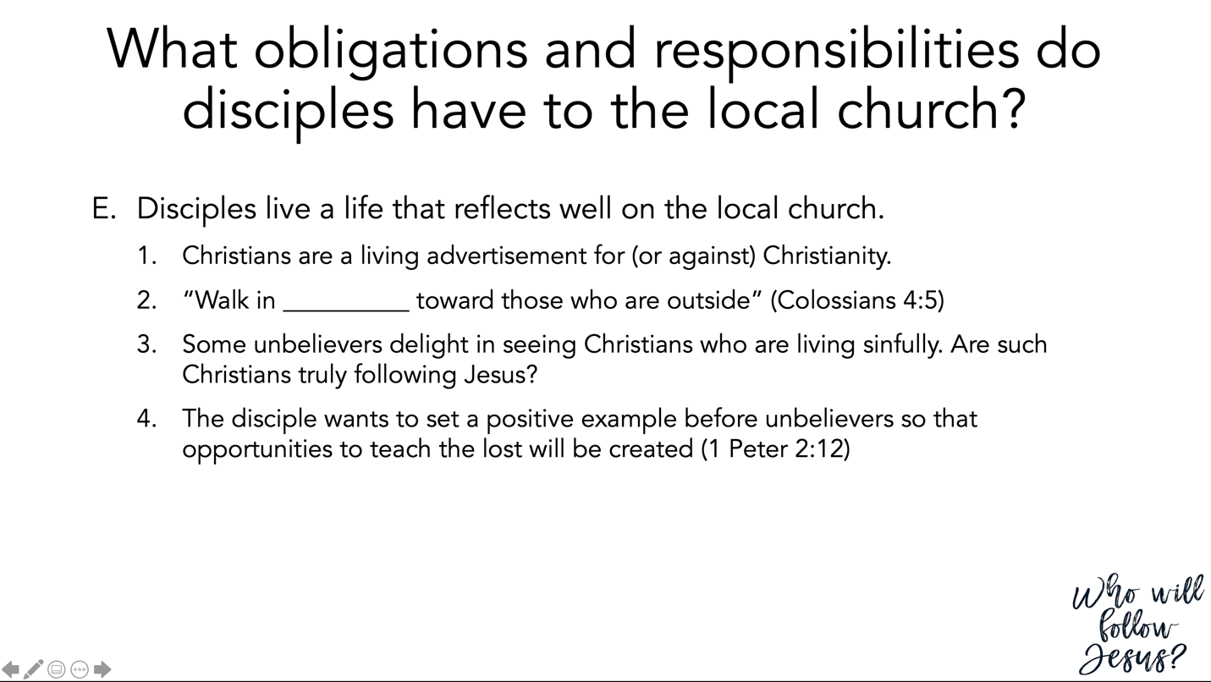

Colossians 4:2–6 (NASB95) – Manifest Christlikeness
² Devote yourselves to prayer, keeping alert in it with an attitude of thanksgiving; ³ praying at the same time for us as well, that God will open up to us a door for the word, so that we may speak forth the mystery of Christ, for which I have also been imprisoned; ⁴ that I may make it clear in the way I ought to speak. ⁵ Conduct yourselves with wisdom toward outsiders, making the most of the opportunity. ⁶ Let your speech always be with grace, as though seasoned with salt, so that you will know how you should respond to each person.

1 Peter 2:4–12 (NASB95) – As Living Stones
⁴ And coming to Him as to a living stone which has been rejected by men, but is choice and precious in the sight of God, ⁵ you also, as living stones, are being built up as a spiritual house for a holy priesthood, to offer up spiritual sacrifices acceptable to God through Jesus Christ. ⁶ For this is contained in Scripture: “Behold, I lay in Zion a choice stone, a precious corner stone, And he who believes in Him will not be disappointed.” ⁷ This precious value, then, is for you who believe; but for those who disbelieve, “The stone which the builders rejected, This became the very corner stone,” ⁸ and, “A stone of stumbling and a rock of offense”; for they stumble because they are disobedient to the word, and to this doom they were also appointed. ⁹ But you are a chosen race, a royal priesthood, a holy nation, a people for God’s own possession, so that you may proclaim the excellencies of Him who has called you out of darkness into His marvelous light; ¹⁰ for you once were not a people, but now you are the people of God; you had not received mercy, but now you have received mercy. ¹¹ Beloved, I urge you as aliens and strangers to abstain from fleshly lusts which wage war against the soul. ¹² Keep your behavior excellent among the Gentiles, so that in the thing in which they slander you as evildoers, they may because of your good deeds, as they observe them, glorify God in the day of visitation.

