Luke 6:20–45 (NASB95) – The Beatitudes
²⁰ And turning His gaze toward His disciples, He began to say, “Blessed are you who are poor, for yours is the kingdom of God. ²¹ “Blessed are you who hunger now, for you shall be satisfied. Blessed are you who weep now, for you shall laugh. ²² “Blessed are you when men hate you, and ostracize you, and insult you, and scorn your name as evil, for the sake of the Son of Man. ²³ “Be glad in that day and leap for joy, for behold, your reward is great in heaven. For in the same way their fathers used to treat the prophets. ²⁴ “But woe to you who are rich, for you are receiving your comfort in full. ²⁵ “Woe to you who are well-fed now, for you shall be hungry. Woe to you who laugh now, for you shall mourn and weep. ²⁶ “Woe to you when all men speak well of you, for their fathers used to treat the false prophets in the same way. ²⁷ “But I say to you who hear, love your enemies, do good to those who hate you, ²⁸ bless those who curse you, pray for those who mistreat you. ²⁹ “Whoever hits you on the cheek, offer him the other also; and whoever takes away your coat, do not withhold your shirt from him either. ³⁰ “Give to everyone who asks of you, and whoever takes away what is yours, do not demand it back. ³¹ “Treat others the same way you want them to treat you. ³² “If you love those who love you, what credit is that to you? For even sinners love those who love them. ³³ “If you do good to those who do good to you, what credit is that to you? For even sinners do the same. ³⁴ “If you lend to those from whom you expect to receive, what credit is that to you? Even sinners lend to sinners in order to receive back the same amount. ³⁵ “But love your enemies, and do good, and lend, expecting nothing in return; and your reward will be great, and you will be sons of the Most High; for He Himself is kind to ungrateful and evil men. ³⁶ “Be merciful, just as your Father is merciful. ³⁷ “Do not judge, and you will not be judged; and do not condemn, and you will not be condemned; pardon, and you will be pardoned. ³⁸ “Give, and it will be given to you. They will pour into your lap a good measure—pressed down, shaken together, and running over. For by your standard of measure it will be measured to you in return.” ³⁹ And He also spoke a parable to them: “A blind man cannot guide a blind man, can he? Will they not both fall into a pit? ⁴⁰ “A pupil is not above his teacher; but everyone, after he has been fully trained, will be like his teacher. ⁴¹ “Why do you look at the speck that is in your brother’s eye, but do not notice the log that is in your own eye? ⁴² “Or how can you say to your brother, ‘Brother, let me take out the speck that is in your eye,’ when you yourself do not see the log that is in your own eye? You hypocrite, first take the log out of your own eye, and then you will see clearly to take out the speck that is in your brother’s eye. ⁴³ “For there is no good tree which produces bad fruit, nor, on the other hand, a bad tree which produces good fruit. ⁴⁴ “For each tree is known by its own fruit. For men do not gather figs from thorns, nor do they pick grapes from a briar bush. ⁴⁵ “The good man out of the good treasure of his heart brings forth what is good; and the evil man out of the evil treasure brings forth what is evil; for his mouth speaks from that which fills his heart.

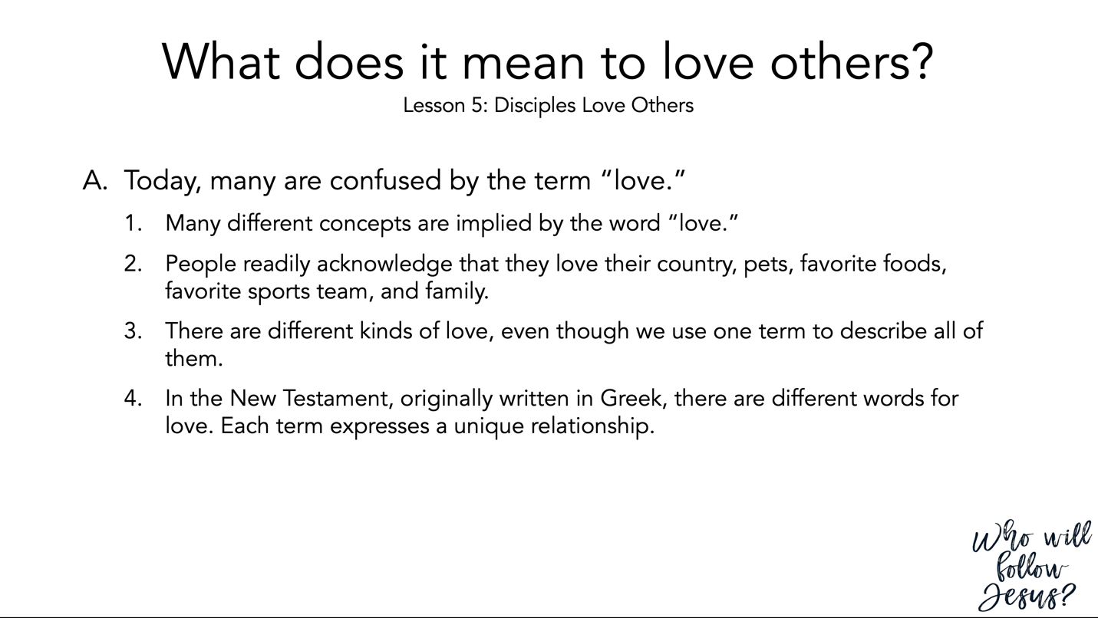

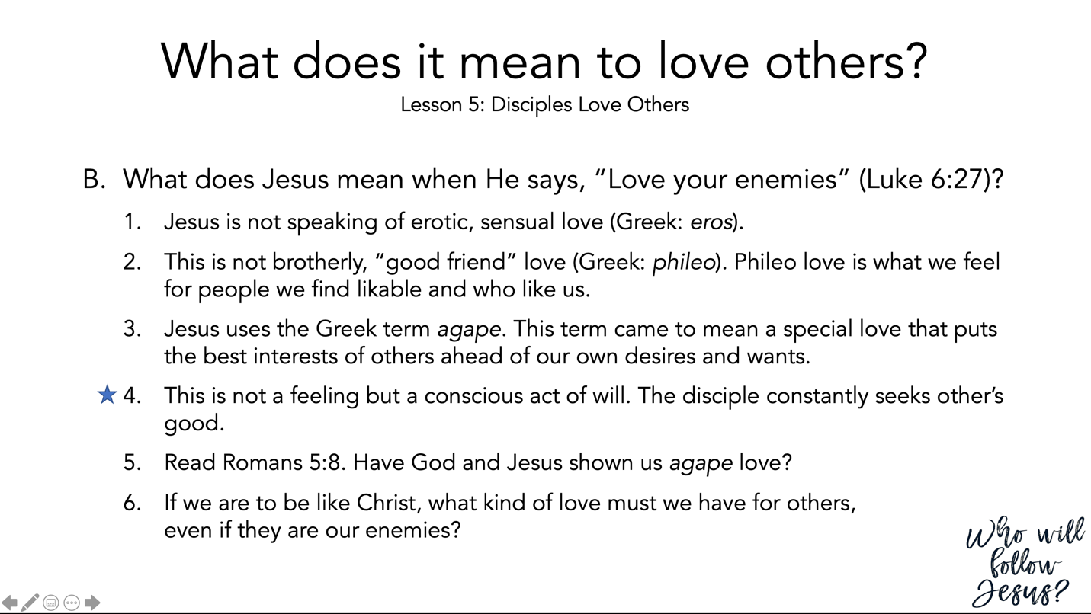

Luke 6:20–45 (NASB95) – The Beatitudes
²⁰ And turning His gaze toward His disciples, He began to say, “Blessed are you who are poor, for yours is the kingdom of God. ²¹ “Blessed are you who hunger now, for you shall be satisfied. Blessed are you who weep now, for you shall laugh. ²² “Blessed are you when men hate you, and ostracize you, and insult you, and scorn your name as evil, for the sake of the Son of Man. ²³ “Be glad in that day and leap for joy, for behold, your reward is great in heaven. For in the same way their fathers used to treat the prophets. ²⁴ “But woe to you who are rich, for you are receiving your comfort in full. ²⁵ “Woe to you who are well-fed now, for you shall be hungry. Woe to you who laugh now, for you shall mourn and weep. ²⁶ “Woe to you when all men speak well of you, for their fathers used to treat the false prophets in the same way. ²⁷ “But I say to you who hear, love your enemies, do good to those who hate you, ²⁸ bless those who curse you, pray for those who mistreat you. ²⁹ “Whoever hits you on the cheek, offer him the other also; and whoever takes away your coat, do not withhold your shirt from him either. ³⁰ “Give to everyone who asks of you, and whoever takes away what is yours, do not demand it back. ³¹ “Treat others the same way you want them to treat you. ³² “If you love those who love you, what credit is that to you? For even sinners love those who love them. ³³ “If you do good to those who do good to you, what credit is that to you? For even sinners do the same. ³⁴ “If you lend to those from whom you expect to receive, what credit is that to you? Even sinners lend to sinners in order to receive back the same amount. ³⁵ “But love your enemies, and do good, and lend, expecting nothing in return; and your reward will be great, and you will be sons of the Most High; for He Himself is kind to ungrateful and evil men. ³⁶ “Be merciful, just as your Father is merciful. ³⁷ “Do not judge, and you will not be judged; and do not condemn, and you will not be condemned; pardon, and you will be pardoned. ³⁸ “Give, and it will be given to you. They will pour into your lap a good measure—pressed down, shaken together, and running over. For by your standard of measure it will be measured to you in return.” ³⁹ And He also spoke a parable to them: “A blind man cannot guide a blind man, can he? Will they not both fall into a pit? ⁴⁰ “A pupil is not above his teacher; but everyone, after he has been fully trained, will be like his teacher. ⁴¹ “Why do you look at the speck that is in your brother’s eye, but do not notice the log that is in your own eye? ⁴² “Or how can you say to your brother, ‘Brother, let me take out the speck that is in your eye,’ when you yourself do not see the log that is in your own eye? You hypocrite, first take the log out of your own eye, and then you will see clearly to take out the speck that is in your brother’s eye. ⁴³ “For there is no good tree which produces bad fruit, nor, on the other hand, a bad tree which produces good fruit. ⁴⁴ “For each tree is known by its own fruit. For men do not gather figs from thorns, nor do they pick grapes from a briar bush. ⁴⁵ “The good man out of the good treasure of his heart brings forth what is good; and the evil man out of the evil treasure brings forth what is evil; for his mouth speaks from that which fills his heart.

---
In the New Testament of the Greek words available to describe love,

eros (sexual love) does not occur in the NT.

Phileo, connoting natural affection, occurs some 25 times, with philadelphia (brotherly love) five times, and philia (friendship) only in James 4:4. Storge, connoting natural affection between relatives, appears occasionally in compounds.

By far the most frequent word is agape, generally assumed to mean moral goodwill that proceeds from esteem, principle, or duty rather than attraction of charm. Agape is very similar in meaning to hesed in that both denote dedication. Agape specifically means to love the undeserving, despite disappointment and rejection. The difference between agapao and phileo is difficult to sustain in all passages. Agape is especially appropriate for divine love. Agape was long believed to be a Christian coinage, but pagan occurrences have recently been claimed. The verb agapao was frequent in the Greek OT. Though agape has more to do with moral principle than with inclination or liking, it never means the cold religious kindness shown from duty alone, as scriptural examples abundantly prove.

---
Romans 5:6–11 (NASB95) – Justified by His Death; Saved by His Life
⁶ For while we were still helpless, at the right time Christ died for the ungodly. ⁷ For one will hardly die for a righteous man; though perhaps for the good man someone would dare even to die. ⁸ But God demonstrates His own love toward us, in that while we were yet sinners, Christ died for us. ⁹ Much more then, having now been justified by His blood, we shall be saved from the wrath of God through Him. ¹⁰ For if while we were enemies we were reconciled to God through the death of His Son, much more, having been reconciled, we shall be saved by His life. ¹¹ And not only this, but we also exult in God through our Lord Jesus Christ, through whom we have now received the reconciliation.

Luke 6:27–36 (NASB95) – Love Your Enemies
²⁷ “But I say to you who hear, love your enemies, do good to those who hate you, ²⁸ bless those who curse you, pray for those who mistreat you. ²⁹ “Whoever hits you on the cheek, offer him the other also; and whoever takes away your coat, do not withhold your shirt from him either. ³⁰ “Give to everyone who asks of you, and whoever takes away what is yours, do not demand it back. ³¹ “Treat others the same way you want them to treat you. ³² “If you love those who love you, what credit is that to you? For even sinners love those who love them. ³³ “If you do good to those who do good to you, what credit is that to you? For even sinners do the same. ³⁴ “If you lend to those from whom you expect to receive, what credit is that to you? Even sinners lend to sinners in order to receive back the same amount. ³⁵ “But love your enemies, and do good, and lend, expecting nothing in return; and your reward will be great, and you will be sons of the Most High; for He Himself is kind to ungrateful and evil men. ³⁶ “Be merciful, just as your Father is merciful.

Romans 12:14–21 (NASB95) – Charity to Everyone, Including Enemies
¹⁴ Bless those who persecute you; bless and do not curse. ¹⁵ Rejoice with those who rejoice, and weep with those who weep. ¹⁶ Be of the same mind toward one another; do not be haughty in mind, but associate with the lowly. Do not be wise in your own estimation. ¹⁷ Never pay back evil for evil to anyone. Respect what is right in the sight of all men. ¹⁸ If possible, so far as it depends on you, be at peace with all men. ¹⁹ Never take your own revenge, beloved, but leave room for the wrath of God, for it is written, “Vengeance is Mine, I will repay,” says the Lord. ²⁰ “But if your enemy is hungry, feed him, and if he is thirsty, give him a drink; for in so doing you will heap burning coals on his head.” ²¹ Do not be overcome by evil, but overcome evil with good.

Luke 6:27–36 (NASB95) – Love Your Enemies
²⁷ “But I say to you who hear, love your enemies, do good to those who hate you, ²⁸ bless those who curse you, pray for those who mistreat you. ²⁹ “Whoever hits you on the cheek, offer him the other also; and whoever takes away your coat, do not withhold your shirt from him either. ³⁰ “Give to everyone who asks of you, and whoever takes away what is yours, do not demand it back. ³¹ “Treat others the same way you want them to treat you. ³² “If you love those who love you, what credit is that to you? For even sinners love those who love them. ³³ “If you do good to those who do good to you, what credit is that to you? For even sinners do the same. ³⁴ “If you lend to those from whom you expect to receive, what credit is that to you? Even sinners lend to sinners in order to receive back the same amount. ³⁵ “But love your enemies, and do good, and lend, expecting nothing in return; and your reward will be great, and you will be sons of the Most High; for He Himself is kind to ungrateful and evil men. ³⁶ “Be merciful, just as your Father is merciful.

Luke 10:30–37 (NASB95) – The Good Samaritan
³⁰ Jesus replied and said, “A man was going down from Jerusalem to Jericho, and fell among robbers, and they stripped him and beat him, and went away leaving him half dead. ³¹ “And by chance a priest was going down on that road, and when he saw him, he passed by on the other side. ³² “Likewise a Levite also, when he came to the place and saw him, passed by on the other side. ³³ “But a Samaritan, who was on a journey, came upon him; and when he saw him, he felt compassion, ³⁴ and came to him and bandaged up his wounds, pouring oil and wine on them; and he put him on his own beast, and brought him to an inn and took care of him. ³⁵ “On the next day he took out two denarii and gave them to the innkeeper and said, ‘Take care of him; and whatever more you spend, when I return I will repay you.’ ³⁶ “Which of these three do you think proved to be a neighbor to the man who fell into the robbers’ hands?” ³⁷ And he said, “The one who showed mercy toward him.” Then Jesus said to him, “Go and do the same.”

Luke 6:37–42 (NASB95) – Do Not Judge
³⁷ “Do not judge, and you will not be judged; and do not condemn, and you will not be condemned; pardon, and you will be pardoned. ³⁸ “Give, and it will be given to you. They will pour into your lap a good measure—pressed down, shaken together, and running over. For by your standard of measure it will be measured to you in return.” ³⁹ And He also spoke a parable to them: “A blind man cannot guide a blind man, can he? Will they not both fall into a pit? ⁴⁰ “A pupil is not above his teacher; but everyone, after he has been fully trained, will be like his teacher. ⁴¹ “Why do you look at the speck that is in your brother’s eye, but do not notice the log that is in your own eye? ⁴² “Or how can you say to your brother, ‘Brother, let me take out the speck that is in your eye,’ when you yourself do not see the log that is in your own eye? You hypocrite, first take the log out of your own eye, and then you will see clearly to take out the speck that is in your brother’s eye.

Luke 6:6–11 (NASB95) – Jesus Heals a Man with a Withered Hand on the Sabbath
⁶ On another Sabbath He entered the synagogue and was teaching; and there was a man there whose right hand was withered. ⁷ The scribes and the Pharisees were watching Him closely to see if He healed on the Sabbath, so that they might find reason to accuse Him. ⁸ But He knew what they were thinking, and He said to the man with the withered hand, “Get up and come forward!” And he got up and came forward. ⁹ And Jesus said to them, “I ask you, is it lawful to do good or to do harm on the Sabbath, to save a life or to destroy it?” ¹⁰ After looking around at them all, He said to him, “Stretch out your hand!” And he did so; and his hand was restored. ¹¹ But they themselves were filled with rage, and discussed together what they might do to Jesus.

Romans 3:22–26 (NASB95) – The Revelation of God’s Judgment
²² even the righteousness of God through faith in Jesus Christ for all those who believe; for there is no distinction; ²³ for all have sinned and fall short of the glory of God, ²⁴ being justified as a gift by His grace through the redemption which is in Christ Jesus; ²⁵ whom God displayed publicly as a propitiation in His blood through faith. This was to demonstrate His righteousness, because in the forbearance of God He passed over the sins previously committed; ²⁶ for the demonstration, I say, of His righteousness at the present time, so that He would be just and the justifier of the one who has faith in Jesus.

John 7:14–24 (NASB95) – Jesus’ Authority is from God
¹⁴ But when it was now the midst of the feast Jesus went up into the temple, and began to teach. ¹⁵ The Jews then were astonished, saying, “How has this man become learned, having never been educated?” ¹⁶ So Jesus answered them and said, “My teaching is not Mine, but His who sent Me. ¹⁷ “If anyone is willing to do His will, he will know of the teaching, whether it is of God or whether I speak from Myself. ¹⁸ “He who speaks from himself seeks his own glory; but He who is seeking the glory of the One who sent Him, He is true, and there is no unrighteousness in Him. ¹⁹ “Did not Moses give you the Law, and yet none of you carries out the Law? Why do you seek to kill Me?” ²⁰ The crowd answered, “You have a demon! Who seeks to kill You?” ²¹ Jesus answered them, “I did one deed, and you all marvel. ²² “For this reason Moses has given you circumcision (not because it is from Moses, but from the fathers), and on the Sabbath you circumcise a man. ²³ “If a man receives circumcision on the Sabbath so that the Law of Moses will not be broken, are you angry with Me because I made an entire man well on the Sabbath? ²⁴ “Do not judge according to appearance, but judge with righteous judgment.”

Matthew 7:1–6 (NASB95) – Judging Others
¹ “Do not judge so that you will not be judged. ² “For in the way you judge, you will be judged; and by your standard of measure, it will be measured to you. ³ “Why do you look at the speck that is in your brother’s eye, but do not notice the log that is in your own eye? ⁴ “Or how can you say to your brother, ‘Let me take the speck out of your eye,’ and behold, the log is in your own eye? ⁵ “You hypocrite, first take the log out of your own eye, and then you will see clearly to take the speck out of your brother’s eye. ⁶ “Do not give what is holy to dogs, and do not throw your pearls before swine, or they will trample them under their feet, and turn and tear you to pieces.

John 3:16–21 (NASB95) – For God So Loved the World
¹⁶ “For God so loved the world, that He gave His only begotten Son, that whoever believes in Him shall not perish, but have eternal life. ¹⁷ “For God did not send the Son into the world to judge the world, but that the world might be saved through Him. ¹⁸ “He who believes in Him is not judged; he who does not believe has been judged already, because he has not believed in the name of the only begotten Son of God. ¹⁹ “This is the judgment, that the Light has come into the world, and men loved the darkness rather than the Light, for their deeds were evil. ²⁰ “For everyone who does evil hates the Light, and does not come to the Light for fear that his deeds will be exposed. ²¹ “But he who practices the truth comes to the Light, so that his deeds may be manifested as having been wrought in God.”

Ephesians 5:22–33 (NASB95) – Marriage Like Christ and the Church
²² Wives, be subject to your own husbands, as to the Lord. ²³ For the husband is the head of the wife, as Christ also is the head of the church, He Himself being the Savior of the body. ²⁴ But as the church is subject to Christ, so also the wives ought to be to their husbands in everything. ²⁵ Husbands, love your wives, just as Christ also loved the church and gave Himself up for her, ²⁶ so that He might sanctify her, having cleansed her by the washing of water with the word, ²⁷ that He might present to Himself the church in all her glory, having no spot or wrinkle or any such thing; but that she would be holy and blameless. ²⁸ So husbands ought also to love their own wives as their own bodies. He who loves his own wife loves himself; ²⁹ for no one ever hated his own flesh, but nourishes and cherishes it, just as Christ also does the church, ³⁰ because we are members of His body. ³¹ For this reason a man shall leave his father and mother and shall be joined to his wife, and the two shall become one flesh. ³² This mystery is great; but I am speaking with reference to Christ and the church. ³³ Nevertheless, each individual among you also is to love his own wife even as himself, and the wife must see to it that she respects her husband.

1 John 3:16–24 (NASB95) – Love in Action
¹⁶ We know love by this, that He laid down His life for us; and we ought to lay down our lives for the brethren. ¹⁷ But whoever has the world’s goods, and sees his brother in need and closes his heart against him, how does the love of God abide in him? ¹⁸ Little children, let us not love with word or with tongue, but in deed and truth. ¹⁹ We will know by this that we are of the truth, and will assure our heart before Him ²⁰ in whatever our heart condemns us; for God is greater than our heart and knows all things. ²¹ Beloved, if our heart does not condemn us, we have confidence before God; ²² and whatever we ask we receive from Him, because we keep His commandments and do the things that are pleasing in His sight. ²³ This is His commandment, that we believe in the name of His Son Jesus Christ, and love one another, just as He commanded us. ²⁴ The one who keeps His commandments abides in Him, and He in him. We know by this that He abides in us, by the Spirit whom He has given us.

Galatians 6:1–5 (NASB95) – Bear and Share the Burdens
¹ Brethren, even if anyone is caught in any trespass, you who are spiritual, restore such a one in a spirit of gentleness; each one looking to yourself, so that you too will not be tempted. ² Bear one another’s burdens, and thereby fulfill the law of Christ. ³ For if anyone thinks he is something when he is nothing, he deceives himself. ⁴ But each one must examine his own work, and then he will have reason for boasting in regard to himself alone, and not in regard to another. ⁵ For each one will bear his own load.

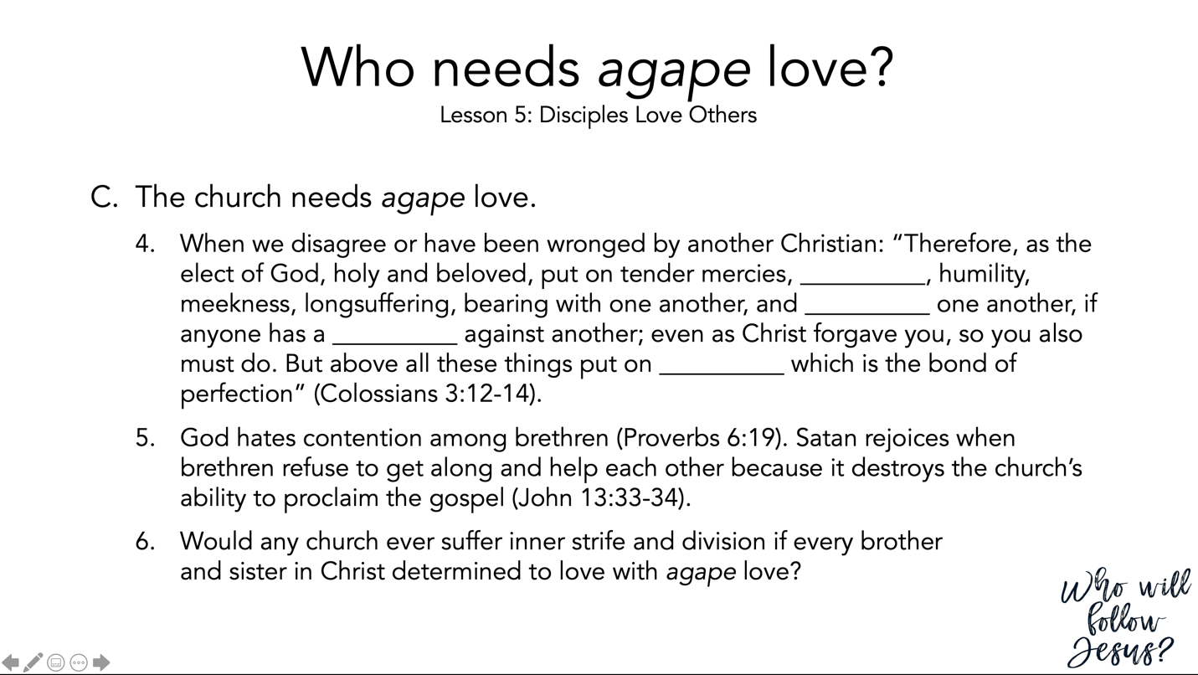

Colossians 3:12–17 (NASB95) – The Characteristics of Christ
¹² So, as those who have been chosen of God, holy and beloved, put on a heart of compassion, kindness, humility, gentleness and patience; ¹³ bearing with one another, and forgiving each other, whoever has a complaint against anyone; just as the Lord forgave you, so also should you. ¹⁴ Beyond all these things put on love, which is the perfect bond of unity. ¹⁵ Let the peace of Christ rule in your hearts, to which indeed you were called in one body; and be thankful. ¹⁶ Let the word of Christ richly dwell within you, with all wisdom teaching and admonishing one another with psalms and hymns and spiritual songs, singing with thankfulness in your hearts to God. ¹⁷ Whatever you do in word or deed, do all in the name of the Lord Jesus, giving thanks through Him to God the Father.

Proverbs 6:16–19 (NASB95) – What the Lord Hates
¹⁶ There are six things which the Lord hates, Yes, seven which are an abomination to Him: ¹⁷ Haughty eyes, a lying tongue, And hands that shed innocent blood, ¹⁸ A heart that devises wicked plans, Feet that run rapidly to evil, ¹⁹ A false witness who utters lies, And one who spreads strife among brothers.

John 13:31–38 (NASB95) – Jesus Says that Peter Will Fail
³¹ Therefore when he had gone out, Jesus said, “Now is the Son of Man glorified, and God is glorified in Him; ³² if God is glorified in Him, God will also glorify Him in Himself, and will glorify Him immediately. ³³ “Little children, I am with you a little while longer. You will seek Me; and as I said to the Jews, now I also say to you, ‘Where I am going, you cannot come.’ ³⁴ “A new commandment I give to you, that you love one another, even as I have loved you, that you also love one another. ³⁵ “By this all men will know that you are My disciples, if you have love for one another.” ³⁶ Simon Peter said to Him, “Lord, where are You going?” Jesus answered, “Where I go, you cannot follow Me now; but you will follow later.” ³⁷ Peter said to Him, “Lord, why can I not follow You right now? I will lay down my life for You.” ³⁸ Jesus answered, “Will you lay down your life for Me? Truly, truly, I say to you, a rooster will not crow until you deny Me three times.

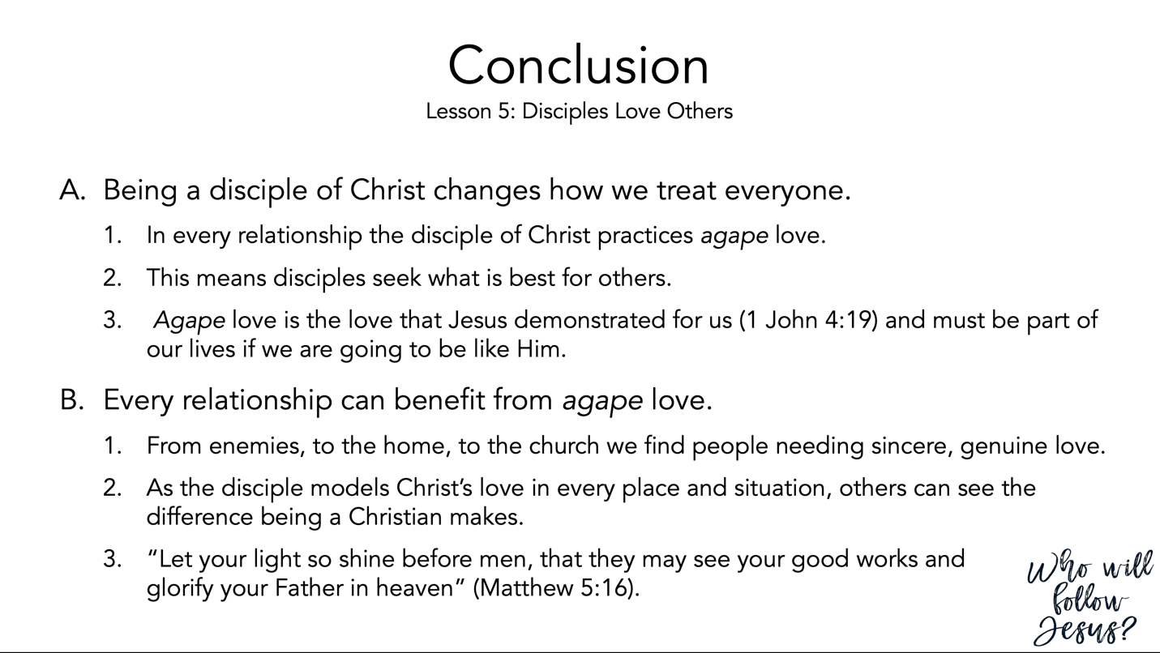

1 John 4:17–19 (NASB95) – The Consummation of Love
¹⁷ By this, love is perfected with us, so that we may have confidence in the day of judgment; because as He is, so also are we in this world. ¹⁸ There is no fear in love; but perfect love casts out fear, because fear involves punishment, and the one who fears is not perfected in love. ¹⁹ We love, because He first loved us.

Matthew 5:13–20 (NASB95) – Disciples and the World
¹³ “You are the salt of the earth; but if the salt has become tasteless, how can it be made salty again? It is no longer good for anything, except to be thrown out and trampled under foot by men. ¹⁴ “You are the light of the world. A city set on a hill cannot be hidden; ¹⁵ nor does anyone light a lamp and put it under a basket, but on the lampstand, and it gives light to all who are in the house. ¹⁶ “Let your light shine before men in such a way that they may see your good works, and glorify your Father who is in heaven. ¹⁷ “Do not think that I came to abolish the Law or the Prophets; I did not come to abolish but to fulfill. ¹⁸ “For truly I say to you, until heaven and earth pass away, not the smallest letter or stroke shall pass from the Law until all is accomplished. ¹⁹ “Whoever then annuls one of the least of these commandments, and teaches others to do the same, shall be called least in the kingdom of heaven; but whoever keeps and teaches them, he shall be called great in the kingdom of heaven. ²⁰ “For I say to you that unless your righteousness surpasses that of the scribes and Pharisees, you will not enter the kingdom of heaven.

Elwell, W. A., & Comfort, P. W. (2001). In Tyndale Bible dictionary (p. 827). Wheaton, IL: Tyndale House Publishers.

